An Angel’s Wing Inc

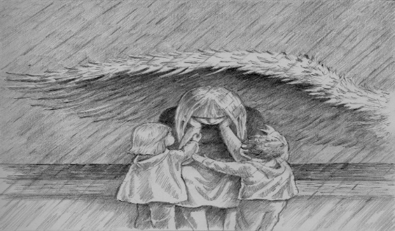
1567 Lisbon Street,

Lewiston, Maine 04240

207-241-0624

TYPE OF SERVICES REQUESTED (name, address & telephone if applicable)
ORGANIZATION WHO REFERRED YOU: _______________________________________

Amount: Needed $_____________ Are you employed?__________ Insurance:_________________
Detox:________________________ Inpatient________________________ Recovery home_____________________

ORGANIZATION WHO REFERRED YOU: _______________________________________

Have you ever been through the detox, rehabilitation, sober living before?___________ if yes, when and where?_________________________________________________________________________________________

Are you or have you been homeless?__________________ when?_________________________________________

Do you have access to basic needs? Food ________ shelter __________ Medication (if applicable)_______________

What is your history of drug alcohol use? Drug/Drugs of choice?____________________________________________

How much and how often?

Have you experienced DT’s (severe alcohol withdrawal) or any severe withdrawals in the past?

Are you pregnant?____________

Are there currently or have you experienced past suicidal thoughts or actions, aggressive behavior, violent thoughts or
harmful thoughts to yourself or others? ______________________________________________________________

Current medications:______________________________________________________________________________

Any mental health diagnosis:________________________________________________________________________

PTSD:________ Anxiety disorders:_________ eating disorder:_____________ Mood disorder:____________________

Have you experienced any Covid related symptoms within the last 7 days:____________________________________

Are you currently seeing a health care physician Date::__________Psychiatrist:________________________

_Dentist:___________________________ Eye doctor:

Substance Use Disorder referral service

Applicant Information
Full Name: |  |  |  | Date:
 | Last | First | M.I.

Address:
 | Street Address | Apartment/Unit #

 | City | State | ZIP Code

Phone: |  | Email

Serviced in the Military? ___________ |  |  | Do we have permission to speak with the facilities your requesting help for?  Yes____ No_____
 |  |  | Sign:

Barriers
Please list any disabilities, health problems or barriers you may have:

Emergency Contact
Next of Kin: Name/relation: |  | Tele#:

I certify that my answers are true and complete to the best of my knowledge.
If this application leads to assistance, I understand that false or misleading information in my application or interview may result in my release.
Signature |  | Date:

Types of future services that may be needed:

1.____________________________________

2.____________________________________

3.___________________________________

4.____________________________________

