Mystery Day!

Oh, where will we go?

A Day of fun we shall have Though

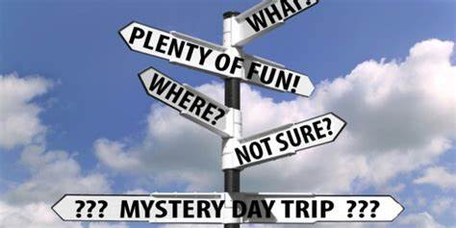

**August 8th, 2025**

**Depart from Sams Club, 4420 King Ave E.**

**9:00AM to approximately 6:15PM**

Transportation, entrance fees, lunch and dinner included

$139.00 for a day of some shopping, food, learning, walking and friends!

**????????????????????????????????????????????????????????????????????????????**

------------Tammy’s Global Adventures------------

Welcome!! We are delighted that you have chosen to travel with us. Along with your payment, this confidential form must be filled out by each individual and sent back to:

1430 Country Manor Blvd Suit 1, Billings MT 59102

406-698-8335 [Tammyglobalta@gmail.com](mailto:Tammyglobalta@gmail.com)

Please make checks payable to Tammy’s Global Adventures

NAME OF TRIP/TOUR: _____________________________________________ TRIP DATES: ________________________________

PRINT YOUR NAME _____________________________________________________

ADDRESS: _____________________________________________________________CITY: ______________________________________

STATE: _____ ZIP: ___________ HOME PHONE: ________________________________CELL: ____________________________________

IN CASE OF EMERGENCY, LIST PERSON (S) TO CONTACT:

NAME: _________________________________ RELATIONSHIP: _________________________PHONE: ________________________________

List allergies and any Health/Medical Problem(s) we need to know: ____________________________________________________

Total amount enclosed: $ _______________ Check _______-Payable to Global Travel Adventures by Tammy

HOLD HARMLESS RELEASE: * I hold, Tammy’s Global Adventures and Gals Going Global harmless and forever release the company, its agents and employees from any and all cause or causes of action, claims, costs, and liabilities of any kind, nature or description involving, or relating to any and all harm, injury or damage suffered or sustained by me in any manner arising out of this event or tour/trip. This “hold harmless/release” applies to my heirs, personal representatives, successors and assigns. I further certify that I am in sufficient health to make this tour/trip. I have read the above information and agree to the terms and conditions of the travel arrangements.

Signature: _____________________________________________ Date: ___________/____________/___________