***A Thursday evening Welcome Reception will be held. Please check PANE.US for more information.***

**Day 1 – Friday, April 26, 2019**

8:30- 9:00AM REGISTRATION AND BREAKFAST,

WELCOME AND INTRODUCTION

9:00-10:00AM **GI Surgery**

Joel Goldberg, MD

Asst Professor of Surgery, Harvard Medical School, Boston, MA

10:00-10:15 AM BREAK

10:15-11:15AM **Pulmonary Oncologic Pathology Diseases of the Pleura and Chest Wall**

                                    Lucien Chirieac, MD

Pathologist, Brigham & Women’s Hospital

Discuss the surgical pathology specimens from patients with malignant mesothelioma and other chest diseases.

11:15-11:30AM BREAK

11:30-12:30PM **Gross Ovarian Pathology**

David Kolin, MD, PhD

Brigham and Women’s Hospital, Boston, MA

Review gross pathology of benign and malignant ovarian tumors. Review suggested grossing protocols for common ovarian lesions. Introduction of corresponding microscopic findings.

12:30-1:30PM LUNCH (provided)

1:30-2:30PM **Lung Wedge Biopsies**

Lynette Sholl, MD

Brigham and Women’s Hospital, Boston, MA

.

2:30-2:45PM BREAK

2:45-3:45PM **Neoadjuvant Breast Specimens & Sentinel Lymph Node Evaluation**

Beth Harrison, MD

Brigham & Women’s Hospital, Boston, MA

3:45-4:00PM BREAK

4:00-5:00PM **Worms, Wheezes and Weird Diseases**

Tony Mattia, MD

North Shore Medical Center

Boston, MA

***All are welcome to join the group for an after-conference social and dinner following Friday’s presentations. Please check PANE.US for more details. (Event not included in conference fees.)***

**Day 2 – Saturday, April 27, 2019**

8:00-8:30AM REGISTRATION AND BREAKFAST,

WELCOME AND INTRODUCTION

8:30-9:30AM **Improving the Transfer of Medical History in Surgical Pathology Handover**

Collen Hebert, PA(ASCP), DHA

Hartford Hospital, Hartford, CT

Review the current literature on pathology errors and international handover guidelines for medical practice. Present the steps to making a process improvement within an organization. Present research model to improve surgical pathology handover communication. Present the possible direction of future research in surgical pathology handover communication and the role PA’s have in promoting this initiative.

9:30-9:45AM BREAK

9:45-10:45AM **Twin/Molar Placental Pathology**

Alice Sedlack, PA(ASCP)

Brigham and Women’s Hospital, Boston, MA

10:45-11:00AM BREAK

11:00-12:00PM **Flotsam and Jetsam: A Cautionary Tale**

Harold Sanchez, MD

Bridgeport Hospital, Bridgeport, CT

Provide a brief overview of quality management & patient safety in surgical pathology. Examine pitfalls in surgical specimen processing in general & “floaters” in particular. Highlight the role of pathologist assistants in patient safety. Discuss the consequences to the patient, the pathology department and the hospital of lapses in specimen handling. Provide (and solicit) suggestions for ways to improve safety and minimize risk

12:00-1:30PM EXTENDED **LUNCH** (provided) to honor Leo Kelly retiring after over 46 years of service to the PA profession.

1:30-2:30PM **Targeting DNA Damage Repair Defects in High Grade Serous Ovarian Cancer**

Sarah Hill, MD, PhD

Dana-Farber Cancer Institute, Boston, MA

A focus on the generation of organoid models of human ovarian tumors to help better understand the molecular defects present in each tumor and how best to target them. Discussion of the important clinical issues in ovarian cancer treatment today and how we can scientifically understand them using organoids

2:30-2:45PM BREAK

2:45-3:45PM **Cardiovascular Medical Devices and Heart Transplant**

Robert Padera, MD PhD

Brigham & Women’s Hospital, Boston, MA

3:45-4:00PM BREAK

4:00-5:00PM **The Practice of Yoga for PA's: Both at and Beyond the Bench (Safety lecture)**

Sarah Blizzard, PA(ASCP), RYT

Yoga for the PA on and off the bench. To apply our background of anatomy to understand yoga poses. Also learn the why of poses; the inherent structure to make us feel good. Learn poses you can bring into the lab to alleviate common PA ergonomic problems.

5:00-5:30PM **Yoga practice session**

Sarah Blizzard, PA(ASCP) RYT

Following the lecture, there will be an optional 30 minute gentle yoga practice session that can be done in business casual clothes. Those who would like to participate are invited to bring a mat or towel if they wish. (No CME credit offered)

**Day 3 (morning) – Sunday, April 27, 2019**

8:00-8:30AM BREAKFAST AND ANNOUNCEMENTS

8:30-9:30AM **Overview of Endobronchial Ultrasound-Guided FNA**

Jeffrey Mito, MD, PhD

Brigham & Women’s Hospital, Boston, MA

Participants will recognize the advantages and limitations of EBUS fine needle aspiration. Participants will be able to explain the importance of rapid on-site evaluation (ROSE). Participants will be able to identify common pitfalls in interpreting EBUS specimens.

9:30-9:45AM BREAK

9:45-10:45AM **Non-Ovarian GYN Pathology**

David Kindelberger, MD

Harvard Vanguard Medical Associates, Atrius Health, Needham, MA

To appreciate the gross pathologic features of benign and malignant non-ovarian gyn tumors. To be aware of gross pathologic-histologic correlations seen in various non-ovarian gyn tumors. To develop a practical approach for optimal grossing of complex non-ovarian gyn specimens.

10:45-11:00AM BREAK

11-11:30AM **The Evolving Role of the Pathologists’ Assistant**

Kristina Grieco, PA(ASCP)

Brigham & Women’s Hosp, Boston, MA

A discussion of one PA’s role in neuropathology and hematopathology, which includes reading slides, ordering IHC’s, ordering chromosomal and molecular studies and preparing the reports.

11:30-12:00PM **Special Studies & Tissue Allocation at the Bench**

Mary Kate Cronin, PA(ASCP) Brigham & Women’s Hosp, Boston, MA

Presentation of a review of special studies and tissue allocation for efficient grossing

*Target Audience*

This program is designed for Pathologists’ Assistants.

*Accreditation*

Attendees should only claim credit commensurate with the extent of their participation in the activity.

*Disclosures*

PANE/MAPA adheres to the ASCLS Standards for Commercial Support. Faculty disclosure information will be made available during the activity. Faculty members are also expected to disclose to participants any discussion of off-label and/or investigational use of pharmaceutical products or devices during their presentations.

*Course Registration:*

It is strongly recommended that you register early for this program. Registration may be limited due to space. Registrations will be accepted on a first come, first served basis according to the date registration forms and payments are received.

*Standard Registration Fees:*

All Lectures/Breakfast and Lunch provided

PA One Day- $130

PA Two Days- $160

PA Three Days- $185

Student One Day- $45

Student Two Days- $65

Student Three Days- $85

*Hotel Accommodations*

Lodging is available for the PANE/MAPA Conference at the Hilton Homewood Suites Boston Brookline-Longwood Medical

Located by Boston's city center, the hotel is a 5 minute drive or 20 minute walk to Brigham and Women's Hospital. The Hilton Homewood Suites is also a 5 minute walk from Boston's MBTA transit system's Brookline Village stop. PANE/MAPA are arranging for a possible free daily shuttle service to and from BWH for transit to and from the PANE conference each day

The PANE/MAPA special rate for the conference is $199 plus tax for a single King. Please use the Group Code PANE/MAPA or reference the PANE room block. The rate can only be guaranteed till March 26. For other dates please contact the hotel.

<http://homewoodsuites.hilton.com/en/hw/groups/personalized/B/BOSBRHW-PMM-20190425/index.jhtml>

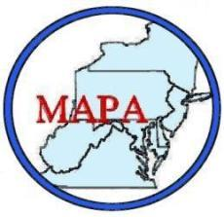

4th Semi-Annual

Joint PANE/MAPA

(Pathologists’ Assistants of New England / Mid-Atlantic Pathologists’ Assistants)

Educational Conference

**April 26-28, 2019**

Brigham and Women’s Hospital

Boston, MA

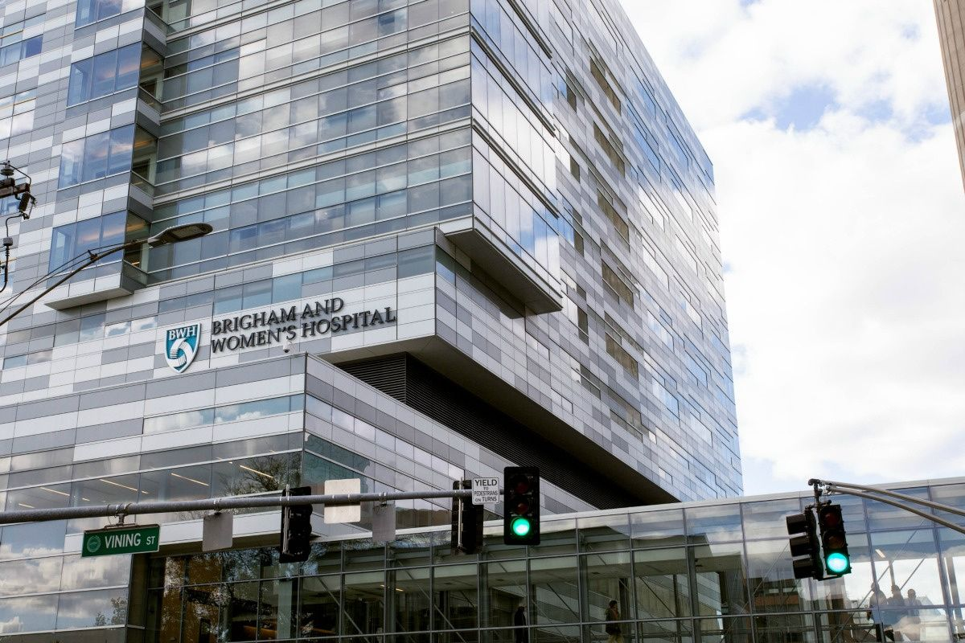

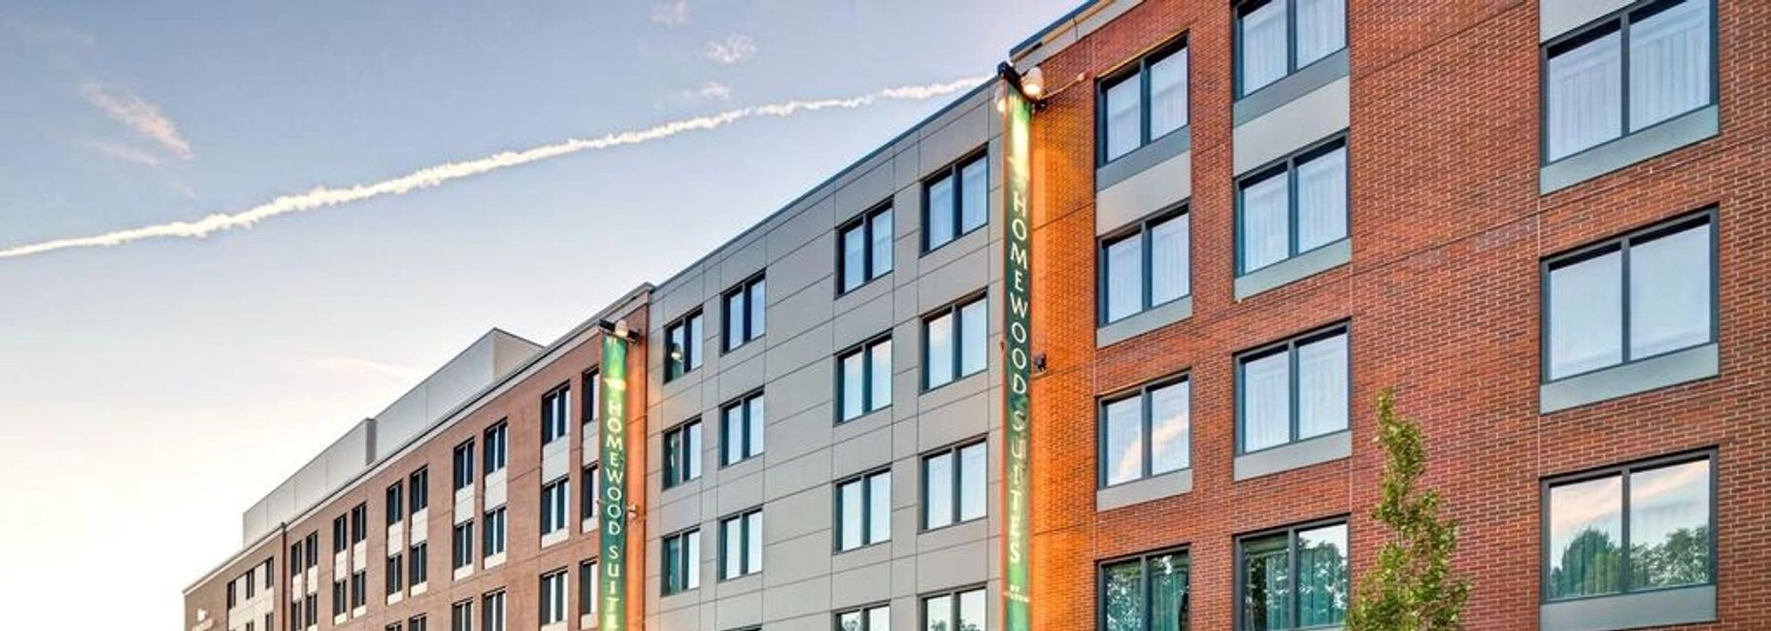

Hilton Homewood Suites Boston Brookline-Longwood Medical