**Design Name**

**Submitted in Response to the Real World Design Challenge**

Submitted by

**Team Name**

Team Member Names  
 (List team members, with age, grade, email addresses and phone numbers, and designate team leader – a table is fine to list information)

**School/Organization Name**

**Address**

Submission Date

Coach(s)/Advisor(s): Coach Name  
Coach Contact Info (Address, Phone, E-mail)

**Team/Coach Validating Signatures:**

Participating students/team members completed Formative Surveys:

[REMOVE: Only the above statement and coach’s signature are required to demonstrate surveys were completed (honor system)]

__________________________________________________

[REMOVE: An electronic signature of the coach is expected.]

[REMOVE: A visual representation of the final design is required on cover page]

[REMOVE: While the template is provided for convenience as a Word document, it is highly recommended that the report is submitted as a PDF to ensure proper formatting]

Table of Contents

Executive Summary 1

Specification Table 2

1. Team Engagement 3

1.1 Team Formation and Project Operation 3

1.2 Acquiring and Engaging Mentors 3

1.3 State the Project Goal 3

1.4 Tool Setup/Learning/Validation 3

1.5 Impact on STEM 3

2. System Design 3

2.1 Engineering Design Process 3

2.2 Project Plan 4

2.3 Subsystems 4

2.4 Lessons Learned 5

2.5 Component and Complete Flight Vehicle Weight and Balance 5

2.6 Final Design Drawings 5

3. Missions 6

3.1 Concept of Operations 6

3.2 Flight Profile Analysis 7

3.3. Safety Requirements 7

4. Business Case 8

4.1 Cost Analysis 8

4.2 Logistics Details 9

5. Public Affairs/Communications Plan 9

5.1 Public Relations Strategy Template 9

5.2 Products to be Created 9

5.3 Distribution Plan 9

6. Conclusion 10

7. References 10

8. Writing/Format [Remove this section from Final Document] 10

8.1 References and Citations 11

8.2 Tone of Writing/Professional Appearance 11

8.3 Figures and Tables 12

List of Figures

**Figure 1. Three-view of final uncrewed system design.** 5

**Figure 2. Description phrase to be used as title and description. [If not original] Reprinted [or adapted] from Title (page number), by Author first initial. Second initial. Surname, year, place of publication: Publisher. Copyright [Year] by the Name.** 13

List of Tables

**No table of figures entries found.**

# Executive Summary

[One-page Executive Summary includes brief narrative describing the design solution. Judges will be looking for a high level (less technical in style for this section) overview of how you solved the problem. This summary should be written so you give a short comprehensive description of your solution. A person reading this one-page summary will understand your solution without needing specific technical expertise nor knowing the specifics of the problem being solved. An executive summary should not contain any citations. (In the event of two teams having close scores at any level of the competition, this section will be used as a "tiebreaker." A special judges committee will use this summary to resolve any judging disputes between teams with close scores, especially at the National competition.)]

# Specification Table

|  |  |  |  |
| --- | --- | --- | --- |
| Criteria | Value | Met (yes/no) | Section #, page # |
| Aircraft | | | |
| Maximum takeoff weight |  |  |  |
| Empty weight |  |  |  |
| Wingspan (fixed-wing) or max width (other) |  |  |  |
| Number of missions to delivery all supplies |  |  |  |
| Operating range (at least 30 km: 15 km between Supply Depot and Drop-off Location) |  |  |  |
| Communication range (at least 15 km) |  |  |  |
| Performance | | | |
| From Supply Depot, aircraft takes off (and lands) vertically within 6 m X 6 m location or from 200 m x 6 m rough runway |  |  |  |
| Aircraft reaches altitude of at least 60 m within 100 m of liftoff from Supply Depot |  |  |  |
| Airspeed for flight between Supply Depot and Drop-off Location |  |  |  |
| Aircraft vertically descends and ascends at least 50 m for hovering to lower supplies at Drop-off Location |  |  |  |
| Time to complete a single supply mission |  |  |  |
| UAS Command, Control, and Communication | | | |
| Provide real time and accurate location information |  |  |  |
| Detect and Avoid (DAA) | | | |
| Aircraft must detect static and dynamic obstacles |  |  |  |
| Aircraft must avoid conflicts |  |  |  |
| DAA system architecture must fit with C3 capabilities |  |  |  |
| Lost Link Protocol | | | |
| Aircraft must have protocols in case of partial loss of communications |  |  |  |
| Aircraft must have protocols in case of total loss of communications |  |  |  |

## Team Engagement

### 1.1 Team Formation and Project Operation

[Explain the degree to which teams develop a strategy to win that includes establishing leadership in project management, science, engineering, mathematics, marketing and communications, etc. What skill set does each member bring to the team?]

### 1.2 Acquiring and Engaging Mentors

[Describe the degree to which your team worked aggressively to identify and leverage mentors early and throughout the challenge process.]

### 1.3 State the Project Goal

[Demonstrate understanding of the parts of the Challenge Statement and how they relate to the project goal. Has the team listed and demonstrated an understanding of each system element and the relationship to the design solution?]

### 1.4 Tool Setup/Learning/Validation

[Degree to which the team described how they overcame challenges and came up with workable solutions for technical issues: installing and operating tools (CAD), learning to use the tools, and validating that the tools are working as needed.]

### 1.5 Impact on STEM

[Discuss how participating in this challenge has influenced your perspectives on STEM and on your potential career paths. Also, discuss the impact the Challenge has had on STEM interest in your school.]

## System Design

### 2.1 Engineering Design Process

[Discuss the engineering design processes you used. Include conceptual, preliminary, and detailed design phases. This section discusses the processes while the details are provided in 2.3.]

### 2.2 Project Plan

[Discuss the process of how your team developed a timeline to accomplish the challenge showing milestones to come up with your final solution. You must show a Gantt chart or similar type of project management chart detailing project timeline with tasks and milestones.]

### 2.3 Subsystems

[Discuss, in the subsequent sections, how the design process was used for each of the following subsystems (conceptual, preliminary, and detailed design phases). Discussion must include how requirements were used to generate ideas, how designs were narrowed down, and how final design fulfills requirements. These subsystems are interrelated, so include how the design of the subsystems affected each other. (Provide introduction here if desired but not required – no points given.)]

#### 2.3.1 Air Vehicle

[Discuss design process and final design of the air vehicle (airframe configuration, power plant [propulsion], flight controls). In addition to discussion requirements provided in 2.3, include:

-Design process must include sketches of ideas during all design phases (missing sketches will result in loss of one fourth of points for this section).

-Final design must include description of components including number required.

-Clear description on how C3, payload, and ground/support affected design.]

#### 2.3.2 Command, Control, and Communications (C3)

[Discuss design process and final design of C3. Discussion of the ground control station must be included in this section. In addition to discussion requirements provided in 2.3, include

-Effect of human resources (e.g., operators, monitors, pilots) on design.

-Final design must include description of components including number required. Include final selection of human resources as well including number and cost.

-Discussion of ground control station must include sketch(es). Equipment must be portable.

-Description of equipment/sensors required for detect and avoid must be included in this section. Application of DAA provided in 3.3.1.

-Description of equipment required for providing real time and accurate location. Application of equipment provided in 3.3.3.]

#### 2.3.3 Payload

[Discuss design process and final design of the payload system (supplies that are transported). In addition to discussion requirements provided in 2.3, include

-Effect of the different supplies (water, gasoline, specific hard plastic cases) on storage within the air vehicle.

-Discussion of delivery method, i.e., lowering of supplies. Must include sketch(es).

-Include effect of the human element on the design of the delivery method (i.e., how will a person load/remove supplies).

-Final design must include description of components including number required.]

#### 2.3.4 Ground/Support Equipment

[Discuss design process and final design of the ground/support equipment. In addition to discussion requirements provided in 2.3, include

-Effect of human resource (e.g., ground crew) on design

-Final design must include description of components including cost and number required. Include final selection of human resource as well including number and cost.]

### 2.4 Lessons Learned

[Discuss key lessons that were learned during design.]

### 2.5 Component and Complete Flight Vehicle Weight and Balance

[Provide results of the weight and center of gravity analyses. Location of the center of gravity must be provided numerically (from a datum point) and graphically. The graphical location of the center of gravity may be shown on the 3-view of the design (Section 2.6), but if on the 3-view, it must be referenced and discussed in this section.]

### 2.6 Final Design Drawings

[Include drawings of the final design (with dimensions) in this section. At a minimum

-3-view of the aircraft.]

[Example] The following, Figure 1, depicts the three-view of the final unmanned system design.

[ADD FIGURE-CENTERED]

**Figure 1. Three-view of final uncrewed system design.**

## Missions

### 3.1 Concept of Operations

[Describe how the system will be operated during the different mission phases. Keep in mind the expectations for all stakeholders. (Provide introduction here if desired but not required – no points given)]

#### 3.1.1 Pre-Mission

[Detail the pre-mission.

-As part of this section, include an overview of the initial setup of all equipment at the supply depot. Note: This initial setup is not included in the 6-hour time limitation for supply delivery, but faster and easier initial setups may be beneficial.

-As part of this section, include an overview of all flights in a day for the aircraft: a) any required setup of equipment at ground control station prior to first flight (time for this setup is included as part of 6-hour time limitation), b) number of flights needed, and c) supplies delivered in each flight.

-Include steps to prepare aircraft for a mission (location of a staging area, loading supplies, checking correct fuel/charge, programming flight path, completing final safety check of aircraft and environment, movement of aircraft from staging area to takeoff area - vertical zone or runway, etc.). Who performs the different tasks?]

#### 3.1.2 Flight to Drop-off Location

[Detail how your system completes the flight to the delivery location.

-What communication is required prior takeoff and begin flight? What other communication is required between aircraft and operators, between different aircraft, etc. during flight to the drop-off location?

-Describe typical flight path to at least 60 m altitude within 100 m of liftoff.

-Describe airspeed and altitude ranges for flight to drop-off location.

-Analysis of performance is discussed in section 3.2.]

#### 3.1.3 Supply Delivery

[Detail the supply delivery method used by the aircraft.

-Describe typical flight path to delivery.

-Describe supply delivery (aircraft cannot land).

-Describe typical flight path after delivery.

-Analysis of performance is discussed in section 3.2.]

#### 3.1.4 Flight to Supply Depot

[Detail how your system completes the flight back to the supply depot.

-What communication is required? What other communication is required between aircraft and operators, between different aircraft, etc. during flight to the drop-off location?

-Describe airspeed and altitude ranges for flight to supply depot.

-Describe typical flight path to landing.

-Analysis of performance is discussed in section 3.2.]

#### 3.1.5 Post-Mission

[Detail the post-mission.

-Describe steps to prepare aircraft for another mission. How is aircraft prepared? Who performs the tasks? Time for these steps is included as part of the 6-hour time limitation.

-Describe steps after final mission of the day for the aircraft. Include any breakdown of ground control equipment for the end of the day. Time for these steps is included as part of the 6-hour time limitation.

-As part of this section, include an overview of the final breakdown of all equipment at the supply depot when the wildfire mission is complete. Note: This final breakdown is not included in the 6-hour time limitation for supply delivery, but faster and easier final breakdowns may be beneficial.]

### 3.2 Flight Profile Analysis

[Demonstrate through analysis that your system can successfully meet the design criteria provided in the Challenge Statement. Part of this discussion will be proof that the aircraft carries enough energy (e.g., battery or fuel) to complete the full mission. Another aspect will be the communication range.]

### 3.3. Safety Requirements

[Describe how the system fulfills the safety requirements and ensures public safety. (Provide introduction here if desired but not required – no points given)]

#### 3.3.1 Detect and Avoid

[Discuss design and implementation of the DAA. Include

-Reasoning behind location of decision-making process: onboard or at ground control station

-Clear discussion of how DAA fits with C3 capabilities from 2.3.2

-Clear discussion that DAA allows aircraft to sense, detect a conflict, and avoid any cooperative or non-cooperative obstacles. Must provide distances/times for detection ranges and decisions and reasons/justification for those selections. Must include communication required with DAA such as communication between aircraft and operators.

-Description of needed capabilities/technology if all tasks cannot be accomplished with current technology.]

#### 3.3.2 Lost Link Protocol

[Describe the protocols/procedures when the aircraft experiences a partial loss of communication and a total loss of communication. In both cases, clearly describe what steps the aircraft and operator will perform.]

#### 3.3.3 Integration with Manned Aircraft and Other Aircraft

[Describe requirements to integrate UAS successfully and safely into flight with manned and other aircraft. Note that aircraft will be flying in a high-stress situation during an active fire.]

#### 3.3.4 Additional Safety

[Explain any additional safety features or procedures for your design. These additional safety features are to account for possible emergency scenarios or for any other considerations your team decides is necessary. These safety features are in addition to those already discussed earlier in this report. Remember that since no pilot is onboard, methods must be used to replace all roles performed by a pilot.]

## Business Case

### 4.1 Cost Analysis

[Teams will be assessing the costs related to the design. Teams should understand how much the fixed and variable costs are for the groups who are using the design to fight fires. (Provide introduction here if desired but not required – no points given)]

#### 4.1.1 Operating Costs

[Explain what the total operating cost (variable costs) would be for your system including the cost of personnel and fuel. Make sure to describe the following. (a) Give a breakdown of how much fuel or energy (battery) is used for each flight. (b) Give a breakdown of how your personnel costs. How many people used and what job types they will be performing. (The pay rates and types of positions are listed in the detailed background personnel section). (Hint: Remember variable costs are only things consumed on the mission such as fuel/energy or paying for the time of an employee.)]

#### 4.1.2 Fixed Costs

[Describe what your total fixed costs (cost of equipment and the vehicles) are for your system. Give both a total fixed cost and a description of how much you are spending on all components including the Air Vehicle, payload, and C3 equipment. Explain and justify the cost of your system giving examples of why the components are necessary to complete the missions.]

### 4.2 Logistics Details

[List the personnel you need to prep and fly your UAS. Describe what roles are used for and describe what tasks they perform needed to prep and fly the aircraft. If anyone performs multiple roles explain how they will have enough time between tasks for each role.]

## Public Affairs/Communications Plan

[Provide a brief conclusion to your Engineering Design Notebook. Summarize the important aspects of your design. Why is your design the best design for this challenge (make sure to base your argument on the analysis and justification you provided in your Engineering Design Notebook)? Be sure to justify all the design choices that you made.]

### 5.1 Public Relations Strategy Template

[An internal document that is not shared with the public; the products you create based on the strategy document are the items shared with the public. Think of a public relations strategy as a planning document; oftentimes it may change if a situation, dates, or other parts of the project change. (Provide introduction here if desired but not required – no points given)]

#### 5.1.1 Background and Purpose

[Provide background for the strategy (such as a short summary of the design challenge and why it matters), along with a brief summary of your public relations strategy. Briefly explain why a public relations strategy is important in this situation. What challenges, beyond the technical challenges themselves, can make it difficult to get support?]

#### 5.1.2 Audience and Messaging

[Include primary and secondary audiences, if applicable. Include an outcome for each audience: why are you connecting with them? What do you want to happen because of their involvement? What are the main points you are trying to make (these can be bullet points)? Explain how the topic is important to your local audience. (Use tools such as FIRMS, available under resources on RWDC website, to help explain how your system is important.)]

### 5.2 Products to be Created

[Show samples of media products that need to be created for distribution (examples of these are listed in the detailed background document).]

### 5.3 Distribution Plan

[How will media products and messaging go out to the audiences specified (e.g., will social media be used)? What is the method for the media products to be distributed? What is the action plan for distribution of materials? Who is responsible for distribution and when will items be distributed?]

## Conclusion

[Provide a brief conclusion to your Engineering Design Notebook. Summarize the important aspects of your design. Why is your design the best design for this challenge (make sure to base your argument on the analysis and justification you provided in your Engineering Design Notebook)? Be sure to justify all the design choices that you made.]

## References

This is where the details of any reference citations are maintained. Do not include a reference citation in the References section if it has not been directly cited in the body of this document. These references should be ordered alphabetically. If any of the references have the same author and year, place in order by the first word in the title and add an alphabetical identifier to the year (e.g., 2012a) and ensure this year and identifier is used in any in-text citations.

See the following for APA formatting of required references: <https://owl.purdue.edu/>

## Writing/Format [Remove this section from Final Document]

Neat, orderly and readable, font size no smaller than 11 pt Arial throughout (except Specification Sheet) with 1.5 line spacing, except in Executive Summary, Captions, and References (single spaced allowed). Letter size paper (8.5 in. by 11 in.) with 1-in. margins; pages numbered. The Engineering Design Notebook must follow the paragraph order of the Scoring Rubric including paragraph numbering.

The Engineering Design Notebook submission is limited to 80 pages maximum including cover page and appendices. Sections past the 80-page limit will receive a score of 0. Additional points may be deducted in individual sections if content is not in correct location or hard to understand. For each individual section, up to 20% of the maximum points available for that section may be deducted for grammar.

### 8.1 References and Citations

Reference citations are to be used, where appropriate, to support work. Use the following research and reference guidelines in the development of your submission:

You should have references identifying the merit of your proposed research and supporting any assertions you make. As part of this process, you need to perform a basic literature review and identify supporting material as part of your proposal. Add references and citations to support why your research is worth pursuing. What is the value of performing it? What will it identify that other research has not? Provide some detail regarding any problems or issues that can be used as rationale to support why this is valuable.

Add a supporting citation to every sentence that is not entirely your own observation. It is good practice to use supporting citations as it lends credibility to what you are stating. Add citations throughout document when you state something that is not your own original thought. If you do not cite a source and it is not your original thought, it is PLAGIARISM.

1. When you have more than one sentence in your quote use a block quote format.
   1. See References->Direct Quotation on the Purdue online writers lab (OWL) website for further detail: <https://owl.purdue.edu/>
   2. See the following block quotation:

Every sentence that contains information that is not ENTIRELY your own words or thoughts needs to contain the citation for the source from which it came. Even if this means citing almost every sentence of a paragraph, it must be done. You can, however, build citations into your sentence throughout the paragraph to avoid an excess of parenthetical documentation at the end of each sentence (APA Frequently Asked Questions…, p.2).

1. All direct quotes need a page, section, or paragraph number reference (e.g., Terwilliger, 2012, p. 4).

### 8.2 Tone of Writing/Professional Appearance

Avoid an informal or narrative tone. Instead, focus on use of formal tone in academic writing as described in the following material:

<http://writingcenter.waldenu.edu/1082.htm>

Use the following grammatical and writing guidelines in the development of your submission:

Always spell check

First time use should define an acronym. For example, “The use of **uncrewed aircraft systems (UAS)** has served to reduce risk to humans by removing the crew from a hazardous operating environment (U.S. GAO, 2008).” Subsequent uses through the remainder of the document should be, “UAS.”

* Paragraphs should be at least three sentences long

Spell out numbers under 10

* Use numerals for numbers over nine

When referring to a variable, such as population (*N*), it should be in italics

Refrain from using contractions (e.g., don’t, can’t, didn’t, etc.)

Avoid colloquial, superlative, or slang expressions in scientific/academic writing (e.g., on the other hand)

Refrain from self-referencing (e.g., I, myself, me) in scientific/research writing. If you must refer to yourself, do it in the third person. For example, the researcher will…

### 8.3 Figures and Tables

Figure and table reference should appear in the following format (always precede the caption and image/table with an in-text reference to explain or depict the connection to the text). For example, Figure 2 depicts an example for the purposes of explaining figure use, reference, and appearance.

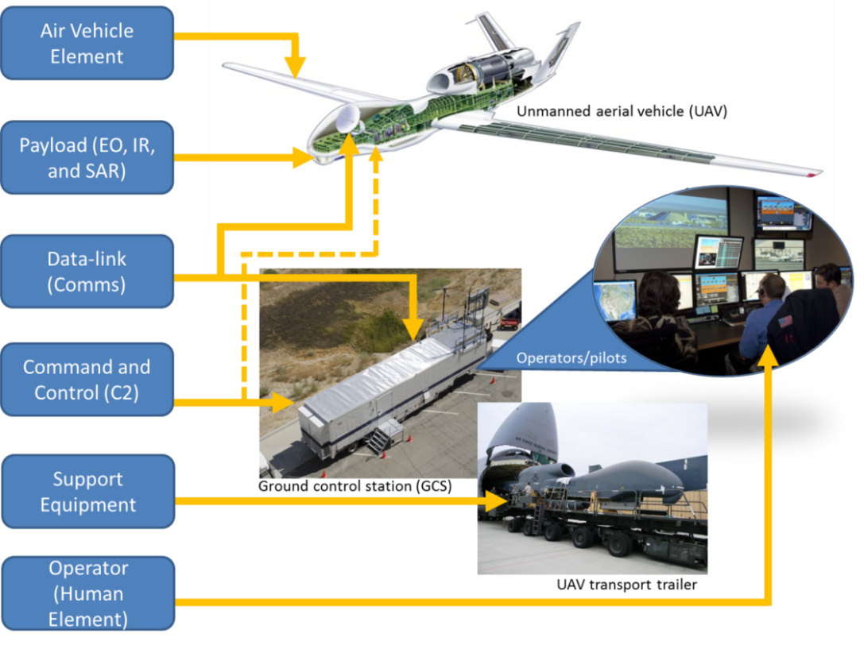

**Figure 2. Description phrase to be used as title and description. [If not original] Reprinted [or adapted] from Title (page number), by Author first initial. Second initial. Surname, year, place of publication: Publisher. Copyright [Year] by the Name.**