The Creed at Hel’s Gate
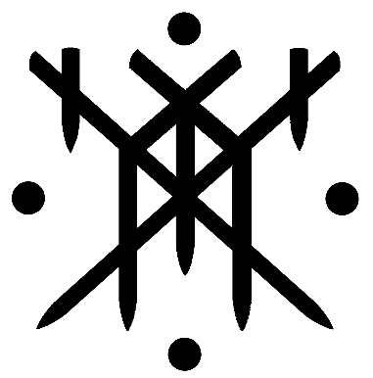

Preamble

We are Heljalingar (Offspring of Hel) a Heathen community located in the Missoula valley and surrounding areas.

Our members have differing ideals and differing paths, but the fates have brought us together in kinship. We work to be a part of the solution to the tribulations we face in and outside of the community.

We are peaceable tribalists who are AGAINST bigotry of any kind and will tolerate NO acts of hate within our community.

This document is intended to be adapted and revised based upon the needs of the Kindred.

1

Our primary goal is to acquire land (preferably in the country) on which to build a Heathen community center. We hope that by strengthening our own Kindred we may better serve the wider world around us.

2

We do not define ourselves as “Folkish” or “Universalist”. We believe in a modern tribal lifestyle in which the Kindred ultimately chooses who to accept as kin. However, we do not discriminate or exclude individuals based on racial, cultural, religious, spiritual, sexual, or gender specification. Character is what matters.

To become a member of our tribe, one must participate in our cultural practices with us. We welcome people of all faiths and spiritual paths or lack thereof. To be fully accepted as kin one must participate in our traditions. Certain exceptions will be made if one desires to be kin but cannot participate in all aspects of our practices due to religious or personal restrictions. For example, vegetarians will not be expected to eat meat.

We shun dogma and seek to build a culture and tradition of our own; a continuation of our ancestors' ways rather than a copy of them.

3

Kith are welcomed friends of the Kindred. Kin are members of the Kindred. To become kin one is expected to have demonstrated service and devotion to the Kindred. Members must be active for a full year before being considered for kinship. Approval for new kin must be unanimous among the current kin.

Respect is given when earned and earned when given.

4

There will be no linear hierarchy and no caste system. We are egalitarian and have no place for political or spiritual leaders.

The details of how our council roles are organized are found in the Political Charter.

It is essential to note that we believe personal freedom of our kith and kin to be paramount, so long as it does not infringe on the safety or personal freedoms of other kith or kin.

Our hierarchy exists in order to facilitate organization and efficiency. Those members of the Kindred who hold titles do so as a duty to the tribe, not as a means of control. We honor the dedicated folk who are elected or chosen for these various roles, but only as long as that honor is deserved.

5

Frith means peace and fellowship. Frith must not be broken.

See the General Code of Conduct for more details.

Should any of our members break peace with one another, that is their business. Should a mediator be requested, the kindred will provide one. See the Mediation Process document for details on how disputes are examined and settled.

Should any broken peace infringe upon the frith of the kindred, it becomes a matter for the kindred as a whole to deal with. We do not have written laws, and each dispute will be dealt with according to its nature.

Frith is sacred and comes before all else.

6

In essence we aim to honor the traditions of our various Indo-European connections by learning about their material culture, food, clothing, art, poetry, languages, myths, rituals, and practices. The focus is on exploring our ancestors and expressing our heritage in a dignified way. We aim to learn from the mistakes of the past and ensure the practical sustainability of Heathen European traditions into the modern age and ages to come.

