**Mental Health Support Group – A 2018 meeting schedule**

**For persons living with mental illness**

**Free twice a month meetings from 6pm-8pm in Apple Valley**

**Support Group Purpose and Goals-**

For those living with mental health challenges – you are not alone!

This group promotes social connection and support. This is not therapy or for crisis intervention.

This group promotes compassion, mindfulness and self-care and communication.

This group is led by a trained facilitator who themselves live with mental illness.

**Please share with persons needing a free support group!**

Did you know that one in four persons suffers a form of mental illness?

Did you know that services for mental health care are growing in the High Desert but more are needed?

**Support Group Location: Ascension Lutheran Church – open to all residents of Victor Valley!**

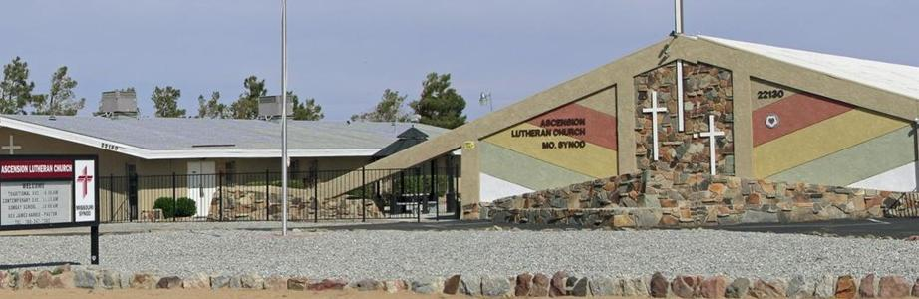

**Ascension Lutheran Church is located in the village of Apple Valley at 22130 Ottawa Road. Meetings are 6pm-8pm on the dates listed below. Meetings are FREE and CONFIDENTIAL with local resources provided.**

**2018 MEETINGS ARE THURSDAY EVENINGS AS NOTED BELOW:**

**JANUARY 11TH AND 25TH 6-8PM JULY 12TH AND 26TH 6-8PM**

**FEBRUARY 8TH AND 22TH 6-8PM AUGUST 9TH AND 23TH 6-8pm**

**MARCH 8TH AND 22RD 6-8PM SEPTEMBER 13TH AND 27TH 6-8pm**

**APRIL 12TH AND 26TH 6-8PM OCTOBER 11TH AND 25TH 6-8pm**

**MAY 10TH AND 24TH 6-8PM NOVEMBER 8TH AND 29TH 6-8pm**

**JUNE 14TH AND 28ND 6-8PM DECEMBER 13TH AND 27TH 6-8pm**