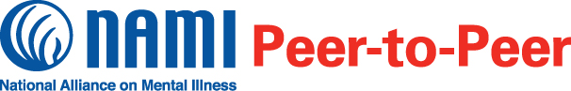

**What is the NAMI Peer-to-Peer Education Program?**

NAMI Peer-to-Peer is a 10-session recovery-focused course for adults (aged 18 and over) with mental health conditions. The NAMI Peer-to-Peer education program is:

* Free and confidential
* Held TWICE a week for two hours each session
* Led by trained peer mentors with mental health conditions
* A great resource for information on mental health and recovery
* Offers respect, understanding, encouragement and hope
* Builds on the strength and resilience of participants



NAMI Inland Valley, the local organization of the National Alliance on Mental Illness, will offer NAMI Peer-to-Peer from 1/8/19 until 2/7/19. The class will be held on Tuesday and Thursday from 1-3 PM at VCSS Victorville Campus 15400 Cholame Rd, Victorville, CA 92392.

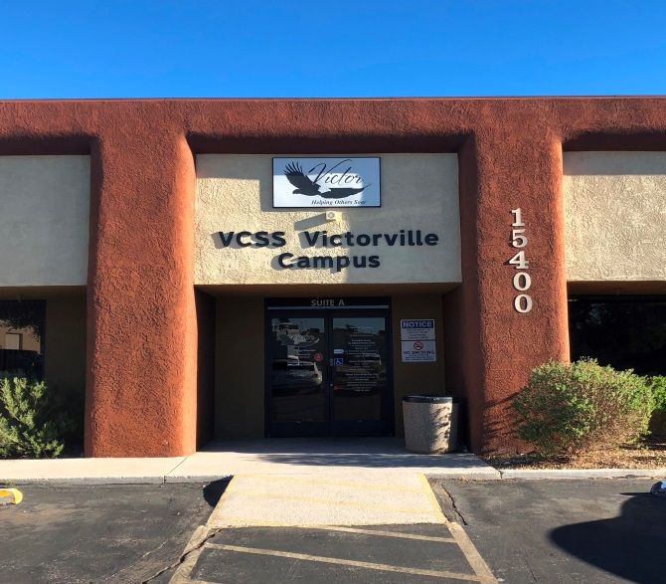

**Participant Perspectives**

“NAMI Peer-to-Peer is uplifting, life-saving and an eye-opening experience that changed how I see myself.”

“The biggest thing I gained from this class was to become my own advocate and best friend.”

“Seeing my peers’ strength and dedication to their recovery was personally meaningful.”

**Register for NAMI Peer-to-Peer today!**

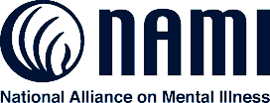

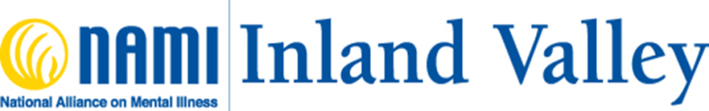

**Registration is REQUIRED.**

**Classes fill up quickly so register TODAY!**

**Call 760-217-4109**

**About NAMI**

NAMI, the National Alliance on Mental Illness, is the nation’s largest grassroots mental health organization dedicated to building better lives for the millions of Americans affected by mental illness. NAMI {Affiliate Name} is an affiliate of NAMI {State}. NAMI {Affiliate Name} and dedicated volunteer members and leaders work tirelessly to raise awareness and provide essential education, advocacy and support group programs for people in our community living with mental illness and their loved ones.