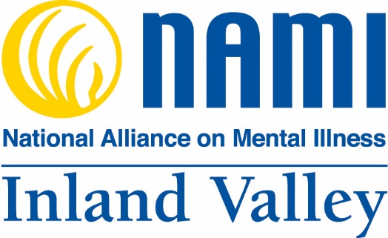 2018 – 2020 Strategic Plan
The National Alliance on Mental Illness (NAMI) is the nation’s largest grassroots organization providing advocacy, education, support and public awareness so that all individuals and families affected by mental illness can build better lives.
NAMI Inland Valley, an affiliate, undertook strategic planning to achieve our goals and focus our energies to build support and public awareness through advocacy and education. This planning process allows us to identify the most important objectives to focus our energies in the upcoming three years.
Our key strategic goals reflect our commitment to moving forward and to building capacity within the High Desert communities. This requires reaching more diverse individuals and populations and bringing them into the NAMI community.
We are united by our lived experience with mental illness. Strengthened by our collective voices, we commit ourselves to realizing a world where all persons affected by mental illness experience resiliency, recovery, and wellness.
Overview:
In our 2018 – 2020 Strategic Plan, we selected strategic goals where we will invest our resources. We believe these goals offer strong potential for impact by advancing our mission and achieving our vision.
- Attract and Retain Members
- Build Relationships with Like-minded Community Partners
- Expand Public Awareness to Build Capacity
- Build A Robust Advocacy Program in the High Desert

Our Mission:
To provide advocacy, emotional support, understanding, and public awareness so that all individuals and families affected by a mental illness can build better lives.

Our Vision:
NAMI Inland Valley envisions the High Desert as a place where all persons affected by mental illness experience resiliency, recovery, and wellness.

Summary of the Process:
NAMI Inland Valley is an affiliate of NAMI National – started in 1979 by a small group of East coast families. Similarly, a small group started the High Desert’s first mental health support group to help area families who have loved ones living with a mental illness. The group’s experiences with the High Desert’s Mental Health systems led them to recognize the need to bring a NAMI Affiliate to the area. They worked with past leadership of an inactive affiliate in the Rancho Cucamonga/Upland areas to revitalize NAMI Inland Valley (Inland Valley). The two groups merged in October 2017 and incorporated December 26, 2017. Inland Valley was successful in completing the re-affiliation process with NAMI California in September 2018.
Our strategic plan focuses strongly on two NAMI cornerstones; advocacy and education. Those efforts are combined with special attention to building a robust infrastructure to ensure visibility and longevity. With the High Desert areas needs in mind, our strategic plan includes initiatives for outreach, support and education to build our capacity, connection and growth so that we can help all individuals and families in the High Desert affected by mental illness build better lives. Inland Valley’s presence in the High Desert is key now that the High Desert communities are experiencing explosive population growth that includes demographic shifts, a growing number of low to moderate-income families and, with the prevalence of mental illness, unequipped mental health systems. Data collected in a 2017 health assessment (published by St. Mary Medical Center) reports that 9% of adults (18 years and older) are in serious psychological distress within the High Desert cities of Adelanto (population 32,000) and Victorville (population 120,000) and are more at risk. In the United Way’s 2017 comparison of eight significant health and social needs within 31 San Bernardino County cities and towns, it reported that calls for mental health services made up nearly 3% per 10 residents (n=64,529) in Victorville and Lucerne Valley, and nearly 2% in Apple Valley. In Adelanto with a significant Spanish speaking population, the percentage is lower due largely to the lack of resources in Spanish.
Feedback from local mental health advocates and church leaders include the need for training and support groups to promote education and recovery. There is also a need for mental health providers to: work together, collaborate across agencies and disciplines, and to support stigma reduction and mental health education. Key initiatives are included in our plan to address building relationships, collaboration and advocacy with our like-minded community partners.
Inland Valley’s members shared personal experiences comfort and unite us and we sought initiatives that intersect our passions, strengths and resources to maximize their impact and advance our mission.
Selecting Strategic Goals and Key Initiatives:
We have listed our Strategic Goals with Key Initiatives in a sequence that reflects the amount of new focus we must bring to their implementation. Ideally, each enhances and advances the others.
1) Attract and Retain Members  - Develop Membership Programs  - Provide F2F Facilitator and Teacher Trainings  - Add Additional Meeting Locations, Times, and Speakers  - Solicit Meeting Speakers |  | 2) Build Relationships with Like-minded Community Partners  - Invite Like-minded Partners to Speak at and Attend Meetings  - Prepare an Introduction Letter  - Prepare a Giving Letter  - Develop Community Fundraising Opportunities
3) Expand Public Awareness to Build Capacity  - Leverage Website Exposure  - Increase Advertising Efforts  - Participate in Local Health Fairs  - Develop Sponsorships  - Develop Planned Giving Programs |  | 4) Build a Robust Advocacy Program in the High Desert  - Offer Additional F2F and P2P Support Groups and Educational Trainings  - Attain Representation on the Behavioral Health Commission  - Engage Mental Health Care Providers and Social Services with Shared Missions to Advocate for Better Mental Health Care
Strategic Framework

OUR IMPACT | VISION
NAMI Inland Valley envisions the High Desert as a place where all persons affected by mental illness experience resiliency, recovery, and wellness.

OUR BUSINESS | MISSION
NAMI Inland Valley provides advocacy, emotional support, understanding, and public awareness so that all individuals and families affected by a mental illness can build better lives.

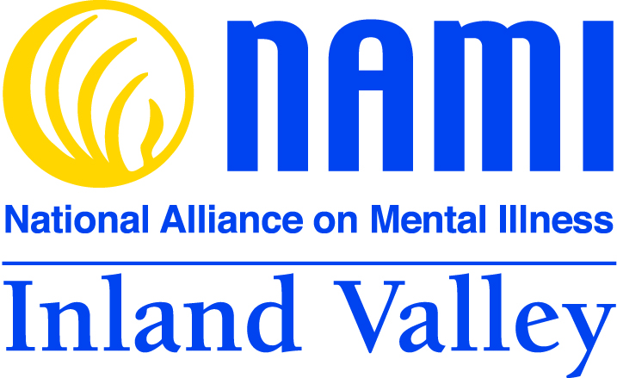
Goal
Goal
Goal

Goal
Expand Public Awareness to Build Capacity
Build A Robust Advocacy Program in the High Desert
Build Relationships and Collaboration with Like-minded Community Partners
Attract and Retain Members

- Develop Membership Programs, i.e. trainings and meetings
- Provide Teacher Trainings
- Establish Additional Meeting Locations
- Offer Evening General Meetings
- Solicit Meeting Speakers

- Invite Community Partners to Speak at Meetings
- Invite to General Meetings Like-minded:
  - Therapists
  - County Mental Health Professionals
  - Law Enforcement
  - Social Service Nonprofits
- Prepare a Letter of Introduction to Providers and Sponsors
- Prepare a Giving Letter
- Develop Community Fundraising Opportunities

- Update Website Regularly
- Increase Advertising Efforts
- Participate in Local Health Fairs
- Build Sponsorships
- Develop Planned Giving Programs

- Offer additional F2F and P2P Support Groups and General Meeting Locations
- Attain Representation on the Behavioral Health Commission
- Engage Mental Health Care Providers and Social Services with Shared Missions to Advocate for Better Mental Health Care

Balanced Scorecard Strategy Map

 | Categories
 | Financial | Internal | Learning and Growth | Community
Objectives | - Increase Revenues through:  - Increased Membership  - Donations  - Fundraisers  - Grants | - Increase Membership  - Develop Sponsorships Building Programs  - Develop Fundraising Opportunities | - Provide Community Educational Programs  - Increase Public Awareness  - Increase Meeting Attendance | - Increase Membership  - Increase Sponsorship  - Develop Relationships with and Engage Community Partners with Shared Missions to Advocate for Better Mental Health Care
Initiatives | - Grow Membership  - Establish a Planned Giving Program  - Develop Sponsorships  - Develop Fundraising Opportunities  - Seize Grant Funding Opportunities | - Provide F2F Facilitator and Teacher Trainings  - Establish More Meeting Locations  - Create Sponsorship Development Committee | - Develop Membership Incentives  - Provide F2F Education Programs  - Provide Peer Connections Training  - Prepare and Distribute Letters of Introduction to Providers and Sponsors  - Prepare Giving Letter | - Provide Additional F2F and P2P Support Groups and Trainings  - Offer Evening General Meetings  - Build Outreach to Like-minded Community Partners  - Leverage Website Exposure
Measures | - Increase Membership by 40% in 2019, and 50% in 2020  - Participate in NAMIWalks  - Devise Local Fundraisers for each year 2018-2020  - Increase Revenues Through Planned Giving  - Create a Grant Matrix | - During 2019, Continue Monthly Advertising Efforts:  - Local Newspapers  - Local Radio stations  - Newsletters  - Flyers  - Invite Speakers to Monthly Meetings | - Offer 2 F2F Facilitator Training Class and 1 P2P Mentoring Training in 2019  - Offer Peer Connections Training in 2019  - Track Website Exposure  - Number of Introduction and Giving Letters Distributed  - Speaker Coverage | - Increase community outreach in 2019  - Add 1 Meeting Location in 2018 and 2 in 2019  - Add 1 P2P Support Group in 2019

