NAMI Inland Valley Family Support Group – 2019 Meeting Schedule
For Family Members of Someone Living with Mental Illness
Support Group’s Purpose:
Provide peer directed emotional support, education and resources to help family members with loved ones living with mental illness – you are not alone!
Provide no-cost nationally recognized training.
Support mental health providers with free services promoting resilience and recovery.
Did you know that services for mental health care are growing in the High Desert but more are needed?
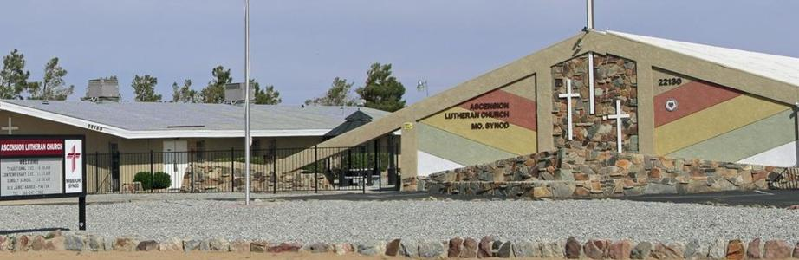
Ascension Lutheran Church is located at 22130 Ottawa Road in Apple Valley. Meetings are held on the 2nd and 4th Thursday of the month from 6 PM – 8 PM on the dates listed below. Meetings are FREE and CONFIDENTIAL with local resources provided.
2019 MEETINGS SCHEDULE
JANUARY 10th AND 24th JULY 11th AND 25th
FEBRUARY 14th AND 28th AUGUST 8th AND 22nd
MARCH 14th AND 28th SEPTEMBER 12th AND 26th
APRIL 11TH AND 25th OCTOBER 10th AND 24th
MAY 9th AND 23rd NOVEMBER 7th AND 28th
JUNE 13th AND 27th DECEMBER 12th AND 26th

Sponsors:

Mental Health Peer Support Group – 2019 Meeting Schedule
For Persons Living with Mental Illness
Free twice a month meeting from 6pm-8pm in Apple Valley

For those living with mental health challenges – you are not alone!
This group promotes social connection and support. This is not therapy or for crisis intervention.
This group promotes compassion, mindfulness and self-care and communication.
This group is led by a facilitator who themselves live with mental illness.
Did you know that services for mental health care are growing in the High Desert and more are needed?
Ascension Lutheran Church is located at 22130 Ottawa Road in Apple Valley. Meetings are held on the 2nd and 4th Thursday of the month from 6 PM – 8 PM on the dates listed below. Meetings are FREE and CONFIDENTIAL with local resources provided.
2019 MEETINGS SCHEDULE
JANUARY 10th AND 24th JULY 11th AND 25th
FEBRUARY 14th AND 28th AUGUST 8th AND 22nd
MARCH 14th AND 28th SEPTEMBER 12th AND 26th

APRIL 11TH AND 25th OCTOBER 10th AND 24th
MAY 9th AND 23rd NOVEMBER 7th AND 28th
JUNE 13th AND 27th DECEMBER 12th AND 26th

Sponsors:

