Buccanwood Miniature and Pygmy Goats

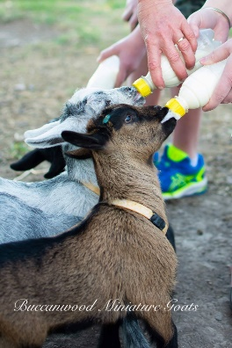 Welcoming your new family member home

Here are a few helpful details and useful information to get you started with your new friend/s

FEEDING ROUTINE
0 month - 1 month = 3 feeds a day (morning, lunch time, evening)
1 month - 2 months = 2 feeds a day (morning and evening)
2 months - 3 months = 1 feed a day (same time daily)

Fresh water should be available in a bowl

Your baby should receive a 300- 350ml bottle at every feed. Please do not be tempted to feed your baby more than it needs. This could make your baby suffer with scours or bloat. Do not feed water in bottles. We use full cream milk replacer from Coles or Woolworths for the kids there is no need to spend money on expensive formulas.
Always check the temperature on your wrist so you are not feeding your baby milk that is too hot or too cold. It will feel a comfortable temperature on your wrist, lukewarm is ideal
FIRST HARD FEED
When the babies start nibbling on things then you should supply them with:
1 part steamed flaked barley with molasses, 3 parts chaff 1 cup should suffice to start.

Hay such as grassy Lucerne/barley hay is good, other roughage such as tree branches (strictly suitable for goats) should be a regular additive to their diet throughout their whole lives. Goats are not grazers and will prefer branches and low shrubs. Goats are known as browsers.
TREATS
Apples, carrots, sweet potato (not normal potato as it contains too much starch), banana chips, Weetabix, and watermelon. They will all prefer different foods try a few things out …. sultanas are a great snack to try for training

DO NOT FEED RUBARD ,AVOCADO AS THEY ARE TOXIC. OTHER PLANTS TO AVOID
:-OLEANDERS AND YESTERDAY,TODAY AND TOMORROW

We provide hay racks/feeders and clean fresh water, it is not the best to feed them directly off the ground as this encourages worm growth

HOOF TRIMMING
Hoof trimming should be done every 2-3 months, if you need assistance, I am happy to help. It’s best not to turn this into a bad experience as that might make it more difficult in the future.

VACCINATING
Goats should be vaccinated every 6 months after their initial kid vaccinations with either:
Glenvac 6-1, 3- 1 or Ultravc 5-1 will suit in areas not prone to Cheesy gland.

WORMING
The best way to ensure your pets are healthy before any treatment is by taking poo samples (these can be pooled / mixed) and having them checked for worms, this will reduce costly worm treatments when not required and avoid excess chemical use in your goat’s digestive system.
Most vets can do the checks for you at around $30 per sample or you can mail in a zip lock bag with your details to:
Reply Paid 84894
Wormcount
PO Box 7110
Mt Crosby QLD 4306
Website: http://wormcount.com.au/
email: John@wormcount.com.au
By mobile or SMS on 041 750 1958
you should contact before sending samples to John (Dr. John Gorham)

LICE
Just like your dog or cat having fleas, goats can get lice (these are not transmitted to us) and tends to be most affluent in the drier winter months, this can be brought in on bedding etc…….Lice are easy to treat but can become very annoying for your goat if not treated causing hair loss as poor condition, you can use a product such as pestene powder most other products need a vets Authorisation but you can ask at your local produce for recommendations as well

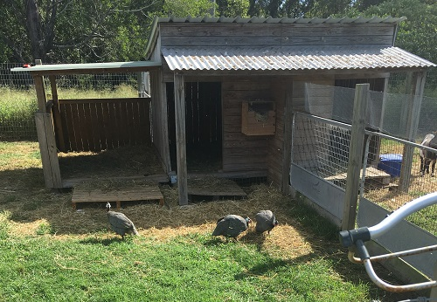
SHELTERS
Goats require shelter from the elements, they do not like the rain but can tolerate heat extremely well, this can be as simple as a lean to or elaborate as you want it to be.

EXERCISE
Goats are Highly intelligent and like to be stimulated, a great way to do this is by adding play equipment, it doesn’t have to be expensive something they can climb on and navigate, old tyres, fallen logs, large rocks/boulders whatever you can imagine
Our goats move freely throughout the day and are secured at night in a smaller area with suitable shelters.

GENERAL INFORMATION
  Goats should not be tethered for long periods of time

Goats require roughage and added minerals to stay in tip top shape. They are browsers and
do not ‘graze’ like sheep

Goats are herd animals and require a minimum two or more to be happy

Only bucks are smelly and do not make good pets

Horns come on all goats unless they are bred with a ‘poll’ gene which means they genetically
will not get horns, otherwise they are disbudded as kids

Both male and female goats can grow beards

Goats do not have top incisors; they have a hard palate designed to strip branches of there
leaves

They will not get out of every fence/ They do not always jump fences

*A Property identification Code is required for your property when keeping livestock, you can apply for this online at

https://www.business.qld.gov.au/industries/farms-fishing-forestry/agriculture/land-management/pic
or via your local DAFF office

REGISTRATION
There are currently 3 miniature goat societies within Australia. The AABMGS inc, the MGBA and the MGA. We are members of the AABMGS and of the MGBA. Have a look at their individual websites and you can decide for yourself which society will be suitable for you. Whichever goats you buy should come with a registration certificate from one of those groups, some can be dual registered. Generally, most people join the society that their goats are registered with however this is not always the case. The rules and registration requirements as well as breed types and breed standards will often be very specific to each association.

AABMGS: http://www.australianallbreedsofminiaturegoatsociety.com/about-the-aabmgs
MGBA: http://www.miniaturegoatbreedersassociation.com.au/
MGA: http://www.miniaturegoatsaustralia.com
Should you require any additional help please don’t hesitate to ask, we put a lot of work into our goats and babies and want the best upkeep for them, there is nothing better than our babies going off to their new special homes to be loved and grow into healthy family additions.

BUCCANWOOD MINIATURE GOATS
http://buccanwoodminiaturegoats.webs.com/about

A bottle, milk powder, some feed plus any after help will be provided to help you get started

Recommended Vet
Curtis Street Vets , Pimpama. Qld
07 5549 0624

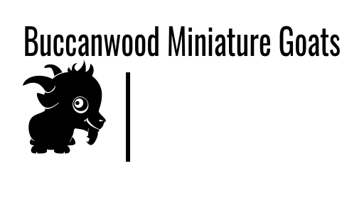

Pygmy or Miniature

Australian Miniatures (minis) originated here in Australia about 19 years ago and were bred by dedicated breeders by breeding small rangeland goats with other larger breeds to bring the heights down. Breeders then chose the best and smallest to breed from to get us where we are today, with Australia's very own miniature goat breed.
Pygmy goat genetics were brought into Australia approximately 6 years ago by importing semen from the United States and have been bred up by crossing them with Australian Miniatures and this is why you will often see a pygmy listed for sale with its percentage. EG: 40% Pygmy means it is also 60% something else but most of the time they are crossed with the minis. Generally, the higher percentage the pygmy is the more it costs to buy.
Minis and pygmies are both excellent breeds especially for pet owners but you will normally find that the pygmies cost more to buy as pets than the minis and this is because it costs pygmy breeders a lot of money to buy their breeding stock because they haven't been in Australia for very long. For instance, a high percentage pygmy buck or doe can cost anywhere around $6000 - $7000 each, so the parents of your little bouncing bundle of joy could have realistically cost the breeder something like $10000 +.

Both will make excellent pets

Buccanwood Miniature Goats
Terms and Conditions

Please read these carefully before committing

All reservations on all goats must be accompanied by a $50.00 (non-refundable) deposit per goat. Refunds will not be given in a change of decision. We do not refund money so please consider carefully before you commit to buy.

I recommend that you view/inspect you animal before you purchase.
Health declarations and vet checks can be arranged at the cost and responsibility of the purchaser if required

We guarantee the 100% health and wellbeing of the animal upon leaving the farm.

Refunds will not be given if a health issue occurs, unless a vet certificate is submitted
All animals are wormed, vaccinated and free of lice to the very best of our knowledge.

Cash payment or direct deposit is preferred. FULL payment must be made before the animal leaves the property.

If paying with direct deposit the FULL amount must be in our
account before the animal is eligible to leave the property.

Kids, Yearlings and all stock sold under 3 years old are sold as potential stock or miniature bred. A height guarantee for animals of ages 0-3 years will never be verified,

Before your purchase we can supply the full lineage or breeding,
your animal will always be provided any heath information you require i.e.: CAE results

Registration paperwork will be completed and sent to the applicable society after the animals are collected, this can take a few weeks for the paperwork to be received form them

Buccanwood Miniature Goats
General Price List

Miniatures
Pet weathers $300.00 - $400
Does $500.00 +
Bucks $600.00 +

Any bucks not considered to be show quality be wethered and sold as a pet

Pygmy does. from $1000.00
Pygmy bucks from $1000.00

These prices depend upon percentage of the animal

Adults goats for sale will be assessed by their temperament, height and priced accordingly, when available for sale.

Goats come with a clean bill of health and registration paperwork.
All animals over 12 months come Tested for CAE and JD,
All kids are from CAE/JD tested parents. Paperwork available on request

We are here to offer you help and support at all stages of your new purchase

