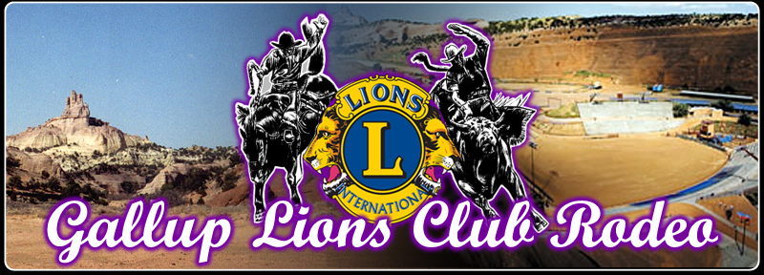
ANNUAL PARADE SATURDAY JUNE 11th, 2022 AT 1:00PM
Entry forms are available at the Chamber of Commerce:
@ 106 W Hwy 66, Gallup NM
Or at www.galluplions.com
Please return completed entry forms to the
Chamber of Commerce.
All entry forms MUST BE RECEIVED BY
Saturday June 11th 10:00am
For more information, contact Roxy at 505-879-9670

Name of Person (s) or Organization:

______________________________________________________________________________

Contact Name: ____________________________Phone#:______________________

Description: _______________________________________________________________
Float, Marching Band, Youth Group, Old Cars, Riding Group. Princesses, Dance Group, etc

THE PARADE WILL BEGIN PROMPTLY AT 1:00pm
Please be early to help things run smoothly.
Parade Route We will line up at Gurley Motor Body Shop,
Run East to 1st Street

GLC Verification & number _________________________

