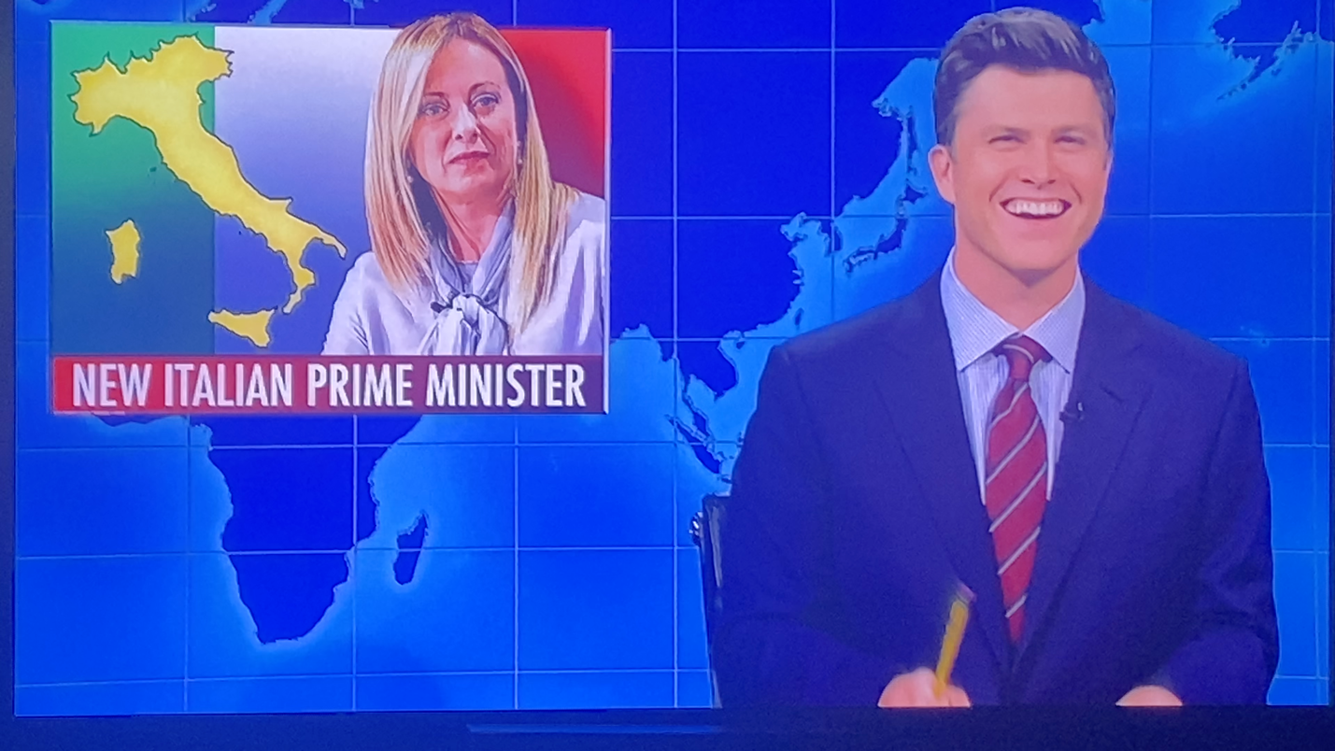
PLEASE LET THEM KNOW!!

So happy to see all your reaction to this never-ending attack on us.
This is not the first time that Saturday night has maligned us:
LET THEM KNOW

Also, please send comments to our

NYS Commissioner of Arbitration
Br John Fratta
(a true fighter for our cause , he was our guest speaker at our ceremony last year)
at
osiajohnf@gmail.com
or text him
646-261-8614

