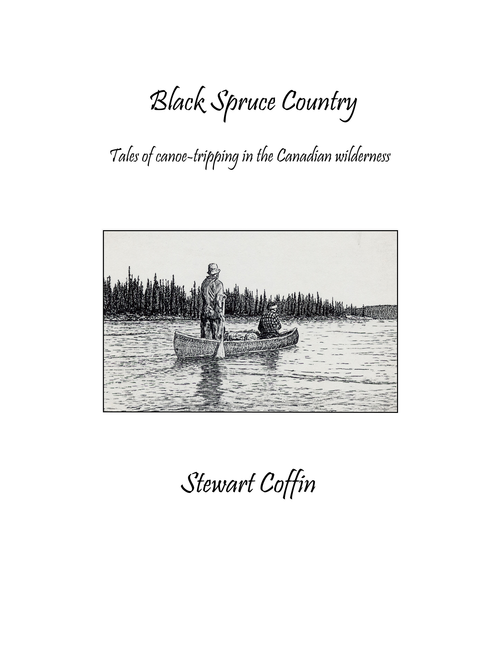

Contents

Introduction 2

Headwaters 4

Windbound 11

The Rescue of Scout 19

Freeze-Dried 24

Donna 31

Honeymoon on the McPhadyen 39

Getting Even 46

Betty’s Canoe 53
Faint and Forgotten 60

Copyright © 2020
Stewart Coffin
Concord, Massachusetts

Introduction

The Windbound tale was one of my early attempts at what might wishfully be call creative writing and illustrating. Much to my surprise, it was accepted for publication in the December 1988 issue of Appalachia, traditionally a mountaineering journal that seldom accepts fiction. On the strength of that, I eagerly spent a couple winters at my typewriter putting together a motley collection of several more stories and anecdotes. Daughter Margie typed my 90-page draft into her computer to produce printable pages. A hundred copies were then run off and stapled at our local copy center and self-published in 1991 as Black Spruce Country. I gave away some, sold some, and I have just discarded the few remaining.
I had sent one copy to Elliott Merrick, esteemed Labradorian author of True North and Northern Nurse, for his comments. To my dismay, he said it needed a lot of fixing up. He was especially critical of the confusing mixture of fictional tales and factual anecdotes, with an equally confusing cast of characters. How right he was. What could I have been thinking? If any reader still has a copy of that edition, please discard it. Better still, shred it! In this complete rewrite, I have left out the anecdotes and tried to tidy up the stories. I have added a new one, Getting Even, which incidentally was inspired by one of Merrick’s short stories, Manhunt in Frozen Labrador, that captured my imagination way back in my teens. I have also reduced the page size. When printed on standard 8-1/2 x 11 typewriter paper, the stapled book can then be trimmed to about 8 x10.
In spite of Merrick’s advice, I never could completely overcome my tendency of mixing fact and fiction. I really did once make and repair canoes, and there really is a canoe called the Big Dipper. All of the stories are set in places my companions and I have journeyed. In the unlikely chance that some readers will choose to retrace that horrendous portage route taken by the resourceful Ed Waters and his faithful companion Sally in the last chapter, or for that matter some of the other routes described, my stories might even serve as a useful guide. However, the last I knew, all of my actual detailed trip logs are now available on-line, although apparently not all in one place and you may have to search a bit to find a particular one.
The illustration on the cover was created by starting out with my photo taken in 1982 of Bob Davis and Dick Irwin in the headwaters of the George River and working it over it with pencil and Photoshop.
While I have this opportunity, I would like to include a few words about my companion book Black Spruce Journals. It all began back in 1956 when I started writing factual accounts of my own canoeing adventures. Over the years, many of those were published in Appalachia, and a few elsewhere. Around 2000, thanks in part to the amazing helping hand of the computer, I started pasting together many of them into the form of a book, copiously illustrated with photographs. After a seemingly endless string of disappointments, it was finally published by Heron Dance Press in 2007. Readers may notice that some of the lines in this work appear to have been lifted from Black Spruce Journals, but of course it was actually the other way around.
Of all my considerable literary efforts so far, Black Spruce Journals is certainly the one dearest to my heart. I wrote it off and on over a span of forty years and, while waiting to find a publisher, spent another seven years laboriously trying to make it better, with countless revisions, over and over, word by word, line by line. One of my objectives was to make the lines read like poetry, even though formatted as prose, with careful attention to rhythm and euphony. Even if no one notices, at least I had the satisfaction of doing it. I also took meticulous care in the placement of line breaks, page breaks, and photo locations. Unfortunately all that was lost when the publisher insisted on brusquely converting my MS Word work of art into InDesign with no regard for my efforts. But at least, much to my relief, it finally did get published, such as it is.
Shortly after publishing my Black Spruce Journals, Heron Dance decided to quit book publishing. So I bought what remained of the 1000 copies printed, and have been selling them or giving them away, until now only a dozen remain. I see it is now listed for sale in used books. Someday perhaps it will be reprinted, and hopefully done properly this time.

Headwaters

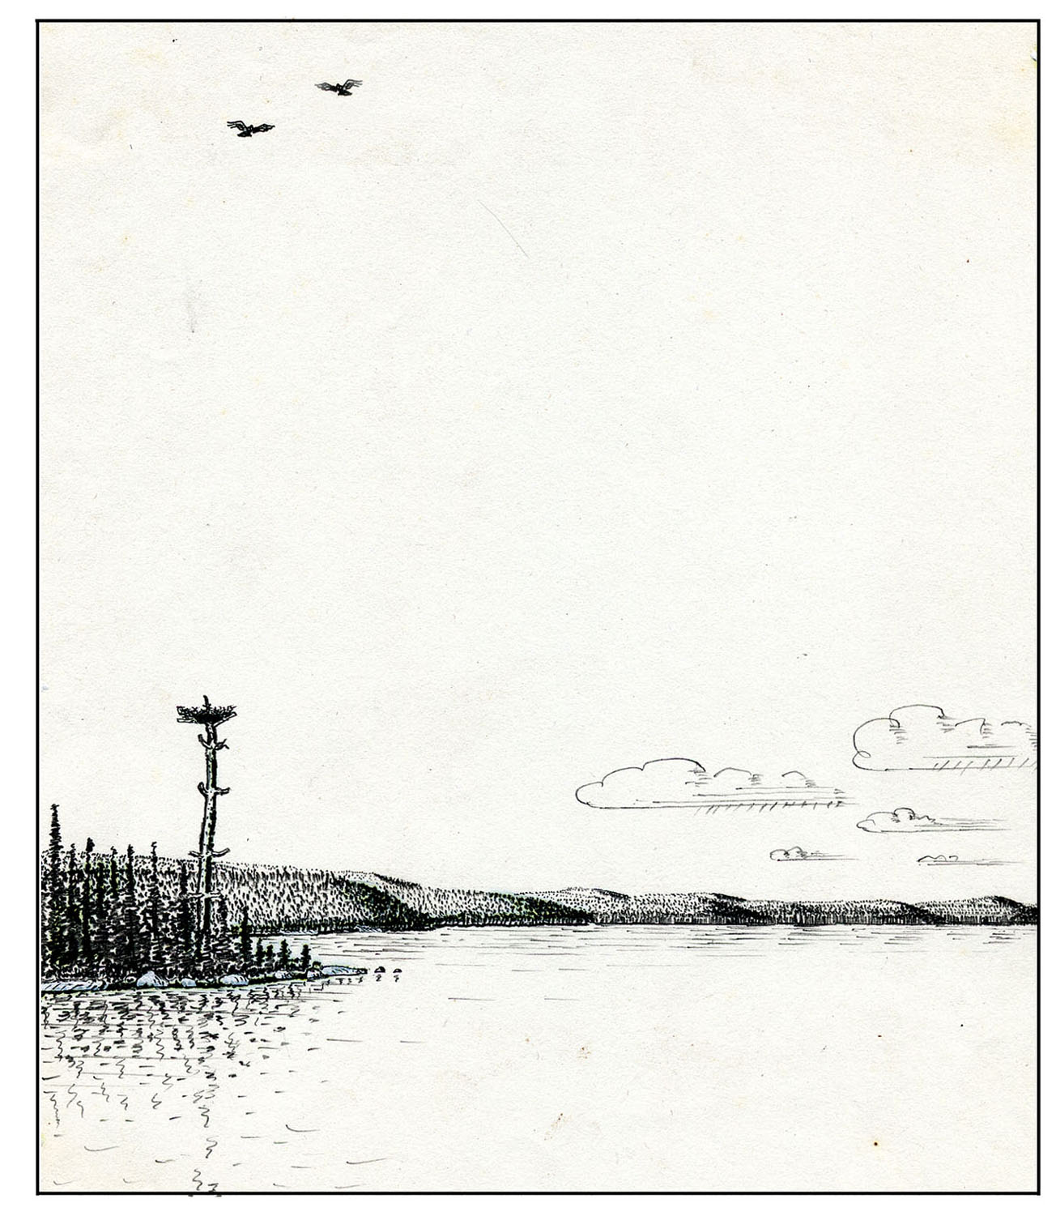
It was not until we had made the portage up around the falls that we had the feeling of finally being back in the real Black Spruce Country that both Ed and I love so passionately. Up to that point, there had been the usual litter and noise that one associates with drinking, motorboats, and fishing (in that order!) in La Verendrye or any other park. All it takes is one good portage to leave it all behind. Upper Cawasachouane Lake was just as pristine and peaceful as Ed and I remembered it to be from our previous trip. It was with a profound sense of reverence that we launched our two canoes and glided quietly up the lake. The only sound to break the silence was the scolding from a pair of ospreys as we passed near their nest in the top of a solitary old pine.
Five miles up the lake, near a rocky point on the right, we found the same campsite that we had brushed out twenty years earlier. How many parties had found it and enjoyed it since then? Quite a few, from the looks. But it was still clean, and the view from the point was still just as fine.
With us this time were my daughter Sandy and her friend Melinda. They had been counselors together at a girls' camp in Maine. For a little vacation before they went back to school, I had proposed this canoe-camping trip in Canada, the first for either of them. Our route was up through the magnificent high lake country of western Quebec into the headwaters of the Dumoine River and thence downstream to its confluence with the Ottawa River.
The girls were having a great time impressing upon us all the camp craft they had picked up during the summer, especially as it was their turn to cook dinner. As soon as we landed, they scurried about like eager beavers. They scoured the woods for punky birch firewood (when there was plenty of dry standing spruce nearby). They constructed a splendid stone fireplace (when two rocks to support the pair of fire irons would have done). They were about to light the cooking fire a good hour before it would be needed until we reminded them that macaroni took only ten minutes to cook. Oh, the boundless energy of youth!
Finally, we asked them if they could think of something really important that they had overlooked. We watched with amusement as they huddled together and puzzled over what it might be. We could imagine them mentally flipping through all their camping manuals and lessons searching for clues. They hauled the canoes out, turned them over, and tied them to a tree. They stood the paddles in the shade, hung up the life jackets, filled the water buckets, each time glancing at us for some sign of approval. When they began to excavate a moat around their tent, we advised them it really wasn't necessary and perhaps not even a good idea. Then they started probing for hints. Sandy asked if it had anything to do with food. I reflected for a moment and then replied that I supposed it did. Finally they gave up in exasperation. Ed and I headed out to the point to enjoy the view and bask in the late afternoon sun, and we invited them to join us.

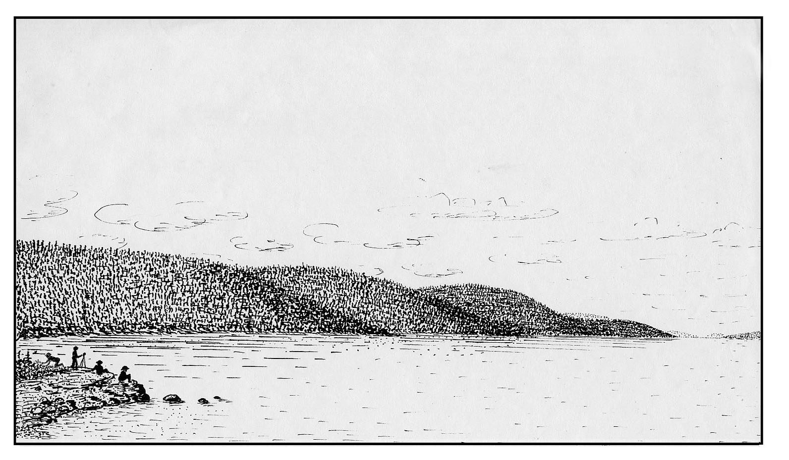
It was that blissful season you get in the high lake country in late August when you can sit around in shorts and not be bothered by bugs. The pair of ospreys were still circling far down the lake, and it was so unearthly quiet we could hear them calling even though they must have been more than a mile away. Across the lake and beyond stretched the great boreal forest, wild and unbroken. To see the characteristic shaggy spires of the black spruce silhouetted against the sky was like meeting old friends once again. Their legions would march along with us as silent company for the rest of the trip.
While the two girls went wading, Ed and I just sat and stared out across the lake. Then we got to talking about past trips and all the good times we had known together in the bush. I told Ed I had been thinking of writing up some of them and perhaps even publishing them as very short stories. Ed is a private sort of guy, and at first he wasn't very enthusiastic about the idea. He asked me if I had been doing much reading lately, especially of contemporary outdoor adventure stories, and I had to admit that I hadn't. He pointed out that there seemed to be three essential ingredients for such stories: booze, narrow escapes, and you-know-what! Well, to begin with, Ed and I are both teetotalers. We don't seem to be blessed with many narrow escapes on our trips either, darn it all. As for the third ingredient, let’s skip that.
When I asked Ed how he ever got started canoe-tripping, he told me he had spent one summer at a boys’ camp in Maine with the expectation of backpacking in nearby Baxter Park. But there was a mix-up in his registration. His name Ed Waters somehow got confused with Headwaters and he ended up in the canoe-tripping unit instead, which he has been thankful for ever since.
At length, we staggered to our feet and made our way back to the mundane affairs of camp and dinner. The girls' macaroni casserole with ham, cheese, and cornflake crumbs, baked in the reflector oven, was a huge success, as was also their blueberry cake made with the cup of berries they had picked out at the point.
While Ed and I were washing dishes, Sandy was studying the maps and asking questions, such as: How many miles today? How many miles from the start? How many miles to go, in how many days, at therefore how many miles per day? After all of these calculations, Ed asked if perhaps she was overlooking something. She and Melinda pondered what it might be: Number of portages? Length of portages? Rapids? Ed kept shaking his head. Finally they gave up. With a wink of his eye and a poke at the map with his soapy finger, he came out with this bit of wisdom: "Just keep in mind, the object is not getting there but rather being here." They never forgot that gem and have been quoting it ever since. Ironically, at that very moment I happened to be glancing at the last page of our trip log made twenty years earlier, which contained a summary of distances traveled each day measured to fractions of a mile! When the girls weren't looking, I discreetly dropped it into the fire.
Ed and I had our after-dinner tea, but the girls preferred cocoa. Melinda pointed out that cocoa had more food value than tea, no doubt quoting from some nutrition course she had studied in school. Ed's famous and oft quoted response: "Food for what? Tea nourishes the soul!"
After we digested that profound observation, Sandy asked if we would now please tell them, by the way, what it was that they had overlooked earlier. We had been expecting this question.
"That was it", I said, glancing out to the point of land where we had spent those precious moments of relaxation and meditation together.
"But Dad, didn't you say it had something to do with food?" (pause) "Oh yea, we get it now. Nourishment for the soul! That's great!" (laughter)
We followed a chain of wild and beautiful little lakes—Padou, Litvine, Roger, Crutch, and Birch—for the next three days, during which it rained rather persistently. We all wore weatherproof parkas of good old basic coated nylon. So many times we have had someone in our party with some expensive new hi-tech raingear and had to stop and build a drying fire to dry out all the rainwater that their "breathable" fabric had inhaled when it was supposed to exhale. You do tend to travel slower in the rain and spend more time in camp. Tripping in wet weather also tends to destroy clothing more rapidly, especially from the waist down. Knees rip; socks wear out. Boots fall apart, especially if you make matters worse by toasting them over the fire every night. Wet bushwacking is especially rough on gear. We were fortunate here in finding good trails all along the way. Waban and Keewaydin, both boys' canoe camps in Temagami, have been tripping in this territory for a long time, Keewaydin as early as 1920. Thus they bridge the gap between the old trapping days and modern recreational use. Those camps have a wonderful heritage and proud tradition, and we probably never would have gone on this route had it not been for them leading the way. Here's hoping the tradition continues.
The skies finally cleared as we paddled into Lac Dumoine. We headed for another fine campsite twelve miles down the lake that Ed and I also remembered from our previous trip. When almost there, we saw a Cessna come in with a canoe, so we were not surprised to find a party of six already there. But there was plenty of room, so we gladly accepted their invitation to join them, and we made camp nearby. Meeting other parties in the bush is a perpetual source of entertainment, and this party proved to be no exception. They belonged to an outdoor foundation centered in Boston. One of the women, Betty, I knew from having paddled with locally. I have forgotten the leader's name, but we facetiously dubbed him Porky owing to certain distinct physical characteristics of his, and so by that name he will be known here. The other guy, Mike, was decidedly more masculine looking, and he dressed in a manner such that every bit of it was obvious. One could only wonder what fun the mosquitoes must have had earlier in the season! We gathered that this was an instructional trip of sorts, Mike being the instructor, and that the other two women in the party were his pupils, or whatever.
We had an entertaining evening with them around the campfire. Porky was surprised to learn that we had paddled in from the north. He was quite interested because he was writing a guidebook to the Dumoine River, The Complete Dumoine Paddler, to be published by his organization. When I showed him our route on the map he quickly lost interest, remarking with an air of disdain that it was all "class-one water," whatever that was supposed to mean. Didn't we realize, he asked, that we could have avoided all that drudgery by flying in as they did?
Mike had observed us as we came paddling in and had noted a number of flaws in our technique which he indicated he would correct once we got on the river tomorrow. Sadly, there wasn't much he could do about our inadequate equipment, especially the lack of toe blocks, thigh straps, and flotation in our canoes. We took the subtle implication of this to be that Ed’s trusty old wood and canvas Prospector and my fiberglass Big Dipper were both beyond salvation. I would have thought Betty might have told him that we were not exactly beginners, but then I realized this was probably her idea of a joke. Can't really blame her. Evidently we did not do a very good job of concealing our own amusement, for later Porky got me aside and asked: did I not realize that Mike was a "world class" whitewater slalom champion in both K-1 and C-2M? (whatever all that was supposed to mean).
Then our two girls decided that it was their turn to have some fun. They had been practicing throwing up the canoes for portaging, and were getting pretty good at it, so they proposed to give the others a lesson. After they had demonstrated it a few times, our friends were invited to try, but only Mike was interested. They had figured he would want to show off his muscles. He deliberately chose the Prospector, the heavier of the two by some ten pounds. He snatched it off the ground easily enough, and with some effort finally got one gunwale awkwardly hooked over his shoulder. But puff and strain as he might, that was as far as he could go. When he yelled out in pain, the girls helped lower it back to the ground lest he drop it. He exclaimed disgustedly that it was a damned fool way to carry a (obscenity) canoe! Thus ended our lessons for the evening.
Going down the lake next morning, we worked out a switch and I paddled with Betty for a while. I asked her why the Foundation had chosen Porky, of all persons, to compile a guidebook on a subject he obviously knew so little about. She laughed and explained that it was the other way around—he chose them! It seems that when Porky joined, his law firm had made a large contribution to their Endowment Fund with the suggestion that Porky would very much like to see his name on the jacket of a book. Porky also expected to advance his rating to 3A-OC/S on this trip (open canoe/solo, Betty explained, but I have forgotten what the "3A" stood for). Betty mentioned that some of the others in the party also were trying for a higher rating on this trip, but it had already been the subject of one heated argument and best not brought up again for a while.
When we got to the scenic pine bluff near the outlet of the lake, we had lunch there and then switched back to our regular partners. At the first rapid, we all ferried dutifully back and forth for a short while under Mike's grim tutelage. We actually did pick up a few pointers. What struck me, though, was that I did not see any of them crack even one smile all the while. Shortly below this rapid, we came to the first falls on the river and an easy 200-yard portage left. Our group did not want to wait while the others helped Porky ooze himself out of his canoe, while all the spray covers were removed, and while all their gear was lashed onto pack frames to be lugged over the short carry, so we bade them farewell. Porky urged us to stay with them while longer. Surely, he insisted, we would not want to pass up the chance to run the class-three section ahead with one of the top rated canoeists in North America. I told him that we expected to do just that anyway. He looked puzzled, so I explained:
"Those two girls can paddle, portage, and cook, and they can do them all very well, at least by my standards. What's even more important, after a hard day of paddling in a driving rain with horrendous headwinds and portaging through slippery muskeg with clouds of mosquitoes, they can still smile at the end of the day as sweetly as a sunset in the Barren Grounds. In your rating system, if you know of anything more important than that, then we would certainly like to know what it is."
We left poor Porky sitting there with a very perplexed look on his face and continued on our way. We all agreed that he was really quite a friendly and likable bloke, as were likewise most of his companions. We hope they had a successful trip and earned all their ratings. Sandy and Melinda certainly earned theirs.
Windbound

After the usual false starts, jerks, and lurches (mostly backwards!) in time with what sounds like minor train wrecks occurring up and down the line, we finally begin to actually crawl forward out of the station, northbound on the incomparable Quebec North Shore and Labrador Railway. Ed glances at his watch and smiles, noting with amazement that this time we are departing a mere hour or so behind schedule. The train slowly threads its way through the sprawling clutter of the switchyards at Sept-Îles, all the while gradually gathering at least a semblance of speed.
After leaving the switchyards, the transition is pleasantly abrupt, for soon the shabby outskirts of this once thriving but now declining shipping terminal are left behind and the boreal forest closes in all around. At mile 10, the train enters a long dark tunnel. The exit from this gloomy passage could scarcely be more dramatic, for one emerges directly onto the bridge over the infamous Railroad Trestle Rapids. Both Ed and I have been here before, although not together. In anticipation, we have our faces already pressed to the window, trying to wipe away layers of accumulated soot for a better view. For us it is one of the scenic high points of the entire train ride, and it brings back many memories of past colossal adventures, here and elsewhere.
The bridge actually marks the foot of this mile-long series of heavy rapids. It is the last major obstacle for whitewater canoeists making the demanding 250-mile run down the Moisie River from headwaters to tidewater. The river runs fast, deep, and unobstructed under the bridge. The biggest problem is avoiding being dashed against the right bridge abutment as the river makes an abrupt turn to the left to pass underneath. As for portaging around it, let’s not say it is impossible, because many things are possible. But few if any canoeists have managed to do it, and most would agree it is quite impractical because of cliffs and vertical concrete bridge abutments on both sides.
But even in high water, the run is not as difficult as it would appear when scouting from upstream or from the bridge. For just as you think you are about to crash into the right bridge abutment there is usually a cushion of water throwing you back the other way. The biggest hazard then is being swallowed up by one of those large swirling holes that appear unpredictably in one place and the next moment somewhere else Actually, neither Ed nor I know of any canoeing parties having been unlucky enough to flounder into one.
For the next twelve miles the train wends it weary way northward along the right bank of the Moisie River, which is here mostly placid. Then it leaves the Moisie to head up the valley of the Nipisso River, a major tributary coming in from the northeast. We make frequent stops every few miles, sometimes for no apparent reason, other times perhaps to discharge a party of fishermen, and Indian family, some train workmen, or to drop off equipment and supplies. Sometimes it is to let a trainload of ore pass on its way south.
The QNS&L was built to transport iron ore from the huge deposits on the Labrador Plateau 360 miles southward to the shipping port of Sept-Îles. The first load of ore was carried in 1954. Soon after that, some of us with a notion for canoe tripping began wondering about the possible access by train to this vast and formerly inaccessible wilderness. We began writing letters, especially to the Canadian and provincial tourist bureaus. Mostly what we wanted was information on travel permits and regulations. Just a few years earlier, two fishermen had gone over Churchill Falls on the Hamilton River, involving a long and expensive search for their bodies, as a consequence of which strict regulations were imposed on travel without licensed resident guides. But the tourist bureaus apparently knew nothing about that. They kept insisting that all canoe trips in that region were prohibited because the waters were leased to salmon fishing camps. What we usually received instead were brochures for the various sporting camps. We did not see how all of the countless lakes and rivers up there could be so leased, and even if they were, why it should concern us, since our main interest was river running, not fishing. This went on for years. Finally we decided that it would be simpler to just go and find out for ourselves, and that is how Ed and I started coming up here way back in the 1960s.
After laboring uphill for 150 miles, we go over the height of land, which marks the provincial boundary between Quebec and Newfoundland, and coast along through the alluring high lake country of the Labrador Plateau. Lakes and ponds, marshes and string bogs are sprinkled in profusion and confusion all across the land, interconnected by an incredible labyrinth of rivers and streams. Most are shallow. Lichen covered boulders protrude everywhere. But it is the ubiquitous black spruce that dominate the landscape. Seen near at hand, they tend to be widely spaced on a lawn of yellow-gray caribou moss, rather like a well manicured rock-garden park. But in the distance, they muster into one solid dark green army by the billions, to the far off horizon and beyond, seemingly forever. This truly is the Black Spruce Country.
Our destination this time is far to the north. The George River rises in a chain of small lakes not far from the northern terminus of the train on the central Labrador Plateau, quickly gathers momentum, and heads straight north towards Ungava Bay and the arctic seas. Only once does this magnificent river pause in its boisterous descent to tidewater, in an expansion known as Indian House Lake. This narrow, fifty-mile-long body of water is a place all too familiar to many a canoeing party by its reputation for horrendous headwinds. And so it was that Ed and I found ourselves reclining in the lee of a giant boulder, staring out across the lake as the waves rolled by our field of view in hypnotic endless procession.
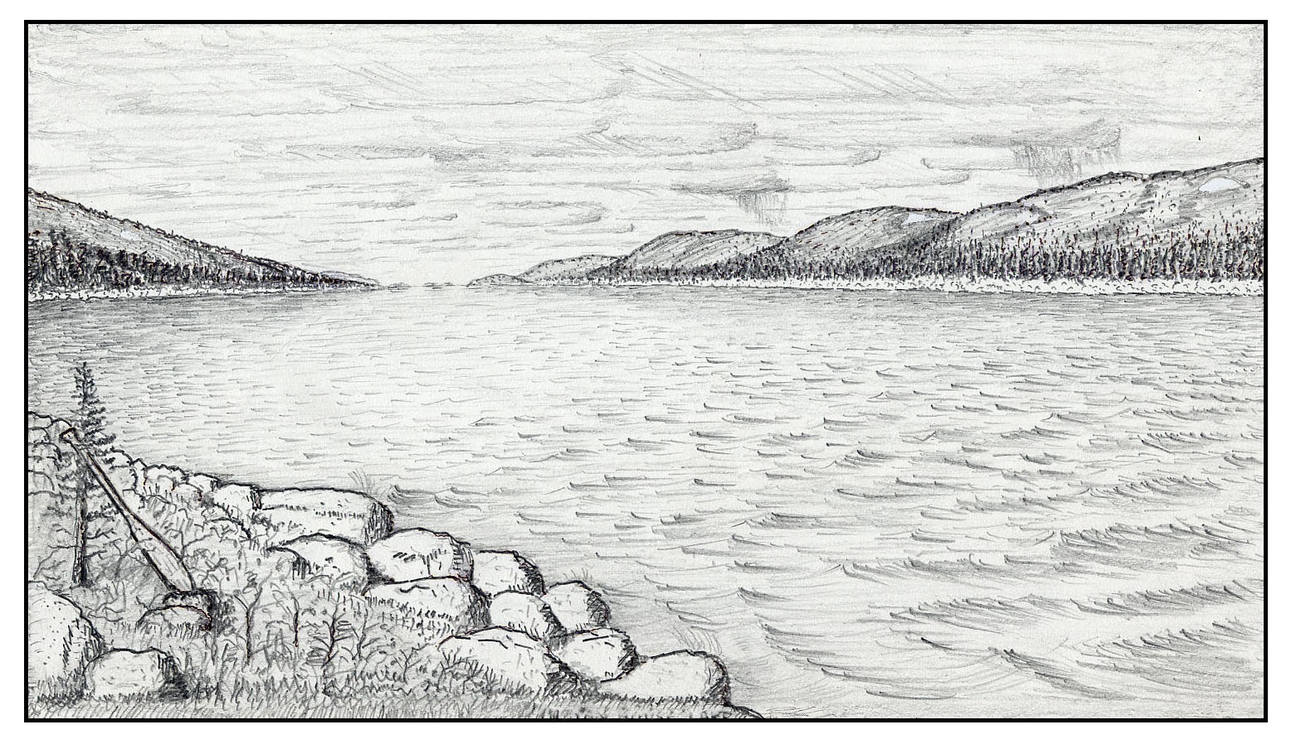

The previous day, our fifth day out, we had entered the lake early in the morning and paddled until midday, when a fresh wind directly in our face pinned us down for the rest of the day. Today looked like it would be a repeat of yesterday.
Ed and I were passing the time by swapping stories. As usual, most of the yarns revolved around eccentric canoeing companions we had known. It is truly amazing how many odd characters one encounters over the course of a few summers of wilderness tripping. Ed was relating in candid detail all of the tribulations of a Barren Grounds trip he and a friend had taken a few years past. His story began to drag a bit after they got windbound for the third time on Angikuni Lake somewhere way off in the Northwest Territories, so during a long pause I asked Ed if I had ever told him about the time I was windbound on Chesuncook.
Ed paused and said nothing, but glanced up at the sky. I supposed the one possibly useful purpose a timepiece might serve up here would be to settle the question of when next to eat again. Ed settled back in his hammock of Labrador tea bushes, pulled his hat down to shade his eyes as he admired the view, and reached for the bag of gorp in his pack.
The boulder we were leaning against was just one of many pushed high up on the banks by the winter ice. The opposite shore, which was less than a mile away at this point, was paved with this loose rock for miles in either direction. The forest was here confined to a belt extending a few hundred yards up the slopes on either side of the lake. There were good stands of spruce in some of the gullies, the largest trees being a foot in diameter but not very tall. Higher up, the steep hillsides supported only scrub growth, predominantly the ubiquitous Labrador tea. The summits were mostly bare rock, forming, or at least giving the appearance of, a continuous mountain ridge. Yet many streams cascaded down the hillsides and into the lake, indicating even higher country beyond. A few patches of snow lingered, and every now and then one would glow brightly when the slanting rays of the afternoon sun happened to break through the low, drifting clouds.
“Well, one weekend a few summer ago I was paddling with some friends on the Rangeley Lakes and . . .”
Ed immediately interrupted to remind me that I was supposed to be on Chesuncook Lake. I told him I was coming to that part, damn it, if only he would be patient.
“We'd stopped on Spirit Island for lunch, and we were just about to shove off when a young couple with a small boy came paddling in. I went over to chat with them for a minute, and we got to talking about different canoe trips in the vicinity. They seemed interested so that went on for a while. You know how I tend to lean on my paddle when I'm talking? Well, I noticed the woman kept staring at my paddle. Finally she asked me with a quizzical sort of smile if I had ever done the West Branch trip. I told her I had once, many years ago.”
I glanced around at the weather and then at Ed. He was chewing on some raisins and peanuts, so I knew he was still awake and I continued my tale:
“That was my first summer vacation after finishing school, and I had only a week, so Tris and I did the West Branch trip starting at Seboomook Lake. When we came out into the head of Chesuncook Lake, a storm was brewing and blowing straight up the lake, so we started looking around for a place to lay over for a while. Pretty soon we saw a Grumman pulled up on the shore. We were getting blown in there anyway, so we decided to have a look. The canoe belonged to a father-and-daughter team. They had been just ahead of us and of course had sailed in there too. It wasn't a bad spot, so we accepted their invitation to join them. After we had set up camp, we went over to chat.
“Things hadn't gone too smoothly for them. Somehow they had managed to upset coming down the West Branch and still weren't completely dried out, but they were in good spirits and laughed it off. But then they had broken one of their paddles nearly in two while coming in to shore in the wind. They were trying to do the impossible and fix it with adhesive tape, for they had no spare.
“With the rest of the day to spend and nothing much to do, an idea entered my mind and I started scouting around with my axe. Just down the shore a little ways I had great luck, for there was a large cedar blowdown with a good straight trunk. So I took a section from the butt, lugged it over to our tent site, and started sawing and chopping away. Of course Tris knew what I was up to, but I let the other two puzzle over it for a while. After a couple of hours it began to look like quite a respectable paddle, although a bit on the small side. Susie - that was the little girl's name – was taking quite an interest in the project, so I let her whittle away on it for a while.

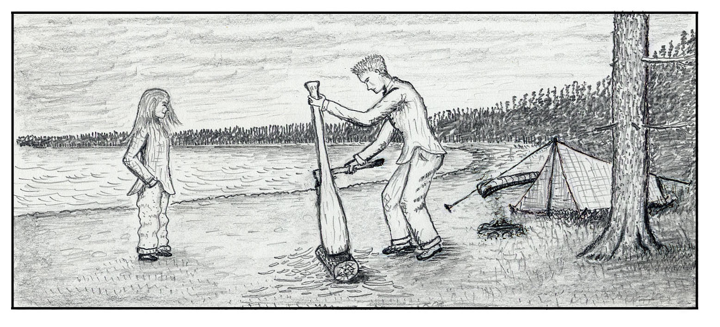
“Next morning dawned cool and cloudy, but the wind had shifted around to the north, and pretty soon patches of blue started to show. Before we shoved off, I put a few more finishing touches on the paddle and gave it to Susie. Well, you should have seen her eyes light up! That paddle was a little taller than she was. I told her to rub a little oil into it once in awhile, and it should be quite a serviceable paddle for many years to come.
“What a beautiful day that turned into, with crystal clear air, big fluffy clouds, a fresh wind blowing us down the lake, and no bugs! We stopped early to camp because we didn't want to start the portage around Ripogenus until the next day. Towards evening, Susie and her father came by. They stopped to return the paddle, but I told them to keep it awhile longer and perhaps we would see them again sometime. I didn't really expect we would, though, because their car was at the dam and they were ending their trip there. I wanted Susie to keep it and use it when she got a little older.”
I paused to check the wind, and it did seem to have dropped a bit. Ed was now popping peanuts. Just the smell made me hungry, so I gladly accepted a handful when he offered them.
“So anyway, there we were on Spirit Island, and with a big grin the woman reaches down into their canoe, hands me one of their paddles, and says, ‘Perhaps you remember this!’ I remembered all right. That was actually one of the better paddles I have made. Usually when you make one like that, you find at least one knot or some crooked grain just where you least want it, but that one was clear and straight. Evidently I had penciled in my initials on the blade when I made it, and although they were no longer legible, she had remembered. And then she had spotted them on my own paddle. I remarked on what good condition it was in after twenty years. She said that she rubbed a little oil into it now and then, just as I had told her. Her husband, who was gradually getting the drift of what it was all about, explained that they took it affectionately on every canoe trip, but now only as a spare.
“My companions were now getting anxious to get going. We had arranged for a shuttle over the Carry Road from Middle Dam to the Devil's Hopyard, and from there we would run the tail end of the Rapid River into Umbagog Lake. She offered to return the paddle, but I told her to keep it awhile longer and perhaps their youngster could start using it in a few more years. Maybe our paths would cross again someday. And with that we bade good-bye and shoved off.”

I glanced at Ed for some sign of approval of my tale. He said nothing, but I did notice that he smiled as he gazed down the lake. He knew perfectly well that there never was any paddle, or any Susie either, and that I had dreamed up the whole thing just for his amusement.
The wind had dropped perceptibly, so we decided to end our snack-and-story hour and push on a bit more down the lake before calling it a day. Indian House Lake is nowhere more than a few miles wide, but it is so straight that one has the impression of being able to see nearly its entire length. Yet as you paddle onward, the vanishing point where land, sea, and sky all come together just seems to keep receding ahead of you forever. Chase after it as you will, you never quite catch it, like the proverbial pot of gold at the end of the rainbow.
As the late afternoon sun dropped ever lower in the western sky, the surrounding hills cast their lengthening shadows across the lake, and the treeless skyline began once again to play its familiar old tricks on our perception of scale and distance. We headed for the next point of land as a possible campsite, with no accurate notion of how far away it was. Our map might have told us, but over the years one develops an aversion to maps. I have known past trips on which we followed our maps so intently that afterwards I was left with a clearer recollection of the maps than of the actual country traveled. Soon we were cruising past that point of land and headed for the next. The haunting call of a loon came floating across the waters, now almost dead calm, and soon it was answered by others. Could this be their story hour? We cruised quietly along and listened.
The canoe we use on these trips is a combination of tradition and practicality. It is wood covered with fiberglass and epoxy, with somewhat the classic lines of the eighteen-foot Prospector. When fully loaded, our trusty Big Dipper glides through the water with little effort at just under three miles per hour. Anyone who has ever done much paddling under these conditions must be familiar with the hypnotic sensation of being forever frozen in space and time, with your bow wave appearing motionless in the water and the rest of the world slipping slowly by. Ahead, your whole universe is represented by a thin dark line stretching from shore to shore, separating sea and sky into two vast kingdoms. In the farthest distance, all merge into one as distant island, real or imagined, flicker mysteriously on and off. Cast adrift upon this strange, endless stream, the mind wanders and gropes for reality. Could it all be just a dream?
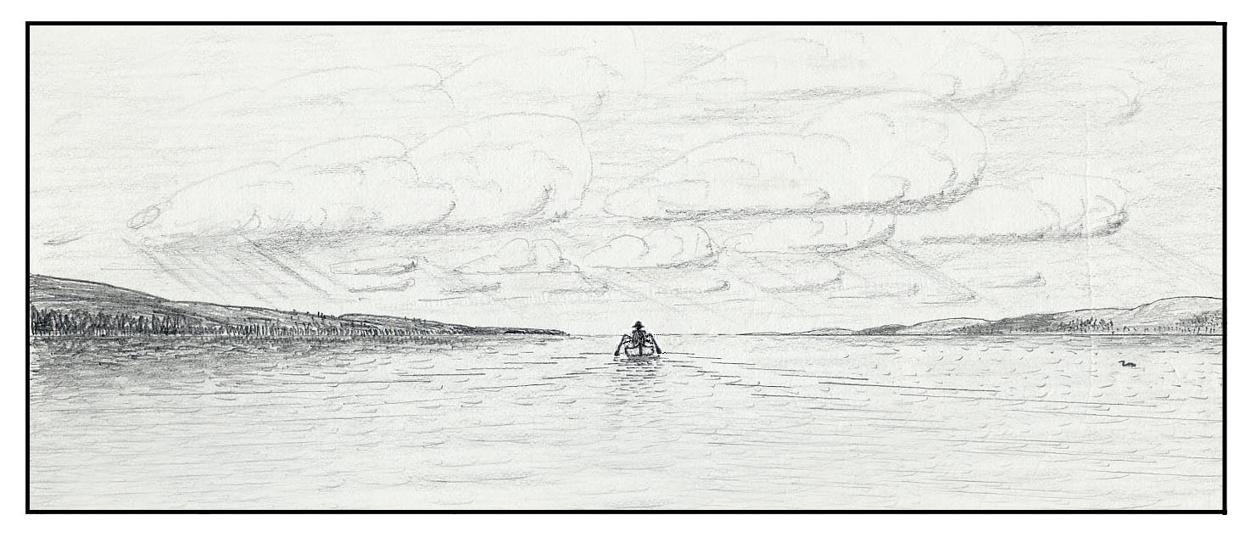
The Rescue of Scout

One time when Ed and I had spent the better part of the day leisurely cruising along a stretch of the Coulonge River that was slow and meandering, Ed asked if he had ever told me about the rescue he and his faithful companion Sally were once involved in on the Rivière de Rêve. The name of the river immediately put me on guard, but for lack of any better way to pass the time at that moment, I told him to please continue. This is his amazing story, as best I can recall, with perhaps a few embellishments that I have added:
“Well, on that particular day, Sally and I had entered a long stretch of the Rêve that was placid and meandering much like this one we’re on now, and it was becoming just a trifle monotonous. In a semi-hypnotic state, I had been staring at our seemingly motionless bow wave as it sparkled in the bright mid-morning sun and the rest of the world drifted slowly astern. I’m sure you know how mesmerizing that can be. It was our third day in a row of fair weather, not many bugs, and a great partner—all pleasant thoughts as we cruised quietly along. For a while I shifted my gaze to the back side of Sally and watched her lovely body flex rhythmically—very pleasant thoughts indeed!”
At that point I told Ed we could skip all that nonsense and get on with the rescue part of the story. But I did appreciate what he meant by the hypnotic effect of paddling for a long time in still water. It affects most of us the same way. Evidently not getting my message, Ed continued with his digressions:
“What a blessing to have a partner like Sally. Whenever I switch sides, without a word being said, she can always sense it and switch on the following stroke. Twenty-five slow, easy strokes per minute, 1500 per hour, 10,000 per day. How many paddle strokes do you suppose in a lifetime? Ever find yourself stroking in time to music? On that day, as I recall, it was a medley of old-time dance tunes—100 beats per minute, four beats per stroke. After awhile, the hot sun beating down from the cloudless sky made me drowsy, and my thoughts began to drift aimlessly. But lo—at last an end to this boredom as something colorful far ahead attracted my attention—
“We must have caught up with the Girl Scout party that we knew was just ahead of us. As we drew closer, I could make them out standing along the right-hand shore of a strong stretch of rapids and looking out across. At first we thought they were just scouting the route through, but as we worked our way closer we discovered, much to our concern, that the unfortunate object of their attention was one of their number stranded on a large boulder in midstream. Sizing up the situation, we beached our canoe well above the start of the rapids, moored it securely to an alder bush, and scrambled down a portage trail of sorts to find a very concerned leader with a distraught bunch of young scouts.
“It seems that the party had pulled in at the head of the rapids, which were obviously unrunnable, planning to either line or carry. But just as they were coming in, a sudden powerful gust of wind had driven one of their canoes back out into the current and capsized it. The canoe had ended up in the eddy below the rapids and was pulled out together with the gear unharmed. One paddler had swum to shore, but the other less fortunate one ended up perched on that boulder in midstream. To make matters worse, she was just above a heavy drop as the river raced by and then plunged over a broad broken ledge and into quieter waters below.
(This situation must be one of the whitewater canoeist's ultimate nightmares. How many of us must fantasize about it in our imagination, wondering how we might go about rescuing the hapless victim. I had encountered and dealt with situations not much different from this a few times myself, but this one of Ed’s sounded like a bit more of a challenge than most.)
“The leader was not to be faulted too much. Sally and I had been buffeted out of control a few times by those same sudden gusts funneling through the narrow canyon as one squall after another blew by on that stormy afternoon. These things will happen. Most of us have done as badly or worse at some time or other. And what did it matter, anyway? All of our attention was directed at the poor girl on the rock and how to bring her safely back to shore.
“While Sally organized a campfire and equipment brigade, the leader and I scrambled along the shore and climbed boulders for a better view as we discussed the situation. ‘Leader’ (never did get her name) was quite concerned because there were only a couple more hours of daylight, and furthermore the river was rising because of the stormy weather. Leaving the girl out there overnight was out of the question, and I reassured Leader that we were not going to.
“I had some ideas as to how we might best organize a rescue, but after studying the wild rapids from every angle they got narrowed down to only about one remaining. However, I said nothing to Leader, as I figured it was her party and up to her to make the first move. Finally she asked, ‘What do you think we should do?’ I told her what I had in mind and she immediately agreed.
“The plan was for Leader and me to ferry out at the head of the rapids in my Big Dipper and drop down to the girl. The reason for taking Leader rather than Sally was that there would be three of us plus one canoe flushed down the river, with probably more rapids below, and the ever-resourceful Sally was needed to be in charge of the critical rescue operations there. Furthermore, my thought was that Leader might be better able to deal with the girl, as we did not know what state of mind she was in. As for whether on not Leader knew how to paddle, that I would soon find out, but my immediate first impression of her was that she was quite a capable gal.
“Sally and the girls soon had the teapot boiling, and they turned their attention to moving gear downstream, including a rescue canoe, paddles, ropes, and another assorted items. Meanwhile, Leader and I headed up the other way with our own gear plus Sally’s large flotation jacket and a canteen of hot chocolate. We waved to the girl to keep her spirits up and she waved back, but she looked rather cold and despondent out there all alone, as well she might. I was still somewhat undecided exactly what course of action we might take after we reached her, as it would be easier to judge from the stranded girl’s vantage point. She had now been out there for three hours. I asked Leader what sort of scout she was, and she replied, "Smallest kid in the troop but with the biggest heart." There was no need to say any more. Before shoving off, we went over the plan one more time. The ferry out would be straightforward, but after that it would be a wild ride indeed down some very powerful rapids, all of which we would be running backwards. As we began our ferry across, while still in relatively smooth water, I switched my paddle to Leader's side and did a quick lean and brace, anxious to see what her reaction would be. Immediately and instinctively, she slapped her paddle down in a strong low brace. What a relief that was! That gal really knew how to handle her paddle. With that question settled, I felt a surge of strength and confidence. Soon we were twisting and bouncing this way and that, gradually working our way downstream with whitewater foaming all around us. With the Big Dipper unloaded and an occasional lean away from the biggest breakers, we had ample freeboard but just barely. With most canoes, we wouldn't even have attempted this.
“As the powerful current carried us by the girl despite our strong upstream paddling, Leader tossed our bow line to her. She sprawled on the rock and the initial shock nearly pulled her off. Gradually she hauled us in and then broke into a big smile. I felt a lump in my throat and my eyes misted. For the moment at least, the roles were reversed and she had become our rescuer!
“It took the combined coordinated effort of all three of us for Leader and me to scramble out of the wildly pitching canoe and onto the small rock island. The canoe was tethered at the end of its forty-foot bow tracking line and allowed to bob downstream in deeper water. The three of us then sat down on our tiny island haven in the midst of chaos, little Scout in the middle (never did get her name either), and partook of the hot chocolate. I spent some time studying the final drop from this vantage point, and then proceeded to the next step of our plan.
“We wrapped Scout in my big life jacket right over her own small one, and I put on Sally’s. I then pulled the canoe in and secured the bow line, but leaving enough out for a grab loop. Leader tied one paddle in while Scout and I restrained the bouncing canoe. We then loaded Scout to squat just ahead of the center thwart, grasping both gunwales. Leader then knelt just ahead of the bow thwart that had now temporarily become the stern thwart, for the canoe was still pointed backward. Holding onto the bow grab loop, I slid off into the deep water with my precious cargo for the next and most critical step. For a while we just drifted down with the current, but as we approached the big ledge that extended nearly across the river, I finally got a footing with my lugged soles on solid granite and brought myself and the canoe to a halt. Then ever so carefully I worked our way along the ledge while all the others on shore looked on and cheered. When we reached the point where I could go no farther, I motioned for Sally to be ready for the grand finale. Downstream from us the river ran fast, deep, and unobstructed, with big standing waves and whitecaps, all the way down to the whirlpool at the bottom. When we could see that Sally was ready I let go with a sideways push into the main current, and down they went on a roller-coaster ride, bouncing from wave to wave and plowing through some. The canoe half-filled, but Leader managed to keep it upright as they finally came to rest in calmer water. I then floated down to join them. Sally and one of the scouts, with Leader’s help, then towed us in. Soon we all were safely back on shore, standing around the drying fire amidst cheers and hugs, and a few tears too. Meanwhile, Sally and I loaded up and headed on downriver.
“Suddenly I realized that we had been paddling for over two hours steady in the hot sun and that it was time for our mid-morning rest stop. A rocky point of land up ahead looked promising, so with my next stroke I nudged the bow a couple degrees in that direction. Sally picked it up immediately, and by a slight turn of her head and change in angle of her next stroke she was telling me yes, let's have a look, without either of us having spoken a word.”
When you have tripped with someone for a long time, this sort of paddle language just seems to come naturally. But at that point I just had to interrupt Ed. I said, “Wait just a minute. Awhile back you were describing a stormy afternoon, and now your back to that sunny mid-morning? What’s going on? Oh yes, I see now, Rivière de Rêve. Ha, I should have known. OK, get on with your story.”
Ed continued: “We haven’t even come to the best part yet. We lounged on the rocks for a while, enjoying some trail snacks as we admired the view. Our Big Dipper, tethered on the end of its tracking line, bobbed gently in an eddy and swung slowly about in the faint breezes. I reminded Sally that we had been discussing a name for our canoe, and I said, ‘How about Silver?’
“Sally’s response was ‘Silver! Sure you're not going color blind, Ed? Aha, I thought your eyes looked sort of misty for a while this morning. Definitely not Silver.’
"All right,” I said, “How about Scout? "
"Scout? Oh yes, I like that Kemo Sabe. But just don't start calling me Tonto.”
Freeze-Dried

By the time I got to know Ed, he had already spent several summers canoeing with friends in the wilds of eastern Canada. One of his favorite pastimes was working out routes for future trips using government survey maps. His usual method was to start from some point in the high headwaters country on the Labrador Plateau, preferably accessible by train or truck, and look for some route more or less connected by blue that would eventually bring them to tidewater. Another requirement was that it be some pioneering route not already overrun by other trippers. And that is how he and Sally ended up one summer on the bridge over the Pekans River.
As Ed and I sat around the campfire on the Coulonge one evening, he told me the rest of the story:

He and Sally had driven to Sept-Îles, taken the train to Wabush, and hired a truck ride to the bridge over the Pekans River. Ed was quite surprised to learn from their driver that another party of four had put in at the bridge three days ahead of them, also headed as they were for the Ste. Marguerite River. Ed and Sally were waiting for the other two members of the party to join them. For some reason or other their companions, Henry and Elaine, had to leave home too late to catch the train, so the plan was for them to drive straight through the night up the new road to Labrador and meet them at the bridge at noon the next day. After Ed and Sally had sat around at the bridge for several hours past their scheduled meeting time, finally a pickup truck pulled up and two friendly guys hopped out to deliver a message to them. It was from Elaine, informing them that Henry was at that very moment in a hospital in Boston having his appendix removed. The driver, by the way, had gone considerably out of his way to deliver the message—just typical of the Newfie hospitality and thoughtfulness that one typically finds up there. The result of all this was that Ed and Sally started the trip with twice the food they needed. They resolved to eat the heavy stuff first and perhaps discard some at the start of the first long portage.
Their route was down the Pekans River, up the tributary Grasse River through a secluded chain of little lakes, and across a height of land into the headwaters of the Ste. Marguerite. They were following what looked on the map to be an obvious route, and so were not surprised to find traces of old portage trails most of the way. It appeared that they and the foursome ahead of them were the only parties to have passed that way in recent years. No doubt others would soon follow. From Ed’s account, it sounded like a fine canoe route through beautiful country for parties who don't mind the numerous portages, of which more later.
Ed and Sally had by this time, together or with others, paddled most of the wild rivers draining the North Shore region. The Ste. Marguerite was the westernmost of these. The next one to the east, the Moisie, was the best known and most popular of any, partly because of its many exciting and mostly runnable rapids. From Ed’s account, it sounded like the Ste. Marguerite was totally different in character. After negotiating a section of unrunnable rapids near the headwaters by lining and portaging, they entered a long scenic section with good current and just a few gentle rapids—a splendid stretch of river it was for just cruising along and meeting moose.
On their tenth day of their trip, they approached the head of a major gorge. The Ste. Marguerite, like the Moisie, was once a fur trade route of sorts between the interior and the Gulf. From Sally's research on historic trade routes of the past, she had learned that the gorge was considered to be impassable, just as it looked on the map, and that there was supposed to have been a multi-day portage route around it that also looked obvious on the map. They had no trouble finding the start of the old portage trail, for just about where they thought it should be they spotted a yellow ABS canoe that had just recently been hauled up on shore. Evidently they had caught up with the party of four. The trail looked to be still quite usable for having been abandoned so long ago.
Ed and Sally decided to make an early camp at the foot of the trail and spend some time going over their provisions. Their trail started out with an 800-foot gain in elevation up the side of the canyon—a significant climb on any canoe portage. Before discarding any food, they decided it might be a good idea to see if the other party could use any of it. So they headed up the trail for an afternoon stroll—Sally with one of their food packs and Ed with the canoe.
They had gone but a short ways when they came to two gals preparing to camp on the trail. They seemed to be pretty upset and weren't too chatty, so Ed and Sally continued on up. At the top of the climb, they came to two guys, one tent, and their other canoe. It seems they had just had a big argument about bringing up the second canoe and at that moment weren't even on speaking terms with each other. But one of them was glad to chat with Ed and Sally. He told them candidly and in some detail how their trip had gone thus far, which can be summed up as not too well. Finally his companion joined in the discussion. On two points they were in agreement. One was the lousy food. The other was the poor attitude of the two gals.
Ed and Sally still hadn't mentioned their extra food. They got together for a private discussion and then came back to the two guys with a proposition. Except that water had to be carried a ways, their site was a good one with plenty of space. Ed and Sally proposed that they all camp together and pool their resources for a grand dinner. The guys agreed, but doubted that the two gals could be persuaded to join in. Ed and Sally headed back down. It took some persuasion on their part, but finally the gals agreed to join the others. Ed and Sally went down to the river to pick up their other two packs. They still had one extra food sack which they tied in a tree to be picked up next morning. Ed checked out the yellow canoe and could see why no one was anxious to bring it up. It was a popular make of ABS canoe, advertised as weighing 79 pounds but actually closer to 85, even without the heavy tracking lines and a few other things tied in that brought it close to 90 pounds. Most discouraging of all was the slightly curved center thwart with some foam attached—an instrument of torture jokingly referred to by the manufacturer as a portage yoke. When they went back up, they found the two gals just finished packing up, so the four of them hiked up together.
Sally took charge of dinner. The other party proposed to contribute a packet of beef stroganoff and noodles, which fit perfectly with Sally's plans as she and Ed had a great surplus of good egg noodles they hated to discard. While Ed tended to the fire, Sally diced two pounds of Hickory Farm beefstick and sautéed it in margarine together with three chopped onions and seasoning. Into her largest pot (4 quart, twice the size of theirs) went two pounds of noodles and more margarine. In a smaller pot—two packages of mushroom soup and two packets of sour cream mix.
When Ed happened to be around the fire and none of the others were nearby, Sally reached into her pocket and with a wink handed him the other party’s packet of "beef stroganoff." Ed read the label: "Freeze-dried, with imitation beef and artificial flavor. 8 ounces. Serves 4."
"Good Lord," he whispered, "about 900 calories. Barely enough for one person even if it were fit to eat." He handed it back to Sally. She glanced around, then opened it and discreetly poured it into the fire as Ed stoked some tinder on to incinerate what might as well have been dried moose turd.
By the time they got around to preparing the dessert, everybody was into the act. One couple gathered firewood and built up the fire for baking, while the other helped Sally with an apricot upside-down yellow cake. It was too large for her baking pan, so it was baked in the large frying pan, and the reflector oven was extended with heavy aluminum foil to accommodate it. Of all the great meals that Sally has come up with over the years, that one must rank as one of her supreme triumphs. And wow, did those four ever put it away! Ed thought that Sally had overdone it and that they would never see the bottom of the noodle pot, but it finally was all gone. At last, one of the guys put down his bowl with a sigh, sat back with a very content look and asked what that was they just had for dinner.
His companion answered, "That was the Out House brand freeze-dried beef stroganoff, with some extra noodles."
"Well, well," he exclaimed, "we finally got our money's worth. From now on, let's have that one on every trip!"
Ed stole a glance at Sally. They could barely contain themselves from breaking out in hysterical laughter. Ed choked on his cake, and Sally made like she was laughing at that. The foursome had certainly "made their day," as they say, and Ed and Sally were really enjoying their company. Everyone sat around the campfire for quite a while that evening and swapped stories over the Lemon Zinger tea and the last of the cake. The foursome seemed pretty content when at last they scraped the bottom of the pan and crawled into their two tents. Ed and Sally sat up awhile longer gazing at the stars and laughing to themselves, for they couldn't help but overhear some very animated sounds coming from the two tents.
Next morning, Ed brought up the other food sack. Sally sorted over their food and gave most of it to the others. Then Ed and Sally struck off down the trail. The portage route followed along a chain of pretty little lakes nestled high among the hills. They saw no more of their friends, who were still enthusiastically cooking and eating a hearty breakfast when last seen, no doubt their first such. Ed and Sally's next camp was on Lac au Poelon. From there, the last portage back into the river was about two miles long and mostly downhill over a faint trail. With their loads now much lighter and less bulky, Sally tumped the wanigan while Ed took their two Duluth packs, one thrown on top of the other. When they reached what they figured to be the halfway point, Ed dumped the packs and went back for the canoe. Meanwhile, Sally continued on down to the river and then came back for the packs as Ed joined her with the canoe.
Two days later, after paddling down the lower river amongst high hills and through a hydro reservoir, they reached a power dam and the Route 138 bridge. Instead of ending their trip there, they portaged around that dam and another just below, and ran a few rapids to tidewater. Their lunch was on a sandy beach with the ocean surf rolling in. What a transition! Ed had always wanted to end a trip by paddling along the North Shore back to the train station, but usually there was at least one member of the party who just couldn't wait to get back to his probably unessential job. Sally is among other things a landscape architect, self-employed or unemployed as the case may be. She said she didn't care when or if she got back. That's the kind of partner to have!
They paddled along a few hundred yards offshore in a gentle swell with light breezes and partially overcast skies. Their last camp was at a rocky point with a magnificent view all up and down the Gulf of St. Lawrence—truly one of their more memorable campsites. The only drawback was the lack of fresh water. They brought along a couple gallons. Ed and Sally sat and watched the inbound and outbound ships off in the distance on this major shipping lane. As darkness came on after a fine sunset, the horizon gradually came alive with twinkling lights, from what and how far away they could only wonder. Then one by one the lights became lost in fog, but the beacon at the Sept-Îles airport continued its periodic flash. When they finally turned in for the night, they were lulled to sleep by all those haunting sounds of the sea—the gentle swish of the surf and an occasional far-off bell or fog horn.
As they paddled into the bay at Sept-Îles the next morning, they had to stay alert for the ship traffic going in and out of this busy port. Most of it was iron ore. They landed at the new municipal park—Parc du Vieux Quai. Sally sat with the gear while Ed went after the car and picked up their ritual indulgence (if only one could write in a whisper), a liter of ice cold chocolate milk and a box of raised donuts. When he got back, he found Sally being accosted by the police. Believe it or not, they had chosen probably the one spot on the entire thousand miles of North Shore coast where canoes were prohibited. Had they bothered to read the long list of park regulations, they would have discovered it for themselves after-the-fact. But the police were friendly and let them stay. The poster also said no picnicking, but since many others were doing so, they did too and nobody objected. While Ed and Sally were eating their lunch, they enjoyed the magnificent view of the Seven Islands rising abruptly a few miles out. On the spur of the moment, perhaps prompted by the extra food they still had as well as the great scenery, after getting an ample supply of fresh water they paddled out to the nearest island and camped there for a couple nights.
Usually at the end of a trip, Sally goes over the food, such as how much was left over and what adjustments to make next time. Because of the circumstances, there was little point in doing so on this trip. Of more interest to them was the other party they had met. As nearly as Sally could figure, the others had been literally starving themselves on a diet of about 1400 calories per person per day. To make matters worse, on all those portages they had had to cope with the extra bulk and weight of their freeze-dried meals, which constituted the bulk of their provisions. Sally once calculated that on a per-calorie basis, those dainty freeze-dried meals prepackaged in foil are on average about 20% heavier, twice as bulky, and four times as expensive as ordinary traditional camp foods found on the shelves of any supermarket. Yet, she says, the myth persists that they are lighter, thanks to deceptive advertising and labeling, misinformed authors who merely copy what others have written, and a gullible public.
As Ed and Sally headed down the highway for home, when they came to the bridge over the Ste. Marguerite River, whom should they meet but their freeze-dried friends just finishing their trip. They stopped to visit for a while, and of course everyone had to get their camera out to record all the smiles and hugs and kisses. What a joyous difference from the first time they met!
They were amazed to learn that Ed and Sally had been there at the bridge two days ahead of them. Ed explained that part of the reason was that for the last half of the trip, he and Sally had been doing one and a half loads per portage rather than two. They couldn't believe it. Then one of the guys asked, "But how can you travel so light without freeze-dried food?" Sally glanced at Ed, who was smiling and rolling his eyes heavenward in that familiar expression of hopelessness. Then she produced a manila envelope containing her food list and notes for the trip and handed it to the guy, with the suggestion that perhaps they could use it just as is on their next trip. But whether or not they did we will never know.

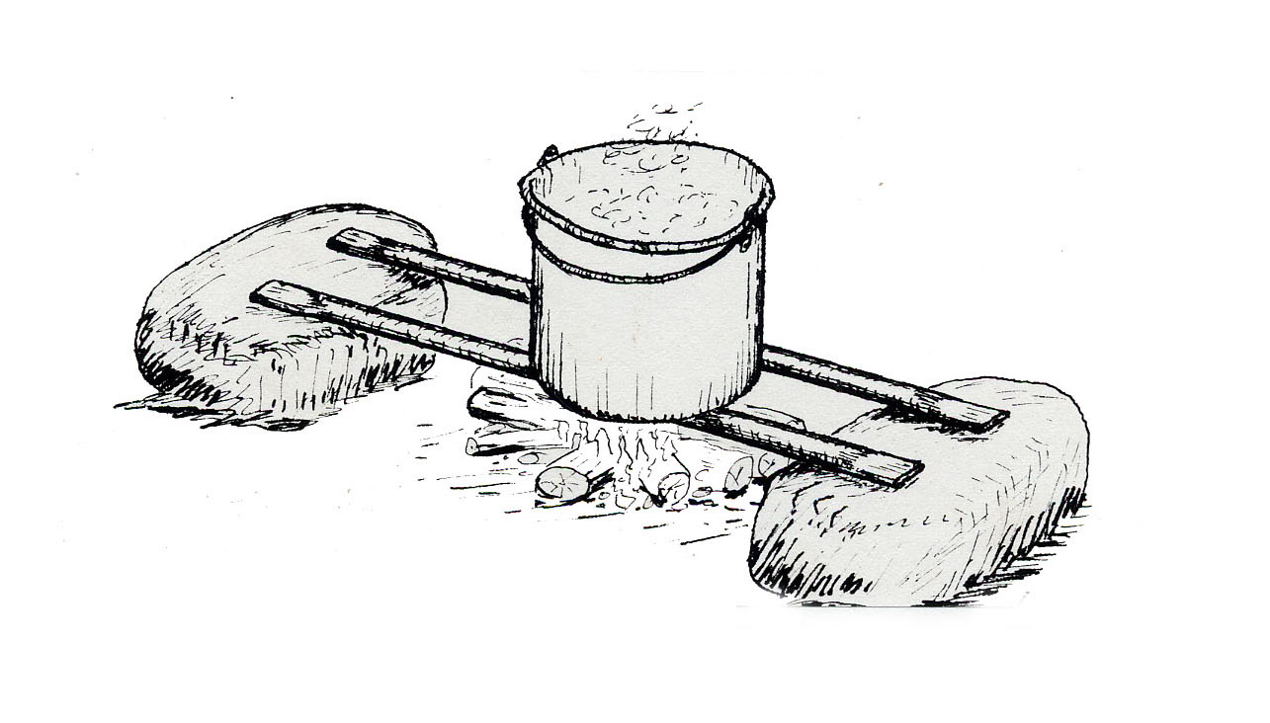

Donna

Donna and I never really expected to meet the two of them again—the "pathetic pair" as Donna referred to them jokingly. The unlikely scene of our unlikely reunion was on the grounds of the DeCordova Sculpture Park and Museum, situated on a scenic hilltop in Boston's western suburbs. It was one of those glorious fall afternoons that we New Englanders must spend the rest of the year patiently waiting for. Donna and I were strolling around checking out the latest "sculptures," but mostly just as an excuse for being outdoors together enjoying the brisk October air.
Donna ran her hand over the welded steel object before us and then cautiously along the jagged edge left by the cutting torch. I asked her what she made of it (as if I didn't already know). She leaned close as though not to be overheard and whispered with a laugh, "Just a piece of junk! Let’s move on to the next."
Just then a young couple came walking over to us, both of them smiling, and the woman said, "You may not recognize us, but we sure know you two.”
I puzzled for a moment, but not Donna, She recognized the woman’s voice and was already laughing. "Oh, how could we ever forget!" she exclaimed. Then it gradually dawned on me who they must be, and I painfully recalled our previous encounter—

I had met Donna six years earlier at the Dana-Farber Cancer Institute, where she had been my wife’s nurse in her final days. She had just recently lost her husband also to cancer. It turned out we had several interests in common, one of which was canoe-camping. For some time we had been discussing the possibility of a wilderness canoe trip in Canada, but our schedules never seemed to mesh. Finally two years ago, we decided it was now or never. Because of a progressive eye condition that Donna was afflicted with, it might be her last chance. Because of her work schedule, it would have to be in early July. I warned her that it would probably be at the peak of the black fly season. She pointed out that she had coped with them enough times in the Maine Woods, and they couldn't be much worse in Quebec. I assured her that they could be and would be. But I knew she was strong in spirit, if not in body. So, the first of July found us chugging along northbound on the good old QNS&L, bound for the headwaters of the Moisie River.
As usual, I ran across old acquaintances among the train crew, and of course I asked them anxiously about the fly season. It turned out that there hadn't been any so far that summer. Too cold. It was so cold when we boarded the train that we both brought along our down jackets, something I couldn't recall ever having done before.
Another matter of some importance to us was the height of the river. As the train emerged from its long tunnel directly onto the bridge over the Moisie River, the spectacular Railroad Trestle Rapids were directly below. At the end of a mile-long heavy rapid, the river piles up against a cliff, makes an abrupt left turn, and passes under the bridge in a rolling boil. It looked higher, browner, and decidedly less inviting that I was accustomed to seeing it, as one might expect this early in the season.
We had thought we would be the first canoeing party of the season, and so were surprised to hear that there had been a party of two on the previous train, three days ahead of us. We did not expect we would overtake the other party, though. Donna is a good companion and steady if not strong paddler, but she would necessarily be taking the portages quite slowly and carefully because she was by this time nearly blind.
Thanks to fresh north winds that felt like they blew right off the polar icecap, we sailed down the headwaters lakes almost effortlessly. Noon of the third day found us having lunch on the first portage, at the cascade below Lac Felix. As we sat on the high bank overlooking the run-out of the rapids, I thought I spied something bright orange in the river. So, when we put in, we ferried across out of curiosity. When I finally managed to snag the mystery object with the T-grip end of my river-running paddle, it proved to be a tent. Thus began a mystery that was to preoccupy our fertile imaginations for the next two weeks, culminating in the most gruesome fiasco that either of us had ever witnessed on a canoe trip.
Good campsites on the upper Moisie are rather scattered, and most parties know where they are either from previous runs or from using one of the published guides. Our fifth camp was at the popular scenic bluff opposite the mouth of the Pekans River. The pair ahead of us had camped there too, and we figured it was probably their fifth camp also. Donna and I had been entertaining ourselves by seeing how much we could deduce about the other pair. So far I had discovered that they were paddling a blue fiberglass canoe which they were also using as a battering ram against numerous rocks. They dragged it bodily over the portage at Rim Canyon. Evidence also suggested it was their tent that I had fished out, as they appeared to be doing without one.
Donna was taking a special interest in their food. At the previous campsite I had found a partially burned foil packet with a label that read more like a confession: "Freeze-dried omelet with imitation ham. Artificial flavor and color. 5 ounces. Serves 2." I couldn't read the label on the latest find, so I handed it to Donna. She took one sniff and said, "Yuk. Freeze-dried imitation raspberry ice cream. Awful stuff! Remember someone had some on the Penobscot last year? What next!"
By this time, our camp routine befitting our platonic relationship had become fairly well established. Donna set up her tiny pup tent, a simple wedge with a pair of poles at both ends, two guys, and a few stakes. I preferred to bed down under a simple shelter tarp. Usually it is hung from a rope between two trees, preferably facing the campfire and a view, or in stormy weather with back to windward and the canoe tucked under the back. At night, the food packs are stuffed under the canoe. In rain, it also serves as the eating and living room. When the trees aren't conveniently situated, other means of support are improvised on the spot using paddles, poles, and rope. I and my bedding have remained dry and comfortable during prolonged wet spells in this veritable reflector oven while some of my companions have been plagued by cumulative dampness and discomfort, depending upon the particular tent design in use. But the big advantage of the lean-to shelter (or Baker tent) is being just a little closer to the wonderful out-of-doors. One suspects that most modern tents are designed (and probably used) by persons who harbor a deep subconscious fear of the out-of-doors and especially nighttime. In high altitude mountaineering, where many of these designs originate, this fear is perhaps well justified, but hardly so in the boreal spruce forests of Quebec. As for insects, on the few times they bother at night I just wear a headnet to bed. But, to get on with our story—
The cool weather continued, and so did the blessed absence of flies. There were a few mosquitoes, but they are seldom a plague in the mountainous terrain of the North Shore region. On our eleventh day, we passed the mouth of the Taoti River and entered the spectacular canyon section of the Moisie. As the scenery changed, so did the weather—drastically! Soon we were basking and bathing in hot sunny weather and paddling in shorts—practically unheard of in this region in July. Where were the black flies, or perhaps more to the point, how soon...?
Our second day in the canyon was even hotter. We spent all morning and early afternoon negotiating the most difficult section, sweating under the blistering sun as we scrambled amongst huge boulders past a stretch of heavy rapids that are sometimes runnable later in the season. By the time we finished, we were both digging frantically in our day packs for our headnets, unused until then. The long anticipated siege had at last begun!
When we reached the scenic campsite opposite the mouth of the Caopacho River, we passed it by because of the flies. I swear I had never seen them so thick, not even in the Barren Grounds. We paddled nearly till dusk and camped on an island. With darkness comes blessed relief from the flies. Our evening meal was by the light of the flickering campfire, the stillness of the night broken only by the gentle sounds of the restless Moisie River lapping the rocky shores of our little island home in the wilderness. One could certainly do worse!
Next morning we were up at the first crack of dawn. There is a short grace period then before the flies get their assault fully organized. When we broke camp at 6 AM the flies were already thick. This day was even hotter than the day before, with sultry winds blowing up from the south and some thunderclouds in the afternoon. Impossible as it seemed, the flies were even thicker than the day before. One could never have imagined them so numerous. At this season, they are also in their most bloodthirsty craze, whereas late in the season they bother more by flying into your eyes and crawling into every opening.
Below the Caopacho, there is a long stretch of the Moisie with easy cruising, with just one portage around Fish Ladder Falls. At the end of the portage, we boiled tea for a light lunch—very light indeed. Beverage could be strained and sipped right through our headnets, but removing them for even a quick bite was unthinkable. The flies were just incredible. Our bodies were completely protected by our clothing. One can travel this way and hardly be bitten at all. It is uncomfortable at first, but one does get used to it and accept it as all part of the game. Also, these phenomenal swarms are usually of short duration. We carried an ample supply of repellent but preferred not to use it on our bare skin except when absolutely necessary. It is toxic, and its effect doesn't last very long.
In mid-afternoon the wind dropped, and the flies became so thick around our heads that I simply could not see well enough for running anything but the mildest of rapids. So we made camp early. Here I had to admit that my no-tent method did have its limitations. An ample screened enclosure for a dining room and lounge would have been most desirable. With time on our hands, it occurred to us to experiment with the orange tent that we had found and carried all this way. Predictably, it proved to be a complicated contraption with springy tubing and elastic cords but, alas, no instructions. Could it have been designed by some M.I.T. engineers during coffee break just as a practical joke? As I fussed and swore, Donna wondered if some of the parts might be missing. Possibly so. Finally we gave up and simply hung the gaudy thing loosely from an overhead line, and crawled inside together with at least a million flies. Before opening our lunch pack, we dispatched our unwelcome guests with a short burst from a spray can of activated pyrethrin. Amazing stuff. In less that a minute the air was cleared, and we enjoyed our late lunch of freshly baked yeast bread, cheese, smoked beefstick, margarine, dried fruit, and nuts.
Next day, the flies were still awesome, but a fresh west wind brought some relief. At the two-mile-long Joseph Rapids, we played it slow and safe, hugging the left shore all the way down. Even so, it was quite an exciting run. At the bottom, I was looking for a good place to beach our canoe and empty out when Donna called out to stop immediately. She said she smelled trouble—literally. Sure enough, on the gravel beach we found signs of a recent camp, but more interesting, evidence of a canoe repair job. Donna had detected the unmistakable noxious odor of fresh polyester resin. I remarked that I hoped they got more resin and fiberglass on their canoe than they left spilled on the beach. It looked like we might soon find out.
The next day, the wind had shifted around to the north, with the usual sprinkles, and the black flies were much diminished. And even more so the following day. We no longer wore our headnets while on the river. With the breeze at our backs and boosted along by a strong current, the scenery whizzed by. Soon the railroad came into view, and we knew the Railroad Trestle Rapids were not far ahead. We made the usual two short portages on the left around chutes and then kept to the right as we approached the main rapids. The left side is impassable because of cliffs along the shore that prevent lining around heavy drops. As the rapids became too violent to run, we began scrambling along the shore and letting the canoe down on its fifty-foot stern tracking line.
I spotted the blue canoe hauled up on rocks a hundred yards ahead at just about the same instant that Donna heard the woman crying, even over the din of the rapids. Proceeding cautiously and apprehensively, finally we arrived upon the dreadful scene. The two were both sitting by a smoldering campfire that had nearly gone out. Both were woefully ill-clothed, with buttoned shirts and loose cuffs. Their clothing was all saturated with fresh blood and caked with dried blood. The woman wore a headnet; the man did not. But hers was the common kind with elastic around the neck, designed for protection from mosquitoes but woefully inadequate against crawling flies. (Donna's and mine tucked in at the neck underneath a tight turtleneck jersey.) The man appeared to be incoherent and almost totally blind; the woman only slightly less so. I will not even attempt to further describe their appalling condition except to say that their badly swollen faces and every bit of their exposed skin looked literally like rare hamburger.
My first-aid courses never included an emergency of this sort, nor did even Donna's medical training. Our one thought was to get them out of there and to a hospital, and soon! Donna and I continued with our outfit, wading and lining down to the big eddy just above the bridge. Then I went back for the blue canoe while the pathetic pair, with Donna's help, groped their way along the shore as best they could. Finally we had everything and everybody assembled at the big eddy, ready to face the last major problem on the river—passing under the bridge.
Donna and I discussed the situation between ourselves. I think we both realized from the start what had to be done, but it was quite an imposition on Donna and perhaps a risk. So I waited until she came out with it herself and indicated her willingness. She would take the woman through in our Big Dipper, and I would follow close behind with the man in their crippled and leaking blue canoe, yelling directions if necessary. We instructed the woman how to squat low in the bow, knees far apart and rear end on the bottom of the canoe—not on the seat. I had the man sitting on the bottom of the blue canoe behind the front thwart, no paddle, both hands on the gunwales.
When we were all set to go, I took the couple's two largest packs, which the woman assured us were watertight, and threw them into the river. Then I launched Donna and her cargo into the swirling eddy and followed close behind with mine. We chased the packs up the eddy and out into the main current to make sure they both went downstream rather than around and around. Then we headed out into the wild waters ourselves.
Readers of my story “Windbound” may recall I have described this notorious rapid as viewed from the bridge. To view it from the canoe is quite another matter. Everything is magnified. The left side would be easy running and lining around the inside of the sharp corner except that there is no practical way to get to it. A ferry across is impossible because a powerful current sweeps across from left to right and fetches up against the right bridge abutment. Actually, the pathetic pair's best strategy might have been to take out a mile above, haul up to the tracks, and wait patiently for the next southbound train, but it probably never occurred to them.
The river flow had been dropping but was still high, running under the bridge at perhaps around 15,000 cubic feet per second. At this level, once you leave the eddy and start down, you have little control over your course. Mainly you just try to keep your canoe upright and pointed downstream. It appears that the current will slam you against the abutment, but usually there is a cushion of rolling and boiling water at the last moment. The reaction is to fend off with your paddle, yet at the same time you are critically aware of the need for constant paddle bracing on both sides. The main hazards are huge boils, cross-currents, whirlpools, and holes that are completely unpredictable and can be rather intimidating. If unlucky, you and your canoe could easily be swallowed by one of them, but I have never known it to happen. In any case, you would wash through all right, but you would likely suffer the indignity of swimming through the next (and last) heavy rapid just below the bridge.
In less time that it has taken to describe, we all careened under the bridge without mishap and headed into the small bay of slower water just above the final rapid. Donna was then right behind, with the woman sitting on the canoe seat! We both pulled in to shore and breathed a great sigh of relief as we emptied out the canoes.
Donna and I lifted and lined the final rapids while the other two resumed their painful way over the boulders along the shore. I then went back for the blue canoe. When we finally had everything and everyone assembled again, we continued as before on down-river and soon recovered the two packs. At the boat landing for Adams Camps, we were lucky to find a family just leaving in their car. Donna tried to explain in snatches of her high school French what the problem was, but there was no need. It was obvious! The family was most concerned and sympathetic. We left the pair in their care, sure that they were in the best of hands, and paddled the remaining ten miles to the Route 138 bridge and the end of another adventuresome trip.

The couple went back over some of the painful details of their misadventure, but actually there was very little that Donna and I hadn't already figured out. They had lost their tent, and very nearly their canoe, while lining down on the wrong side above the first cascade. In their second mishap, they swamped in Joseph Rapids while running full speed ahead, nearly blind and in a state of desperation. There they had banged their canoe pretty badly and the man lost his headnet.
They thanked us profusely for having rescued them. As they started to walk away, Donna asked them, by the way, if they had ever gone canoeing again. They replied most emphatically not, and said they had had nightmares about it ever since. Then the man added, "You can't imagine what it's like to run rapids when you're practically blind!"
Donna smiled and reached out for my arm, guided only by the sound of my voice, and said, "Well, shall we move on to the next." One could detect a note of well deserved pride in her voice as we continued on our way, exploring the mysterious world of modern sculpture.
Honeymoon on the McPhadyen

Starting from an obscure train stop called Eric, our route one summer was down the West Branch of the Magpie River for about sixty miles, then up the Rivière Vital and across a height of land into the headwaters of the Wacouno River, and downstream to the Gulf of St. Lawrence. Like so many of our jaunts, it was just picked off the maps as an interesting looking route through some hopefully wild and scenic country. With the maze of possible canoe routes from which to choose, it is rather like trying to solve a puzzle. Part of the fun is seeing if it turns out to be anything like what you imagined after spending long evenings pouring over maps. Sometimes it does; sometimes not.
A party of eight can be a bit cumbersome on a trip of this sort, especially with some inexperienced members, but our schedule allowed for a moderate pace accordingly. On our sixth day out, we crossed Lac Fournier and ascended a small stream towards the height of land. As our stream gradually grew smaller, short portages up shallows and around beaver dams became more frequent. Here we found traces of old portage trails. At one of these, a strange thing happened.
This particular carry was between two small ponds, or expansions, in the stream. As is so typical in this country, as you approach a watershed crossing, the land becomes flat and marshy. On an overcast day in such terrain, it is easy to become completely disoriented. After completing the portage, seven of us waited for some time at the far end for missing Harry to show up. When he failed to appear, finally Alice went back to look for him. She found him proudly sitting with his pack at the other end of the trail, wondering what was holding us up! Somehow he had become completely turned around on the trail and had gone the wrong way back to the beginning. It took some persuasion on her part to finally convince him of that fact. It was lucky we found him so soon, as he could easily have wandered off on game trails that are often mistaken for portage trails and ended up going in almost any direction to heavens knows where.
Shortly thereafter, there were no more signs of portage trails. It looked like we would be making the carry across the height of land by compass, although from the map we had rather expected at least traces of an old trail at this one obvious connecting route between the two watersheds. The old trails we had seen were probably part of a meandering trap line of many years past and not a main route to anywhere.
In mid-afternoon we came to what was, if our map reading was correct, the portage into the final pond in the chain we had been following upstream. The suggestion was wisely made that we all try to keep together this time. Among my companions on this trip, by far the most experienced in all aspects of wilderness travel were Alice and Gary. They led off, with the others following close behind and myself bringing up the rear. Since the portage was short and followed more or less up the brook, a compass bearing was not necessary.
I have never heard of anyone becoming separated from their party and hopelessly lost on a canoe portage, yet I have always considered it a possibility and something to be guarded against. Not everyone in our party carried map and compass, and even if they did, of what use are they unless one is skilled in their use? These trips are not designed to be orienteering classes, but if they were, some might not pass.
Suppose you are following a blazed trail due west through trackless wilderness and you suddenly find yourself off the trail. You have no idea whether it is north or south of you. Do you walk a calculated distance alternately north and south until you spot a blaze? Keep in mind that when doing this, it is very easy to cross a blazed trail at right angles without seeing it. Then do you go back east hoping to regain the little pond you started from, or do you head west into the unknown? In such circumstances, many persons, even with map and compass, will wander aimlessly. When later asked why they did so, they are apt to answer, "Oh, the compass kept pointing the wrong way," or "Well, it looked more open in the other direction."
All these thoughts were on my mind as I slipped on a log crossing a wet place and went in up to my knees in muskeg. I cut slightly to the right, where the ground was higher and drier, and wondered why Alice and Gary hadn't done likewise. Finally I spotted water farther off to the right and made directly for it. I dumped the canoe off my shoulders and let it fall into a thicket of Labrador tea on the marge of a small bay. My companions were nowhere to be seen. Strange, I thought. They must have strayed off course to the left. I listened for a while. Dead silence. I sat on the canoe and reached into my pocket for a bite of chocolate, but on second thought something told me it might be smarter to get my compass out. When I did so, I discovered to my dismay that I had walked nearly in a circle and was probably at the deadwater we had just portaged out of. I sloshed through a marsh skirting the deadwater until I picked up the footsteps of my companions, which I then followed on the double. I arrived at the end of the short carry sweating profusely, only to find my companions sitting around enjoying a bag of trail snacks while admiring the view. When Harry's partner, Jean, asked me where I'd been, I paused for a moment to catch my breath and muttered, "Oh, just scouting around." I noticed Alice smile at that. I think she could guess!
We paddled across the pond and made camp at the spot where we would start the long portage the next morning. There was no trace of a trail to be found—nothing but unbroken wilderness in every direction. Some of us had rather hoped it would be that way. This was all new to Jean, so as we were sitting around the campfire after dinner, I got the map out to show her and some of the others how we would do it. We would simply take a compass bearing on a small eastern bay of Mule Lake, 300 degrees magnetic, and follow it, marking it as we went along in order that we might return over the same route to pick up our second loads. Harry asked, "Suppose we miss that little bay—what happens then?" Alice and I assured him that we wouldn't miss it.
Soon some of the others joined in and started swapping anecdotes about having been lost themselves, or search and rescue incidents they knew of. I was trying to think of some tactful way to emphasize the importance of staying close together on the portage the next day, but I was spared having to do so by Alice. She asked if anyone had heard the story of the honeymoon couple on the McPhadyen. Gary smiled and expressed his approval as he stoked up the fire, evidently knowing what was coming. Harry put the teapot on to boil, and we drew closer together around the fire as dusk descended on our little encampment in the big wilderness. This was Alice's story, as I remember it:

It was late in the canoeing season a few summers ago. There were two parties on the train, both of them headed for the Moisie River. One party was a foursome of very serious whitewater runners from the Philadelphia area, with their wetsuits, helmets, and all the other usual trappings. The other was a young couple on their honeymoon. Evidently the guy had gone to a summer canoe camp once, but it was her first trip. There was one woman in the Philadelphia party who was especially obnoxious, and when she learned of the couple's plans she shrieked, "What! You're running the Moisie in a (obscenity) Grumman?" Even the stolid miners at the far end of the coach glanced up from their card game in surprise and amusement. She went on: "That's class-three water, for Christ sakes! We're all at least class-three boaters! We're running in roto-molded, cross-linked, air-bagged Mark-Four Chargers! Two of us have done a first descent of a class-three-plus river in Ungava!"
The woman, visibly upset, turned to her man and asked in a southern drawl, "Darling, what class are we?" He tried to act nonchalant and shrugged it off, but after this bantering and ghastly class-three jargon went on for some time, he too was having second thoughts. The upshot of it was that they didn't get off the train at Lac Demille with the Philadelphia frogsuiters but instead continued on to Labrador City, where they hoped to pick up maps and advice for an easier trip somewhere in the vicinity.
By chance, no sooner had they got off the train than they met a bush pilot who talked them into an easy fly-in trip down the McPhadyen River, for which he would also provide a map. Their troubles began almost immediately on the flight in. The plane, an old Norseman, was using too much gas and too much oil; it smoked and smelled. The pilot was nervously shifting his attention back and forth between the map and various gauges. Especially disconcerting was that they were flying in anything but a straight line. When the fuel gauge was down to half, the pilot circled and landed them on a large lake. He explained it was as far as he could take them, but that a short portage into the next lake to the north should put them in the headwaters of the McPhadyen River. Then it would be just an easy downstream cruise to Menihek Lakes and the train stop at Esker. He handed them the map and stuck his finger on where they were supposed to be. Alas, it was a tattered old 1:500,000 aeronautical chart, almost useless for canoeing. His greasy fingerprint covered about ten square miles!
The lake being shallow, the pilot stayed well offshore. The couple loaded up their canoe and paddled to the nearest beach to set up camp while the pilot tinkered with his engine. The woman sat down and wrote a letter to her parents letting them know of the change in plans, while her man climbed to the top of a nearby esker with the map. Pretty soon he came back down and told her that they had better both paddle back out immediately and have a serious talk with the pilot, for he had no idea where they were! Just at that moment, they heard the engine sputter to life in a great cloud of blue smoke, and moments later plane and pilot were fast disappearing to the south.
The distraught couple spent a week just looking for a way out of that lake, exploring one bay after another. They climbed hills looking for other lakes to portage into. The nearest lake was to the west, but they did not dare carry in that direction. If they were anywhere near where they were supposed to be, that lake could be in the Caniapiscau watershed. That would carry them far northward into the vast and forbidding wilderness of the Ungava Peninsula, with no chance of reaching a settlement before their provisions ran out.
Finally they decided to portage into a large lake seen to the northeast and spent a grueling four days doing it. The first part wasn't too bad, but then they ran into extensive string bogs. As they waded across, they had to hold onto the canoe and slide it along to keep from sinking through. Their third camp was in the bog, amidst thick clouds of mosquitoes and no firewood. Finally they had to cut their way through dense spruce thickets to reach the next lake. It took so much out of them, they decided that they must follow waterways from then on.
This lake was even more confusing that the one they had been on, and nothing corresponded with anything on the map. They decided to follow the convoluted shoreline until they found the outlet. The cool days of September brought relief from the black flies, but storms were more frequent, and they were windbound for days at a time. After a week of tough paddling, they suddenly found themselves back where they had started. They had simply circumnavigated a huge island! By this time they were thoroughly discouraged and nearly out of food. Finally they found a passage leading to another large lake to the east, so eastward they paddled, hopefully towards the railroad track, but now on empty stomachs and suffering from the cold.
They explored this way and that looking for a route out of the lake they were on. From the start they had not seen any sign of human passage. A few planes were seen or heard, but usually far off. Sometimes in the evening they thought they heard distant voices, but they were probably just loons calling. One cold, clear night they heard a far off eerie sound that might have been wolves. Whatever it was, the poor woman's nerves were now at their limit. After they set up camp, she would not even leave the tent unless absolutely necessary.
One evening, they camped at the base of a high bare hill in an old burn, so that her man might climb it and look off. When he returned at dusk he was very excited. He told her he had seen a long bay leading eastward, and at the far end of that bay was a building, with a line of telephone poles just beyond which would probably indicate the railroad track! Oh, they were so happy! To celebrate, they had the last morsel of wedding cake they had been saving for some special occasion, together with their last teabag.
Next morning was cloudy and bitterly cold, with a piercing October wind whipping down from the north. With their last remaining bit of strength, they fought their way around a point of land and headed into the long bay. And sure enough, there way off in the distance was not just one but several buildings along the shore with the line of poles behind. They both crouched low because of the bitter wind, the woman burying her head behind the bow deck and the man looking up only occasionally to steer as they slowly made their painful way down the bay. Suddenly the man stopped paddling. The woman sensed it and looked up. Not a word was said as the two of them stared in utter despair at a few boulders strewn along the barren shore and a ridge of burned spruce trunks silhouetted against the somber sky. Grief-stricken, the woman put her paddle down and sobbed. The wind drove them quickly to shore in a barren area left by an old burn, and they landed in a blinding snowstorm. As soon as their tent was up, they hauled the canoe up and tied it down next to the tent for whatever little protection from the wind it might give. They knew they would be paddling no more. Weakened by starvation, nearly frozen and totally discouraged, they crawled into their sleeping bag and hugged each other tightly for whatever warmth and comfort they could offer to each other as the blizzard intensified on into the dreadful night. And that is how they spent the rest of their honeymoon.

We sat there quietly for a while staring into the glowing embers of the dying fire. There was a definite chill in the air. Gary threw an armful of small tinder on the fire to provide some light for finding our way about and putting things away for the night. As Harry got up, he asked in a rather subdued tone of voice the question that was on everyone’s mind: were they eventually rescued? Alice replied, “Oh no. In fact, never even found.”
As Harry and Jean started off towards their tent, Jean hesitated for a moment and then asked, "But wait a minute, Alice, then how did you know all those details?"
Alice was still staring at the fire, and she paused a moment before she replied. "Oh well, just a woman’s intuition I suppose." And as she said that, she glanced at me, and I detected a smile and a slight wink of her eye in the flickering firelight.

The next day, we made the portage into the eastern bay of Mule Lake with no trouble whatsoever. Alice went first with map and compass, Gary second with the axe, and the rest of us followed close behind. Very close indeed!

Getting Even

Ross McLean glanced glumly at the camp logbook and then flipped it shut. "Worst season ever," he mumbled to himself as he packed it away for the winter in a mouse-proof tin box, along with some other papers, and set it on a high shelf. If the fishing didn't improve next year, he might have to close the camp. He stared pensively out the window at the play of the wind gusts on the surface of the lake, the ever changing patterns shimmering in the late afternoon sun. Then he glanced upward at the faded old photo on the wall, which showed himself with two guests of his camp in bygone days, each man holding a trophy sized salmon. He was smiling when that photo was taken, but there hadn't been much to smile about lately. Where had all the salmon gone? Mac thought he knew at least part of the answer.
The last few times he had flown over the Lower Gorge he had noticed some activity there, and he was pretty sure that it was old Tuk-tu and his various family members netting fish. They weren't supposed to be fishing there at all. Those were leased waters, and the fishing rights belonged to his fishing camp. At least that was Mac's understanding of the situation.
Tuk-tu, a notorious poacher, was one of the few Inuit on that part of the Labrador coast still living almost entirely off the land, and Mac at least gave him credit for that. The regulations governing just where the native peoples might or might not hunt and fish were somewhat vague and an ongoing issue of contention. Not that it would have made any difference. Tuk-tu lived by the same simple rules of survival that his ancestors had lived by for countless generations, long before Mac's people had arrived in the New World. Mac had clearly posted the boundary of his domain in both English and Inuit. Sly old Tuk-tu conveyed the impression of understanding neither, but no doubt he understood well enough.
The longer Mac thought about it the angrier he became, and a plan began to take shape in his troubled mind. When he closed up camp tomorrow, instead of flying out on the weekly shuttle plane directly from camp, he would canoe down to the settlement on the coast and be picked up there. And on his way down, he would surprise Tuk-tu and teach him a lesson that he would not soon forget.

Mac reached over and switched on his ancient single side band radio to notify the dispatcher at Nain of his change of plans. All he was able to hear was static, which didn't surprise him too much because the northern lights had been especially brilliant the past two nights. One of these days he vowed to treat the camp to a modern satellite phone, if only he could see some future for his business. He finally did manage an intelligible exchange with the RCMP way up at Fort Chimo, of all places, but of course without mentioning the reason for his change of plans. They promised to relay his message back down to Nain.
Mac started putting together a trail kit—food for two days, teapot, matches, axe, wool blanket, and a few other incidentals. But the most essential item would be his Winchester. A few rounds through the side of Tuk-tu's tent should certainly serve to get the point across. He hesitated for a moment, then put the carbine back and hefted his trusty old Mannlicher 1903 Sporter out of its case on the wall. It would add a bit to the load, but the extra dramatic effect would be well worth it. He hadn't fired it in years, not since his camp had also been used for hunting, and now it was kept around mostly as a conversation piece. He had acquired it many years ago from a trader at Seven Islands in exchange for a silver fox pelt. A guest at the camp who was a gun collector of sorts had once offered Mac two thousand dollars for it. If it were to be offered again, perhaps he would take it the next time.
Mac slid a hefty 8 x 56 cartridge into the magazine and stepped out onto the porch to check the sights. He set the range for 125 yards, one click left for the wind, and took aim at an empty can far down the beach. BAMM! As he staggered from the recoil, he saw the can jump in the sand even though he missed it by a foot. "Close enough," he muttered, as the report echoed back and forth across the valley and gradually faded away.
Early next morning, Mac closed up the camp and started to launch his seventeen-foot Chestnut Prospector. As he did so, he noticed that a thin rim of ice had formed along the shore during the night and crunched under his feet. A flock of geese honked overhead as they headed south. Good time for him to be moving out too, he mused. He was shivering even with his heavy wool hunting jacket, pants, and hat. But his main concern was the wind, already whipping the lake into whitecaps and likely to increase during the day. With its extra depth, the Prospector would provide a margin of safety in running rapids that might otherwise have to be portaged. But he wondered if he had the strength to paddle cross-wind to the outlet, not to mention controlling the big canoe on the river. And so he then made the fateful decision to haul the Prospector back to the shed and reload everything into his little sixteen-foot Peterborough.
When he finally reached the foot of the lake, the wind became more from behind, which made the going a little easier. The high water from recent rains afforded a fast run down river. Towards noon, rounding a bend in the river, Mac glimpsed telltale patches of white periodically rising and sinking from view far downstream, which told him he was coming to Saunders Ledge and his first carry. He approached more cautiously than usual because of the wind gusts, landing a bit upstream and letting the canoe down the last bit to the ledge using the stern tracking line. The ancient portage trail, now barely visible, meandered through the undergrowth of arctic willow and stunted spruce for 100 yards until it emerged on the smooth bare granite near the foot of the pitch. It was seldom used any more and was now largely overgrown with Labrador tea or "tanglefoot," as some of his friends used to call it.
Mac managed to carry all his gear over in one load and then went back for the canoe. As he staggered over the loose rock near shore, the Peterborough seemed to be heavier than usual. It hadn't been used for weeks and should have been fairly well dried out, so what would account for the extra weight? But then, everything had seemed a little heavier than usual lately. Yes, this does happen when you are approaching seventy years, especially if you haven't been doing as much strenuous travel in the bush as you used to. He vowed to keep in better condition in the future. "But what future?" he lamented.
Mac selected a sheltered spot for lunch. The plentiful supply of twigs washed up on the shore served for fuel, and soon the teapot was boiling. He hadn't been down this way by canoe for several years, and probably no one else had either. In the old days this was the only way to and from camp. But now everyone and everything came by bush plane. Around Goose Bay, it was said there were now more men who knew how to fly an airplane than paddle a canoe. People just didn't have the time any more. Everything had to be done faster. As he thought it over while staring out at the river and sipping his tea, oh how Mac longed for the more leisurely pace of times past, way back in the 50s when his first camp was just a wall tent. Ah yes, those were the days. But alas, what the hell was the use of thinking about the past? He loaded up, pushed off into the big eddy below the ledge, and grimly resumed his vengeful mission against what he perceived to be the forces of evil.
The weather had been overcast and cool from the start, but now dark clouds were blowing in from the west and bringing with them scattered showers. Mac wasn't too surprised when some of them turned into snow squalls, the first of the season. But what annoyed him most was that they seemed to be always blowing directly into his face, even though the weather should have been coming from behind. For the canoeist, the natural perversity of wind and weather is something never to be completely understood. In mid afternoon the hills started crowding in on both sides and Mac headed for a campsite that he remembered from times past. Dusk would come early here this time of year, especially in the shadows of the steep spruce covered hills and with the skies heavily overcast.
At first he was undecided about building a fire. With the wind in the direction that it was, he was concerned about tipping off "the enemy" with the smell of smoke before he could actually catch Tuk-tu and perhaps others in the act. But the cold and dampness soon settled the matter in favor of a small fire using the driest standing spruce that he could find. Bread, summer sausage, dried fruit, and tea made up the Spartan supper. With the upturned canoe reflecting the rays of the fire into his bed, Mac was able to keep reasonably dry and sufficiently warm, provided he tossed another log onto the fire every hour or two. That was easily done because Mac lay fitfully awake for most of the night nursing aching muscles, while trying to come up with a diabolical plan of action for tomorrow.
Suppose he were to take out Tuk-tu once and for all with one well placed shot? But this was only a fantasy. He wouldn't actually do anything like that. Mac considered himself to be a devout Christian, and he wouldn't intentionally harm anyone. Of course there was the time when some items were stolen from his old hunting camp up on the Ashuanipi River and he caught two Indian boys suspected of being involved. He had given them a—ah, but why go into that touchy subject again? It all happened so long ago. As for the Inuit, most of them were supposed to have been converted to Christianity by the Moravian missionaries in times past, but Mac sometimes wondered just how thorough and permanent that conversion had been. Those like Tuk-tu had evidently reverted to their old ways and pagan beliefs. Many troubling thoughts kept circulating in Mac's mind until shortly before daybreak, when a few hours of dozing off finally brought momentary relief.
Mac was glad when it grew light enough for him to break camp and continue on his way. The weather was showing signs of changing. Cold blasts of air out of the north felt like they were coming right off the Arctic icecap, and each passing cloud sent down swirls of snowflakes that sometimes limited visibility. Managing the canoe under these conditions was taxing on both his strength and nerves. His reserves were not what they used to be. To make matters worse, his hands were frozen stiff and he was having trouble holding the paddle. Whenever possible, he would rudder the canoe with one hand on the paddle while he tried to warm the other hand in his coat pocket.
Soon he found himself entering a set of strong rapids that he knew to be just above the entrance of the Lower Gorge. This was no place to take chances. The loss of a canoe up here, with the nearest human habitation far distant at this time of year, could have very serious consequences. Nearest humans? Blinded by his rage, he refused to place Tuk-tu and his kind in that category.
Playing the rapids cautiously, he ran close to the left shore. A perverse headwind kept turning the canoe broadside to the current. He hitched forward until he was kneeling with his legs up against the center thwart, but he still had trouble keeping the bow headed downstream. His arms were tiring. If only the wind would let up, but instead it increased, blowing off the Labrador Sea and straight up the gorge. Then in a moment of carelessness the canoe was caught and held in a back curler, and he took on a few inches of water. With the extra weight, Mac now found himself at the mercy of the current, running too fast and much farther from shore than he might have wished, taking on a bit more water with every wave. Oh for the Prospector now. He knew he was in trouble. With all his remaining strength, he plowed into the big eddy that marked the start of the portage. As he did so, the canoe rolled over, dumping him and all its contents into waist-deep frigid water.
After years of living and traveling in the bush, this was certainly not the first time Mac had found himself in a serious predicament. Being one to not panic easily under such circumstances, he proceeded with methodical haste to hold his paddle with one hand and grab onto the stern tracking line of the canoe with the other. But the pull of fast water on a swamped canoe is a force to be reckoned with, and he soon found himself being pulled into deeper water. Swimming was out of the question, especially with the heavy box of rifle shells in his coat pocket. Reluctantly he was forced to let the canoe go, and he watched in utter despair as it slowly circled the eddy, gathered momentum, and then plunged into the thundering gorge and out of sight.
All of Mac's plans and thoughts now changed abruptly. His whole desperate object became one of survival. In the excitement he had been able to momentarily ignore the cold, but he knew that it would soon return with a vengeance. He also knew that no one would start looking for him for at least another day, and that his very survival even until then would probably depend upon his ability to start a fire. His matches and axe were gone. He still had a knife and the box of shells, but nothing else. As for the gun, he soon spotted it lying in what appeared to be chest-deep water about ten yards from shore. He remembered his father once telling that it was possible to start a fire in an emergency by firing point blank into tinder, but he had never actually seen it done and wasn't sure of the details. The nearest thing to tinder he could think of was his wool hat, and he doubted that would work. Still, with few other options, he decided to concentrate on retrieving the gun.
When he waded out, the water proved to be deeper that he had judged. He was still relatively dry from the waist up and was reluctant to plunge in after it. Should he take off his clothes? No, first he would try snagging it with a pole. He must have spent half an hour cutting a pole with his knife, wading out and prying at the gun. But it was stuck among the rocks and refused to budge. He had just about given up when he looked up and beheld the old rascal himself, Tuk-tu, standing on the shore and staring down at him.
Mac waded meekly to shore and pointed at the gun. But there was no need. Tuk-tu had already spotted it and plunged right in after it like an otter. He knew a good gun when he saw one, even when it was underwater. In an instant he came up with it, and thrusting it triumphantly overhead, with his wide toothless grin he scrambled excitedly back to shore. The two of them then headed silently down the portage trail, Mac with his paddle and Tuk-tu with the "elephant gun." When they arrived at the campsite, Tuk-tu's wife Rosie was already heaping more wood on the fire, and both men stood close by for some time to thaw out and dry off.
Tuk-tu then proceeded to dismantle the Mannlicher and Lyman scope in order to thoroughly dry them, and Mac was impressed by the deftness of his work. Evidently the old hunter knew his firearms well. Meanwhile Rosie quietly served up pot after pot of tea, together with a bit of roasted seal meat and arctic char, which evidently was all they had. Mac found himself in a most awkward situation, made all the worse by the language barrier. Then, to his complete surprise, Rosie said in perfectly clear English, "By the way, Mister Mac, your canoe is down on the beach." Even Tuk-tu himself then added a few words of explanation in broken English. Evidently they had smelled his campfire of the night before. And then, while they were down at the foot of the gorge trying unsuccessfully to catch some fish, they had seen his canoe come floating by and had rescued it, practically undamaged.
Mac now had a sudden urge to leave as quickly possible. It was getting late and he wanted to catch the outgoing tide that would boost him along toward Hopedale. Even so, he might arrive well after sunset, but that should not be much of a problem. He had done it a few times in the past by just aiming for the lights at the settlement. But more to the point, he felt uneasy and just wanted to get out of there. No need to explain why.
After a handshake with Tuk-tu and a farewell wave to Rosie, who was now off picking cranberries, Mac headed down the portage trail carrying his paddle and gun. His legs were still a bit stiff from his ordeal, but by the time he reached the beach there was a little bounce in his walk that had not been there in a long time, for he had an inspiration, or perhaps we should call it an epiphany. Tuk-tu's big freight canoe with outboard was hauled up on the beach nearby. Before launching his canoe, Mac tucked the Mannlicher and the box of shells under a tarp in Tuk-tu's boat. He then paddled away with a feeling of energy that had been lacking before, and never looked back.

Betty's Canoe

To my pleasure and complete surprise, Betty stopped by my shop one day seeking some advice and encouragement on making a canoe. I had not seen her since our chance encounter on the Dumoine River the previous summer. It seems that on that outing she had become thoroughly disenchanted with the cult's obsessive class-three jargon and hi-tech trappings, and she longed to get back into traditional canoeing once again. Evidently Ed's wood and canvas Prospector had especially caught her fancy. But she wanted a canoe just large enough for tripping tandem yet light enough that she could portage comfortably, which I took to mean about seventeen feet and not much over fifty pounds.
She had already accumulated a small library of books and magazine articles on the subject, had talked to a few other canoe builders, and had looked at some of their products. Most of them had told her that her ambitions and expectations were not realistic because of the exotic technology involved in modern canoe construction. Others had advised her to forget about "obsolete" ribbed construction and instead make a modern wood strip canoe or, still better, buy one of theirs made by "experienced expert craftsmen." Why, she wanted to know, must traditional ribbed construction be inherently heavy and inferior? I told her I too had been wondering that. How about conventional rib and plank construction, like a traditional canoe but much lighter, with an outside skin of Kevlar and epoxy, rather more like a stripper? As for making it herself, why not? Betty is a person with fierce determination and many talents. I told her that if she could make her own dulcimer, which she had in fact done, then she could certainly make her own canoe. I had some doubts about working space in my shop, but she said she had already arranged with friends in Concord to use their barn over the winter.
Betty and I spent some pleasant weekends together that fall looking at various canoes and trying out some of them on local waters. We finally found an old seventeen-foot E. M. White that suited her notions of what size and shape a canoe should be, so we took some measurements from it and made a few slight changes to suit her particular requirements. The next step was to make a male form. Betty insisted on doing all of the actual woodworking on the canoe herself, but she agreed to let me help with the form, as I had ideas of perhaps using it myself later. I told her that ordinarily the form for a ribbed canoe is quite a major undertaking, because for one thing it is steel-clad to crimp the points of the tacks used to hold the planking to the ribs. I suggested that she use epoxy glue and staples in place of tacks, the staples to be removed later as with a stripper. This she did, and it simplified things considerably.
For the ribs, Betty located a supplier of good air-dried native white cedar in Jackman, Maine. When we visited his shop, he interrupted his work for several hours to show us around his own canoe works, in the course of which we picked up many useful tips. Also to his credit, he strongly encouraged Betty to make her own canoe. "Of course you can do it," he told her, “and there's a satisfaction in tripping with equipment made by your own hand that persons who use factory-made products can never experience." Betty already knew that.
For the planking, I had some full-length boards of marine-grade Sitka spruce gunwale stock that we re-sawed on my ancient Crescent 20-inch band saw. As with the ribs, Betty insisted on making them thinner than recommended by any of the published manuals, with the thickness varying continuously throughout the hull depending upon the requirements for strength and rigidity. After that, I did not follow the progress of the project very closely. I had my own shop work to do. Betty's intention was to finish the canoe over the winter, try it out in the spring, and then take it on a summer trip in the Canadian wilderness. But things went rather slowly. The barn was not heated. Mostly though, she kept running low on money and had to scout around for odd jobs. Betty's main occupation was teaching violin, mostly to children. The one advantage it had was that summer was the slack season. She also played the organ for church and weddings.
It was not until the following summer that all the planking was finally on and sanded down as carefully as one would finish a piece of fine sculpture. We then waited for a spell of dry, sunny weather. Early one morning in late summer while it was still cool, we stretched one layer of three-ounce Kevlar over the outside, with a second layer underneath it below the waterline, and applied slightly thickened epoxy resin using auto body squeegees. When partially set, we applied a thin second coating to completely fill the weave of the cloth, and then left it in the warm sun all day to cure. After a light sanding the following day, it was ready to remove from the form.
All of this innovation was not exactly a trial shot in the dark. Occasionally I had been called upon to re-cover an old wooden canoe. I did it more as a hobby than a business. I usually used S-glass but sometimes Kevlar. The usual advice of traditional canoe builders is to always use canvas, claiming that fiberglass is weaker and heavier. I had found that to be not the case, unless possibly they were comparing the best canvas covering with a slipshod plastering of ordinary fiberglass and cheap polyester boat resin. My re-covered wooden canoes averaged about five pounds lighter than they were before and were stronger too. Old hulls with weak planking have been restored in this manner to many more years of useful service when otherwise they would have been beyond salvation.
Betty had kept careful track of all the materials used and their weight, so we were not too surprised when the hull weighed in at a scant forty pounds. With spruce gunwales, thwarts, and yoke, I told her that it should weigh about fifty-four pounds finished. She labored for many weeks more on the seats, decks, and all the other painstaking details. At my suggestion, she used all stainless steel fasteners rather than the traditional but weaker brass. She did not care for the showy clear wood exterior finish so characteristic of strippers, so she sprayed it with two coats of dark green Imron urethane automotive paint.
All during these final stages, I was never allowed to see Betty's proud masterpiece, as she wanted to surprise me with it when it was done. Finally, after nearly a year of intense and painstaking labor on her part, the big day came. The plan was to paddle out to one of the Boston Harbor islands for a picnic lunch. Betty told me that her former canoeing associates scorned such places because they were all "flatwater." Having so many times enjoyed the exhilaration and met the demanding challenge of tidal rips and whitecaps, one can only wonder what might be their definition of "flat!" We hoped to get at least to Peddocks Island and perhaps all the way out to Great Brewster if we were lucky with the weather. Since Betty had an errand in town and I had one elsewhere, we planned to meet at Hewitt's Cove.
Here I should mention that Betty and I had by this time spent many a pleasant weekend together, canoeing or sometimes hiking, and we had a little game going between us. On every outing, we would each bring some choice selection of music on cassette to share with each other, either on the car stereo or sometimes on her little weatherproof Walkman. This time, I had brought highlights from HMS Pinafore, which I thought more suitable for the christening of her “saucy ship” than the traditional bottle of whatever it is they use.
Well after the appointed time, Betty finally pulled into the parking lot, but alas with empty canoe rack and the look of grief in her eyes. What tragedy could have befallen her baby? She explained that she had parked in South Boston to pick up some sheet music for one of her students, and when she returned only moments later her beloved canoe was gone! The police didn’t have a clue.
What could I say or do? We drove in my car out to Pemberton Point and parked on the beach with a view of the outer islands and the open ocean beyond. "Well, you were just about right," Betty choked out. "Exactly fifty-three pounds. I only hope that whoever got it takes good care of it. It was a good canoe."
And with that, she buried her face on my shoulder and cried her poor heart out. I reached over, popped the Gilbert & Sullivan out of the stereo, and put in Bach instead. Then the two of us just sat there, Betty sobbing and I staring blurry-eyed at the vast ocean and the clouds, deriving whatever comfort we could from the unearthly plaintive strains of the great final chorus from the St. Matthew Passion, “In tears of grief we leave thee.”

Betty and I went canoeing on nearby waterways often that fall. Although she never mentioned it, I could tell she was always on the lookout for her canoe. I had gone through the same futile search once a long time ago, looking all over Cambridge for my stolen bicycle, even though the chances of ever finding it were practically nil. By the following season, Betty had pretty well gotten over the matter, and I was relieved to note that she no longer kept her canoe rack on her car.
One afternoon in late summer, while paddling lazily up the Sudbury River, we finally broached the subject of starting another canoe and what changes we might make. Actually there was very little we would change. That settled, we just paddled along quietly for a while. I stared at Betty's auburn curls glistening in the late afternoon sunlight, and then at her partly hidden shoulders. Betty is rather small and slight of build, but she has the well developed shoulders of a strong paddler. My canoeing buddy Ed says that shoulders are the most important part to check out in choosing a partner. He swears that he could easily pick out his well-built paddling companion Sally from among a crowd of a thousand naked women by looking at just shoulders alone. Knowing Ed, he is probably right, although I'm not sure I could do that.
Suddenly Betty caught me by surprise as she leaned out and bent her paddle in a resolute draw stroke U-turn of the sort you see Mike Galt's partners doing on the cover of Canoe Magazine. We had just passed a cove, at the far end of which were two guys fishing from a canoe. Just one look at her eyes and I didn't have to ask what was on her mind! As soon as they saw us turn, they took in their lines and started paddling downstream, that is if their haphazard motions could be called paddling.
Betty churned the water with her paddle like a molting goose trying to take off, and my every instinct urged me to do the same. But when we observed how ineptly they paddled, I slacked off with my stroke; and after speaking rather sharply to Betty, I finally got her to slow down too. I knew it was hard for her, but we had to plan our strategy. There was no practical place to land a canoe for the next mile, the shallows on both sides of the river being choked with impenetrable thickets of speckled alder. We could overtake them easily at any time.
I told Betty it wouldn’t surprise me if they were both armed with knives, at the very least, and that I valued my intestines even more than her canoe. We would take them on only in deep water, or not at all. That was the only place where we had an advantage, and perhaps a slim one at that. She agreed reluctantly. Our plan was to always keep our bow aimed at their mid-ships and to keep them broadside to us. They were both big guys, sitting of course, and I figured it wouldn't take much to dump them out.
Gradually we closed in on them. As I observed their increasingly erratic paddling, the boy in the stern appeared to be especially clumsy, so I was more concerned about the one in the bow. They kept running into the alders. We had to wait patiently until they finally blundered into midstream. Then we moved in for the kill. Just as we were about to hit them broadside, the guy in the bow made a fatal blunder. As Betty leaned way forward to grab onto their gunwale, he suddenly jumped up into a crouch and swung his paddle at her, cracking the blade cleanly in two over her head. She recoiled for just an instant. Then, with a stream of blood trickling down her face, she lunged for their gunwale and gave it a tremendous yank. This was accompanied by a string of shocking obscenities, the likes of which I had never heard her use before. Wow, was she ever charged up! I think they were about to tip over anyways, but she made sure of it and in they both went. When one of them came back up to the surface, he grabbed for the partially filled canoe as though to climb back in. In the next instant, Betty had scrambled over into her canoe and was jabbing him in the face with her paddle. She followed that up with still more unmentionable obscenities as both of them then turned and swam toward shore.
We emptied the water out of her canoe by lifting it crosswise over my own. Betty then proceeded to paddle triumphantly downstream, back to the Lincoln canoe landing where our car was parked. The two boys were both wearing heavy black leather jackets but no life jackets, and so I held back just long enough to make sure that they both reached shore safely, much to Betty's chagrin. If she had had a lethal weapon at that moment, I think she might have been inclined to put both of them out of their misery. When last seen, they were struggling through the alder tangles, where we expect they spent much of the remainder of the afternoon before reaching dry ground.
When we got back to the landing, we lashed the two canoes onto my rack as best we could, tipped side by side, and drove slowly homeward. We pulled off at the Great Meadows parking area for a snack stop, and I tried to wipe some of the blood off Betty's face and lovely shoulders. She remarked that her canoe appeared to be in surprisingly good shape except for some gouges in the gunwales, one of which we probably put in ourselves when we rammed them. I told her most of them could easily be sanded out, which pleased her. She even wondered if we should go back to make sure the two boys were all right, but I assured her they were.
"Well, Betty," I said, "I didn't really expect you'd ever get it back, but just in case we ever did find it, I've been saving this for the occasion." And with that I popped the cassette into the stereo and turned up the volume.
"Aha," she exclaimed, "how appropriate!" She looked up proudly at her canoe to the triumphant strains of "See the conquering hero comes." What a sight she was! Between disheveled hair and wet, blood-spattered sweatshirt beamed the happiest grin I had seen from her in a long time. We sat there for a while just listening to the Handel and gazing out across the Great Meadows, with the late afternoon sun sinking in the western sky. Then Betty shifted her gaze to northward and cried out, "Labrador, here we come!"
As we pulled out of the parking lot, Betty pushed the rewind button and said, "Let's play it again. Even louder this time."

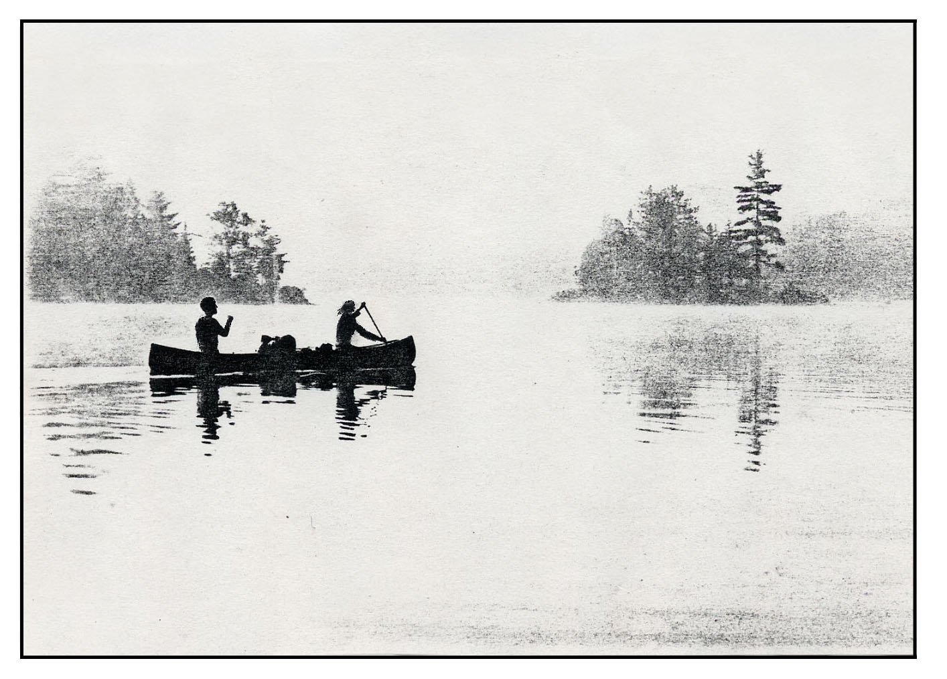
Faint and Forgotten

Dear Ed,
Merry Christmas! What have you been up to these days? Didn't get out much myself last year. Back still bothers a little. Not much energy either. Don't believe I ever completely recovered from that bout with giardia. Think the best cure would be another good trip. Next August perhaps?
By the way, do you realize that as of next summer, twenty years will have passed since that memorable lunch stop of ours at the mouth of the Caopacho, when we dreamed of someday retracing the old Indian route from Ashuanipi to the North Shore? Yet it was one trip we never did. What do you think?
Sincerely,
Sally

Dear Sally,
Happy New Year to you! Haven't been very active myself lately either. Knees bother a bit now; also likewise aching back. Another good trip would surely cure all. By the way, have you noticed that every letter we get now from old tripping companions starts off with a listing of their various physical infirmities?
Old Indian route? Yes, of course I remember. Let's do it!
Sincerely,
Ed

And so it was that Ed and Sally stepped off the train at Oreway in mid-afternoon, on the verge of suffocating from all that cigarette smoke, but soon to be revived by blasts of cold air out of the north that churned the lake into whitecaps. The train ride was not as entertaining as they had remembered from times past. All the train workmen were unfamiliar to them, and none of them seemed much interested in chatting about anything to do with the out-of-doors. From Ed’s perspective at least, the whole operation appeared to be in a state of chronic decline.
The lake was too rough to put in, so they relaxed on the shore in the abundant fresh air to finally enjoy a late lunch. Neither of them had bothered with a timepiece on this trip. As Ed would always say, who needs one up here anyway? Soon the clickity-clack of the train faded away in the distance and the only sound was of the wind and the surf.
From where they were sitting, Ashuanipi Lake was 20 miles across and 35 miles to its northern tip. One never sees but a small part of it, so complicated is its shape, with countless bays, interconnected arms, and islands large and small. In some directions, the unobstructed view of open water vanishes over the horizon—a sight to stir the imagination of any canoe-tripper. If only there were no maps, and one could but wonder what lay beyond. But alas, that can never be any more.
Ed remarked to Sally that as many times as he had set out on a trip in his beloved Black Spruce Country, he could never fail to be moved by this magic moment of departure. Somewhere beyond those islands and headlands was a passage that would lead them out of the lake and into mysterious lands (quoting Kipling) “beyond the passes of the north.” He found it inspiriting to imagine they were exploring new country, even though they knew in their heart that sometime in the dim and distant past every lake or stream had seen paddles dipped into its waters, snowshoe tracks made upon its frozen surface, or moccasin footprints pressed into caribou moss along its shores.
In late afternoon, the wind abated enough for them to paddle three miles due west to make camp on a pretty little island, sparsely wooded over solid bedrock. As usual, the ever-resourceful Sally kept a daily log of the trip. Later she expanded her notes into a story of the trip, and this is her story:

(August 14) This morning was overcast and cool with light winds, a perfect sort of day for lake paddling. My compass was fastened on top of the bow deck, and I watched it closely as we headed for the secluded passageway into the Kapitagas Channel. We couldn't imagine doing this section of our route without a map, but what fun it would be to try (provided one had all summer in which to do it!). We camped in the Channel at another beautiful site.

(August 15) We made two short portages at little waterfalls and then waded up a mile or two of shallow riffles to reach the placid headwaters. Our camp was on a scenic open bluff overlooking Lac aux Cypres. The sites get better every day. Dinner was spaghetti, one of our favorites, with chopped fresh onions, garden-fresh tomatoes, and summer sausage.

(August 16) We had been told by a friend, who went over this route in the opposite direction in 1930 all the way to North West River, that the old trail went out of the south end of Lac a la Marie. We found it badly flooded by beaver, so we pioneered an alternate route one mile west by compass into Fat Fish Lake. This carried us over the divide from Labrador into North Shore waters. We found Fat Fish Lake to have densely wooded shores not conducive to camping, but we finally brushed out a satisfactory site at the north end of an island in the middle of the lake. If it had any fat fish, we could not catch them.

(August 17) A shallow channel led us into Caopacho Lake. We paddled several miles down the lake, fighting wind and waves all the way. After rounding the elbow in this very attractive lake, we were stopped by stiff headwinds, so we camped early at the mouth of a brook. So here we are, six days into our trip, and still no indications of an old Indian route. It would be nice to find at least some artifact for the sake of nostalgia, not to mention the more practical consideration of a portage trail around the impassable canyon that we know lurks ahead.

(August 18) We paddled to the end of Caopacho Lake and then through a chain of ponds connected by a stream with good current, making one short portage around a heavy rapid. Our campsite was the best yet, on top of an esker overlooking a small lake. The country here seems to be all eskers, with good campsites everywhere. The bread we brought with us has run out, so we baked two loaves of yeast bread in the reflector for our next two lunches.

(August 19) After paddling through a few more expansions, we came to a fairly strong rapid. As we drifted to within a hundred yards of it, Ed suggested I stop paddling forward. It is a habit I have found hard to break. I learned to canoe at a camp in Maine and was taught, incorrectly it seems, to always paddle ahead. Except for that, we team up well. Certainly plenty of practice. I can usually tell by the way Ed rudders slightly to the right or left what route he has in mind. It’s better than calling out directions, especially in the wilderness. The course Ed chose was unobstructed, so what few steering strokes we made were to avoid taking on water.
The next rapid was a bit more challenging. If runnable at all, I thought the right side looked better, so I nudged the bow that way, but no reinforcement from Ed, so I knew he was thinking otherwise. As we reached the point where a decision had to be made, Ed turned us sharp left, so I knew that meant bow upstream ferry to land. He figured there might be a portage trail on the left, and as usual he was right. So here at last was some sign of the old Indian route, faint and forgotten, but clearly an old trail.
In the next few miles, the terrain began to change. As we approached the canyon of the Moisie River, the Caopacho began carving out a smaller canyon of its own. The valley became narrower and the banks steeper and densely wooded. Good campsites became harder to find. This afternoon we brushed one out. You can make yourself comfortable just about anywhere in this country if you've a mind to. These creative campsites, as we think of them, can be fun to improvise. The main thing to avoid is having to set things down in the thick undergrowth. Pots tip over and small items get lost. We used the inverted canoe as a table.

(August 20) The next morning, after paddling five miles of fast current with some lively rapids, we came to a prominent large island in the Caopacho. Our map reading told us to not continue any farther into the canyon, which shortly becomes impassable. We looked for a portage trail to Grand Lac au Sable and found a good one, recently used. When we reached the lake, the reason became clear, for we found a cabin. They probably fly in and then hike over to the river to fish. At a shallow passageway leading into the next lake, we cleared out a campsite in rough terrain.
We are now coming to the interesting part of the route. Ahead is some serious portaging, so we need to trim the weight of our food packs. Ed and I figure on about 7000 calories a day for the two of us. For a two-week trip, that would be about 60 pounds of mostly dried foods. But we always supplement this with fresh produce from our gardens—cabbage, onions, potatoes, carrots, tomatoes, peaches, or whatever. The idea is to use them up before the first major portage, which often isn't for several days. But we never do. And who is going to discard fresh garden produce in the wilderness just to save a few pounds? But the problem is that the sack they are in constitutes an odd pack. As usual, we are set up on this trip for two loads each per carry—are our two Duluth packs, the wanigan box, and the canoe. So we had a grand salad for dinner and sadly jettisoned the rest of the tomatoes.

(August 21) There were three more little lakes in the chain. The first two drained north back into Lac au Sable, while the last one was over a height of land and drained south into the Moisie. We were able to follow the faint portage trail except where blow-downs caused detours. The last lake in the chain was the prettiest, half a mile long, nestled between high hills. The steep slopes are heavily wooded except where there are slides or cliffs. These cliffs glisten in the sunlight as water seeps down over their glacially scoured faces and disappears in a jumble of talus, to reemerge as little brooks trickling into the lake.
We had assumed that the portage route followed the brook coming out of the last lake, three miles downhill and then another mile steeply down into the Moisie. We figured possibly three days for this, to allow for some difficulties. On our Moisie trip ten years ago, when we camped opposite the mouth of the Caopacho, we tried to explore up this route but were stopped short by a hopeless jumble of deadfalls left by a recent fire. Of course there was no sign of the trail. We wondered how far up the valley of the Caopacho the burn extended.
After lunch we struck off down the brook. We did find traces of the old trail, but it constantly disappeared in blow-downs only to reappear again farther on. Because of these frequent detours, it was useless as a trail and served only to remind us that we were probably headed the right way. We made camp after thrashing through the tangles for less than a mile.

(August 22) This day was more of the same, only worse. We broke the carry up into short stages, but we tended to get out of step with each other, each of us having slightly different solutions to the blow-down puzzles. The only requirement was that we had the wanigan box with us for our lunch stop, and with some notion of where all the other stuff was, so that all the packs could be advanced to the next campsite.
While sitting around the campfire that evening nursing various bruises and scratches, Ed and I pondered the question of when and why someone might give up this glorious sport as they grew older. Certainly it was of no immediate consequence to us, both being in OK condition and in the prime of life, but you do at least start thinking about such matters when you reach your sixties. Heart? Arthritis? Eyesight? Actually, when we ran down the list of our friends who no longer tripped, loss of interest kept cropping up as the main reason. Hard to believe!

(August 23) Today we thought we might make it into the Moisie, but alas it was not to be, for we entered the burn. Normal portaging became nearly impossible. At every obstacle we faced three choices—crawl under, scramble over, or look for a way around. At lunch stops, we now take an inventory to make sure nothing is lost. So where was the third paddle? It was last seen tied in the canoe the day before. To make matters worse, it was my river-running paddle. I had been using the lightweight paddle on the lakes, and now it would have to do for the rest of the trip. Worst of all was that I never lost anything like that before on a trip, and it vexed me. But Ed couldn't say anything because somehow he had managed to lose his good old felt hat, and it was not like him to do that either.
Had an interesting diversion this afternoon. The brook we had been following descended into a narrow gorge as it began its final plunge into the Moisie. We scrambled down it amongst huge boulders, crossed on a makeshift log bridge, and then scaled precariously up the other side. The reward for our efforts was a campsite on an open bluff overlooking the Moisie River, seen far below. Blueberries grow profusely here, fat and juicy.
As we staggered into camp with the last two packs, we sat down and rested for a moment so as to think clearly before taking the all-important inventory. I reported to Ed that I thought perhaps we were missing something. After he studied the pile of gear for a while it dawned on him too, and he sighed, "Oh my!" in a dejected tone.
We tried to recall where the canoe was last seen. All we could agree was that it was probably stuck in blow-downs somewhere between the last camp and lunch stop. We both went back for it, knowing it would take our combined efforts to haul it through the narrow gorge. Our search for the missing canoe was complicated by our wearing headnets, for the flies were especially active in the burn. When we finally found it, we sat down on it for a while and fortified ourselves with chocolate gorp for the long haul back to camp.
I told Ed I’d been thinking what might eventually prompt us to give up tripping, of this sort at least. He raised his eyebrows questioningly. I asked him how we would explain to friends if we kept misplacing our canoe and couldn’t remember where. He said nothing in reply, but I could see from his expression that he was giving the matter deep thought. We made our weary way back to camp with the wayward canoe.

(August 24) From this camp, it was less than half a mile into the Moisie, but very steeply downhill. The blow-down jams were the worst yet. When we tried to go around them, we found them just as impassable in every direction. Finally we hit upon the only practical scheme, unique in our travels. We loaded the canoe and lowered it straight down the steep slope right over the tops of the blow-downs using our two tracking lines tied end-to-end. The quarter-inch nylon was never intended for this sort of load. It stretched and twanged like a guitar string. Had it parted, there would have been quite a spectacular crash, but it held. It took about ten stages to complete the descent. Then we had to cut our way through dense alder thickets to triumphantly reach the banks of the Moisie River, thoroughly exhausted.
We are both now having problems keeping our balance, slipping and staggering, probably from general fatigue (and old age?). As we got to the river's edge, Ed stumbled on the loose rocks as he was lowering the canoe and went in himself up to his chest. At the same instant, I tripped and fell over backwards, and the wanigan box landed squarely on my lightweight paddle, breaking it almost in two! I held it up for Ed to see as he emerged from the river. He took one look and then we both started to laugh. We sat down together on a flat rock and laughed so hard that tears came to our eyes. If any parties had come down the river at that moment, surely they would have thought they had a pair of lunatics on their hands!
We drifted down the river for one mile and camped at the familiar site opposite the mouth of the Caopacho. Neither of us was particularly hungry, so we had a light dinner of vegetable beef soup and blueberry muffins. Then we set about the task of repairing the broken paddle with epoxy cement. Ed spliced it as best he could and set it by the fire to cure overnight. It should get us down the river, but just barely.
Ed and I then relaxed by the campfire, backs against a large boulder, enjoying our evening tea as dusk came on. Our view was directly across the river and up the valley of the Caopacho, now in deepening shadow. As night descended in the canyon, an orange glow to the east told us that the moon was about to rise over the distant hills. We watched spellbound as it slowly peeked over the ridge, making a ghostly silhouette of the burned spruce along the skyline. The only sound was that of the rapids on the Caopacho echoing up and down the canyon, just as they have done for others since ancient times. It is magic moments like these that you tend to remember, even after all else is forgotten.
