**Google Sheets**

1. Log into the Google account for TechPalsFM by going to drive.google.com and enter in email as TechPalsFM and password capital I, need with 3’s for the e’s, tech pals = In33dtechpals
2. In the search bar, search monthly budget
   1. On the bottom click on simple budget to view what we are going to make and what the cell formulas are
3. Click on the colorful + to create a new sheet, or go to New, scroll down to Sheets, and select from blank
   1. There are many templates for budgets, calendars, to do list, etc that you can explore on your own time
4. Columns and Rows and labels with letters and numbers
5. In Column A1, type expense
6. Click to highlight cell and click the icon of a B for Bold formatting
7. For aesthetics, highlight columns A1, B1, C1 and merge the cells going to Format and scrolling down to merge cells horizontally
8. In B2, Go down the list and enter all of your type of expenses. Hitting enter after each typed expense to move to the next line.
9. In C2, start to list the dollar amount as numbers and go down the list
10. To change the format to display as $, highlight the cells with numerical values by holding down and scrolling. Then select the dollar sign icon from the top format bar.

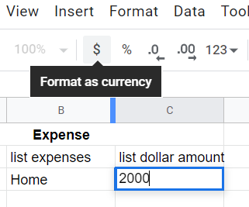

1. Highlight the cells from A1 to C1 and then all the way down your list. Select the border icon to create a pretty border under your table.

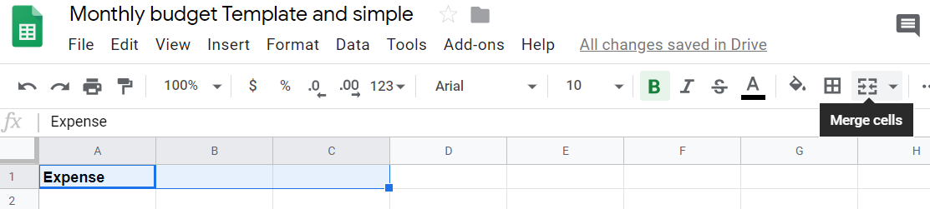

1. Depending on your zoom, you may need to hit the three horizontal dots icon on the far right to see more formatting tools, or you can go to the formatting tab on the top, Select Align and Indent, then select center

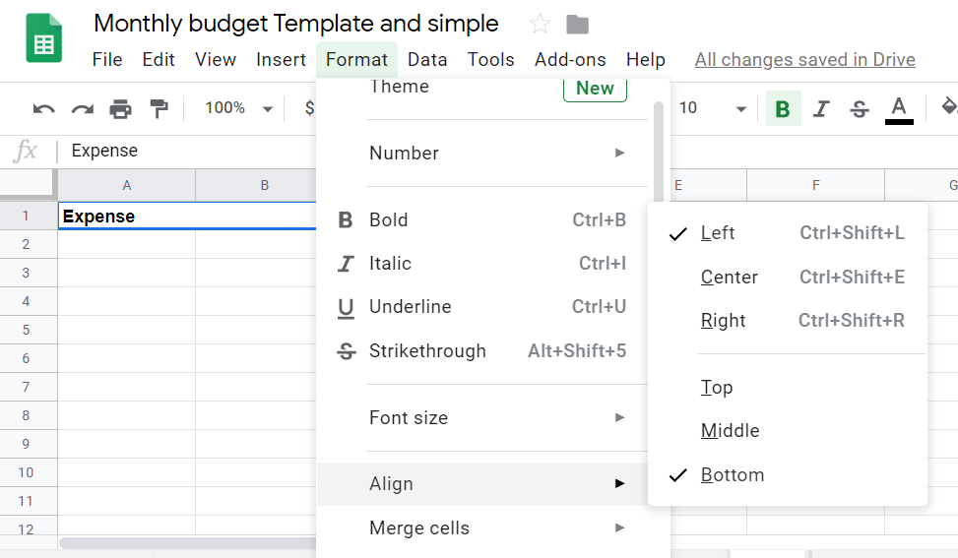

1. In E2 write monthly income, in E3 monthly expenses, in E4 write surplus deficit
2. In E6 write Total Savings, in E7 write years to last, in E8 write funds/year, in E9 Funds/month.
3. In cell F6 write in a number for your total savings. Then format to $
4. In cell F7 write in a number for how many years you need your savings to last
5. In cell F8, type =F6/F7
6. In cell F9 type =F7/12
7. In cell F2 type =F9
8. In cell F3, you can use a function to sum up all of your expense values. You can do this a few ways, the easiest way is to type =SUM( and then you select all of your values by highlighting them, then close the parenthesis. For example, if you have expenses listed from C4 to C18, your function will look like, =SUM(C4,C16)
9. In cell F4 type =F2-F3. This gives you your monthly income minus your monthly expense.
10. You can further play around with formating options to bold and color highlight and border your document. You can also go to the view tab and unselect gridlines to remove the gridlines.

