Exploring Web MD
- Go to the internet on your device and type www.webmd.com into the address bar and press enter, then open the hamburger menu in the top left of the screen once the page loads.
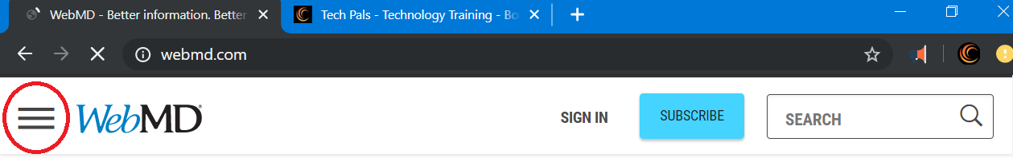
- Select Symptom checker
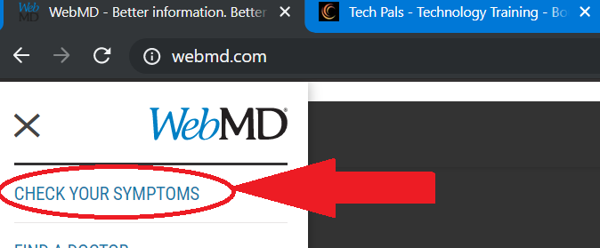
- Scroll down and enter your age and gender, then select continue.
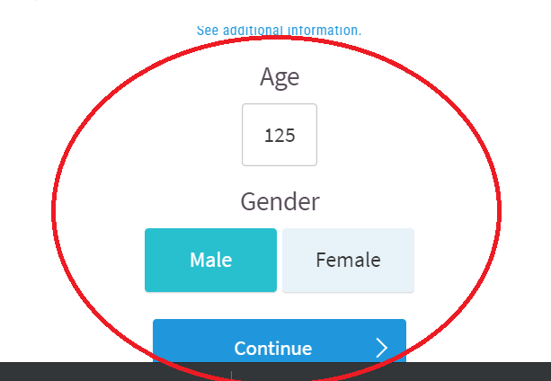
- Type your main symptom into the symptom bar and press add, you may add additional symptoms as well, press add each time.
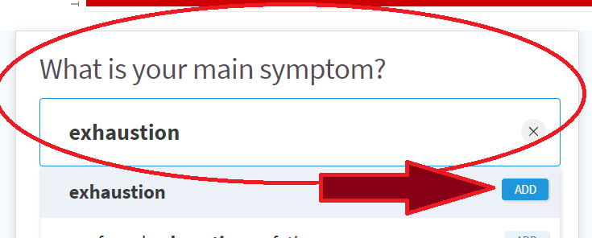
- When satisfied with the symptoms you have entered, scroll down and select Continue.
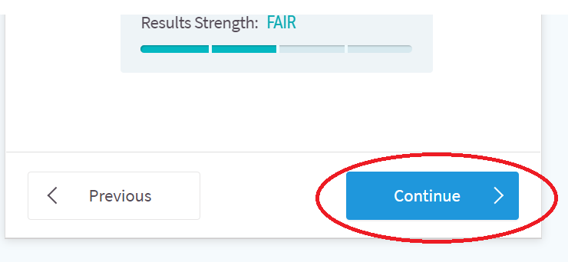

- Enter any medications you are taking or any past or current conditions you are currently experiencing. Then scroll down and select continue.
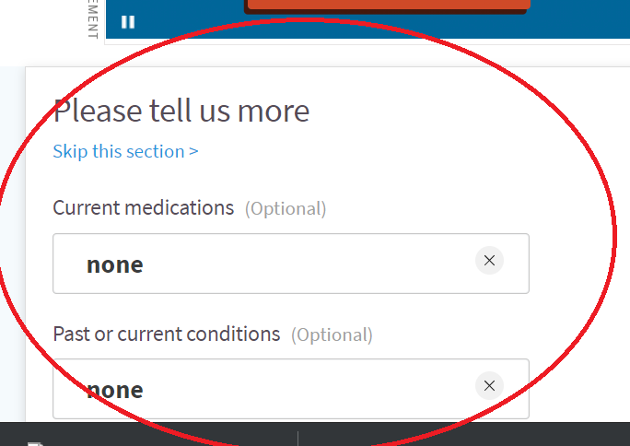
- In the next page you will see all possible conditions that could be related to the information you provided.
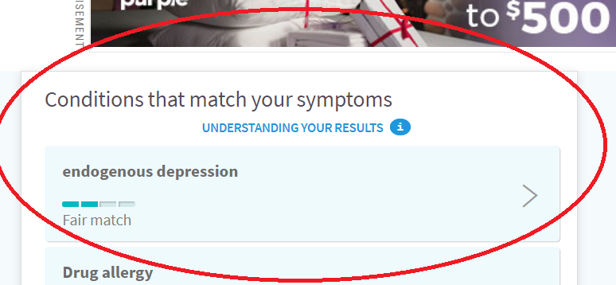
- You can click these conditions to learn more about them.`

