Accessing Google Drive
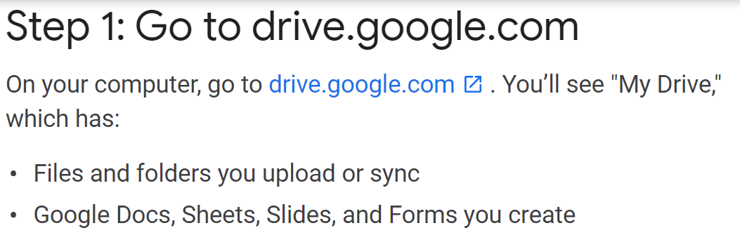
Click the New button to create new folders, or upload new files/folders.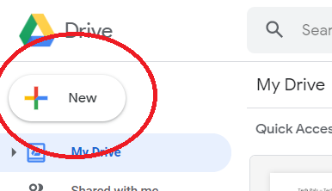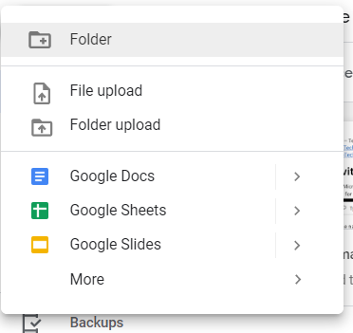

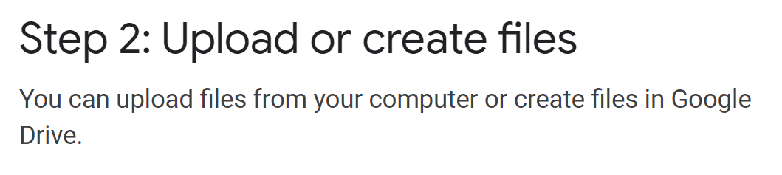
- Click New, then click Folder Upload
- Navigate to Practice FM with quick access button, then click your folder once, then press upload.
- Google Supports 4 main types of files.
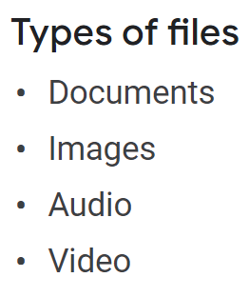
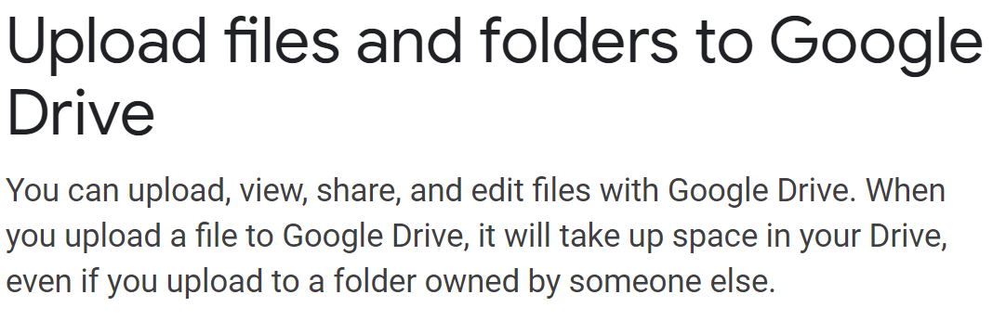
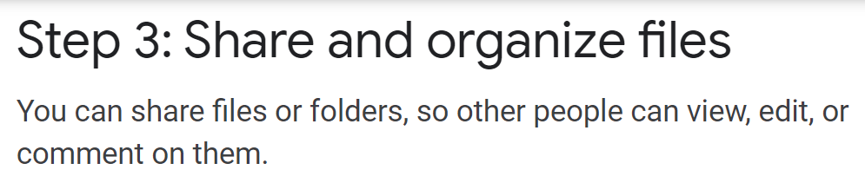
- To share a single file, find the file that you uploaded in the Drive version of the Practice FM folder, right click on the file and select Share.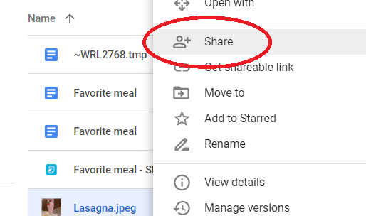

- Type in the techpalsfm@gmail.com into the name and press send at the bottom.
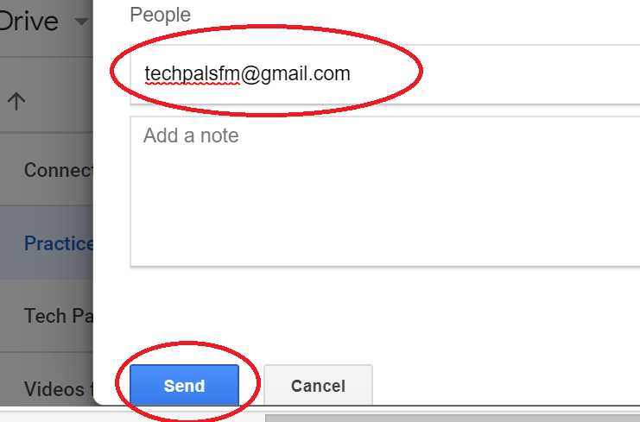
- To upload a folder, select My Drive at the top to return to the main menu of your Drive.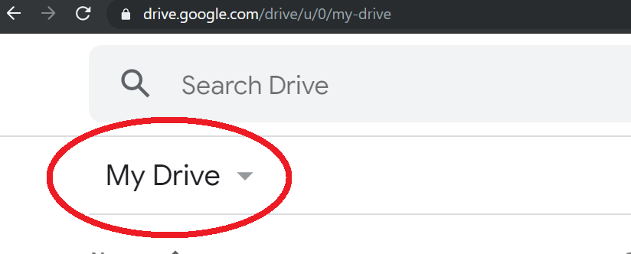
- Right Click on the folder named Practice FM and select share, repeat the process for a single file.
- To see files that have been shared with you, find the Shared with me Tab on the left.
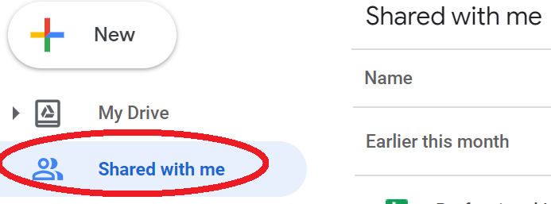
Google Docs
You can also create Word documents, Excel documents, PowerPoint documents, publish Google forms and more.
You can find templates for Budgets, order forms or create your own templates.
Diving into Google Docs requires a class all in its own.

https://support.google.com/drive/answer/2424384?co=GENIE.Platform%3DDesktop&hl=en

