**Bottom Right Side of Screen**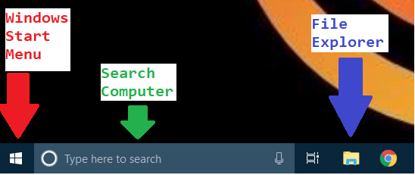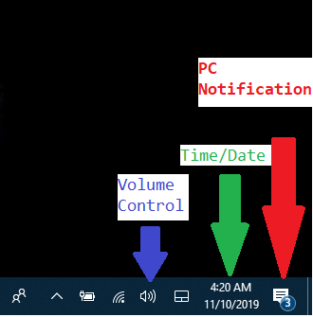

**Bottom Left Side of Screen**

**File Explorer**

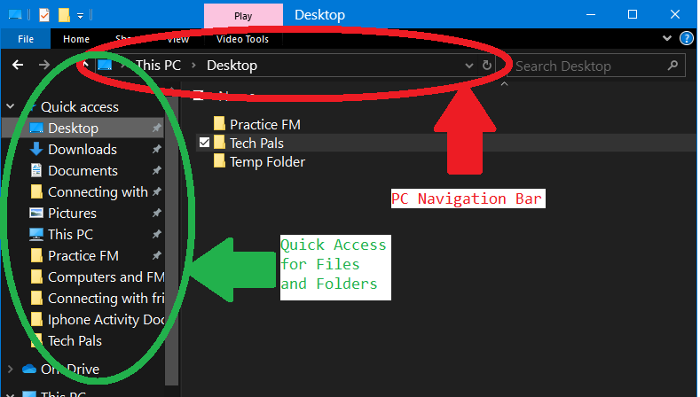

**Upper Right Window controls**