|  |  |  |  |  |  |
| --- | --- | --- | --- | --- | --- |
| **DATE** | **Monday** | **Tuesday** | **Wednesday** | **Thursday** | **Friday** |
| **1/16 2/13 3/13 4/10 5/8 6/5 7/3** | **PAPA JOHNS PIZZA (1EA)**  **VEG.-BROCCOLI (1/4 cp)**  **FRUIT-MIXED FRUIT (1/4cp)**  **GRAIN-INCLUDED IN ENTRÉE**  **RANCH (1oz)**  **MILK (6oz)** | **FRESH BEEF TACO (2oz)**  **VEG.-PINTO BEANS (1/4cp)**  **FRUIT-CANTALOUPE (1EA)**  **GRAIN- TORTILLA (1EA)**  **SHREDDED CHEESE (1oz)**  **MILK (6oz)** | **LUNCHABLE (1EA)**  **VEG.-CARROTS (1/4 cp)**  **FRUIT-CINN. APPLE SLICES (1/4 cp)**  **GRAIN-INCLUDED IN ENTRÉE**  **CHIPS (1EA)**  **MILK (6oz)** | **CHICKEN FRIED STEAK (1EA)**  **VEG.-MASH POTATOES (1/4 cp)**  **FRUIT-PEACHES (1/4 cp)**  **GRAIN-BISCUIT (1EA)**  **MILK (6oz)** | **BEEF FAJITAS (1/4CP)**  **VEG.-MIXED VEGETABLES (1/4 cp)**  **FRUIT-APPLE (1EA)**  **GRAIN-TORTILLA**  **PICANTE (1oz)**  **MILK (6oz)** |
| **1/23 2/20 3/20 4/17 5/15 6/12 7/10** | **CHEESEBURGER (1EA, 1 SLICE CHEESE)**  **VEG.-BAKED BEANS (1/4cp)**  **FRUIT-MIXED FRUIT (1/4cp)**  **GRAIN- HAMBURGER BUN (1EA)**  **MUSTARD, KETCHUP, PICKLES (1oz)**  **MILK (6oz)** | **CHICKEN AND RICE (3/4CP)**  **VEG.-CARROTS (1/4 cp)**  **FRUIT-MANDARIN ORANGES (1/4 cp)**  **GRAIN-SALTINE CRACKERS (2EA)**  **MILK (6oz)** | **SPAGEHETTI (3/4CP)**  **VEG.-BROCCOLI (1/4 cp)**  **FRUIT-FRESH FRUIT (1EA)**  **GRAIN- BREADSTICK**  **MILK (6oz)** | **FRENCH TOAST STICKS**  **(3 EA)**  **VEG.-TATOR TOTS (1/4 cp)**  **FRUIT-PEARS (1/4 cp)**  **SAUSAGE (1 EA)**  **GRAIN- INCLUDED IN ENTREE**  **MILK (6oz)** | **CHICKEN NUGGETS (5EA)**  **VEG.-MIXED VEGETABLES (1/4 cp)**  **FRUIT-ORANGE (1EA)**  **GRAIN-ROLL (1EA)**  **KETCHUP (1oz)**  **MILK (6oz)** |
| **1 / 2 1/30 2/27 3/27 4/24 5/22 6/19 7/17** | **PAPA JOHNS PIZZA (1EA)**  **VEG.-CARROTS (1/4 cp)**  **FRUIT-PINEAPPLE (1/4 cp)**  **GRAIN-INCLUDED IN ENTRÉE**  **RANCH (1oz)**  **MILK (6oz)** | **MAC AND CHEESE (3/4 cp)**  **VEG.-CELERY (1/4 cp)**  **FRUIT-MIXED FRUIT (1/4cp)**  **GRAIN- ROLL (1EA)**  **MILK (6oz)**  **\*\*SCHOOLS- CORN DOG (1EA)** | **FRITO PIE (2oz, CHIPS 1oz)**  **VEG.-CORN (1/4 cp)**  **FRUIT-MANDARIN ORANGES (1/4 cp)**  **GRAIN-TORTILLA (1EA)**  **SHREDDED CHEESE (1oz)**  **MILK (6oz)** | **BOW TIE LASAGNA (3/4CP)**  **VEG.-BROCCOLI (1/4 cp)**  **FRUIT-APPLESAUCE (1/4cp)**  **GRAIN- GARLIC BREADSTICK (1EA)**  **MILK (6oz)** | **TAMALES (2EA)**  **VEG.-PINTO BEANS (1/4cp)**  **FRUIT-PEACHES (1/4 cp)**  **GRAIN-INCLUDED IN ENTREE (1EA)**  **MILK (6oz)** |
| **1/9 2/6 3/6 4/3 5/1 5/29 6/26 7/24** | **BEEF AND MAC (3/4 cp)**  **VEG.-BROCCOLI (1/4 cp)**  **FRUIT-PEACHES (1/4 cp)**  **GRAIN-ROLL (1EA)**  **MILK (6oz)** | **SOFT CHICKEN TACO (2oz)**  **VEG.-PINTO BEANS (1/4cp)**  **FRUIT-ORANGE (1EA)**  **GRAIN-TORTILLA (1EA)**  **SHREDDED CHEESE (1oz)**  **PICANTE SAUCE (1oz)**  **MILK (6oz)** | **SALISBURY STEAK (1EA)**  **VEG.-WHIP POTATOES (1/4 cp)**  **FRUIT-MIXED FRUIT (1/4cp)**  **GRAIN-DINNER ROLL (1EA)**  **BROWN GRAVY (1oz)**  **MILK (6oz)** | **SCRAMBLED EGGS, HAM, AND CHEESE (1EA)**  **VEG.-FRESHCARROTS (1/4 cp)**  **FRUIT-FRESH FRUIT (1EA)**  **GRAIN-HAMBURGER BUN (1 EA)**  **MILK (6oz)** | **BEAN BURRITO (1EA)**  **VEG.-GREEN BEANS (1/4cp)**  **FRUIT-MANDARIN ORANGES (1/4 cp)**  **GRAIN-INCLUDED IN ENTREE**  **PICANTE SAUCE (1oz)**  **MILK (6oz)** |

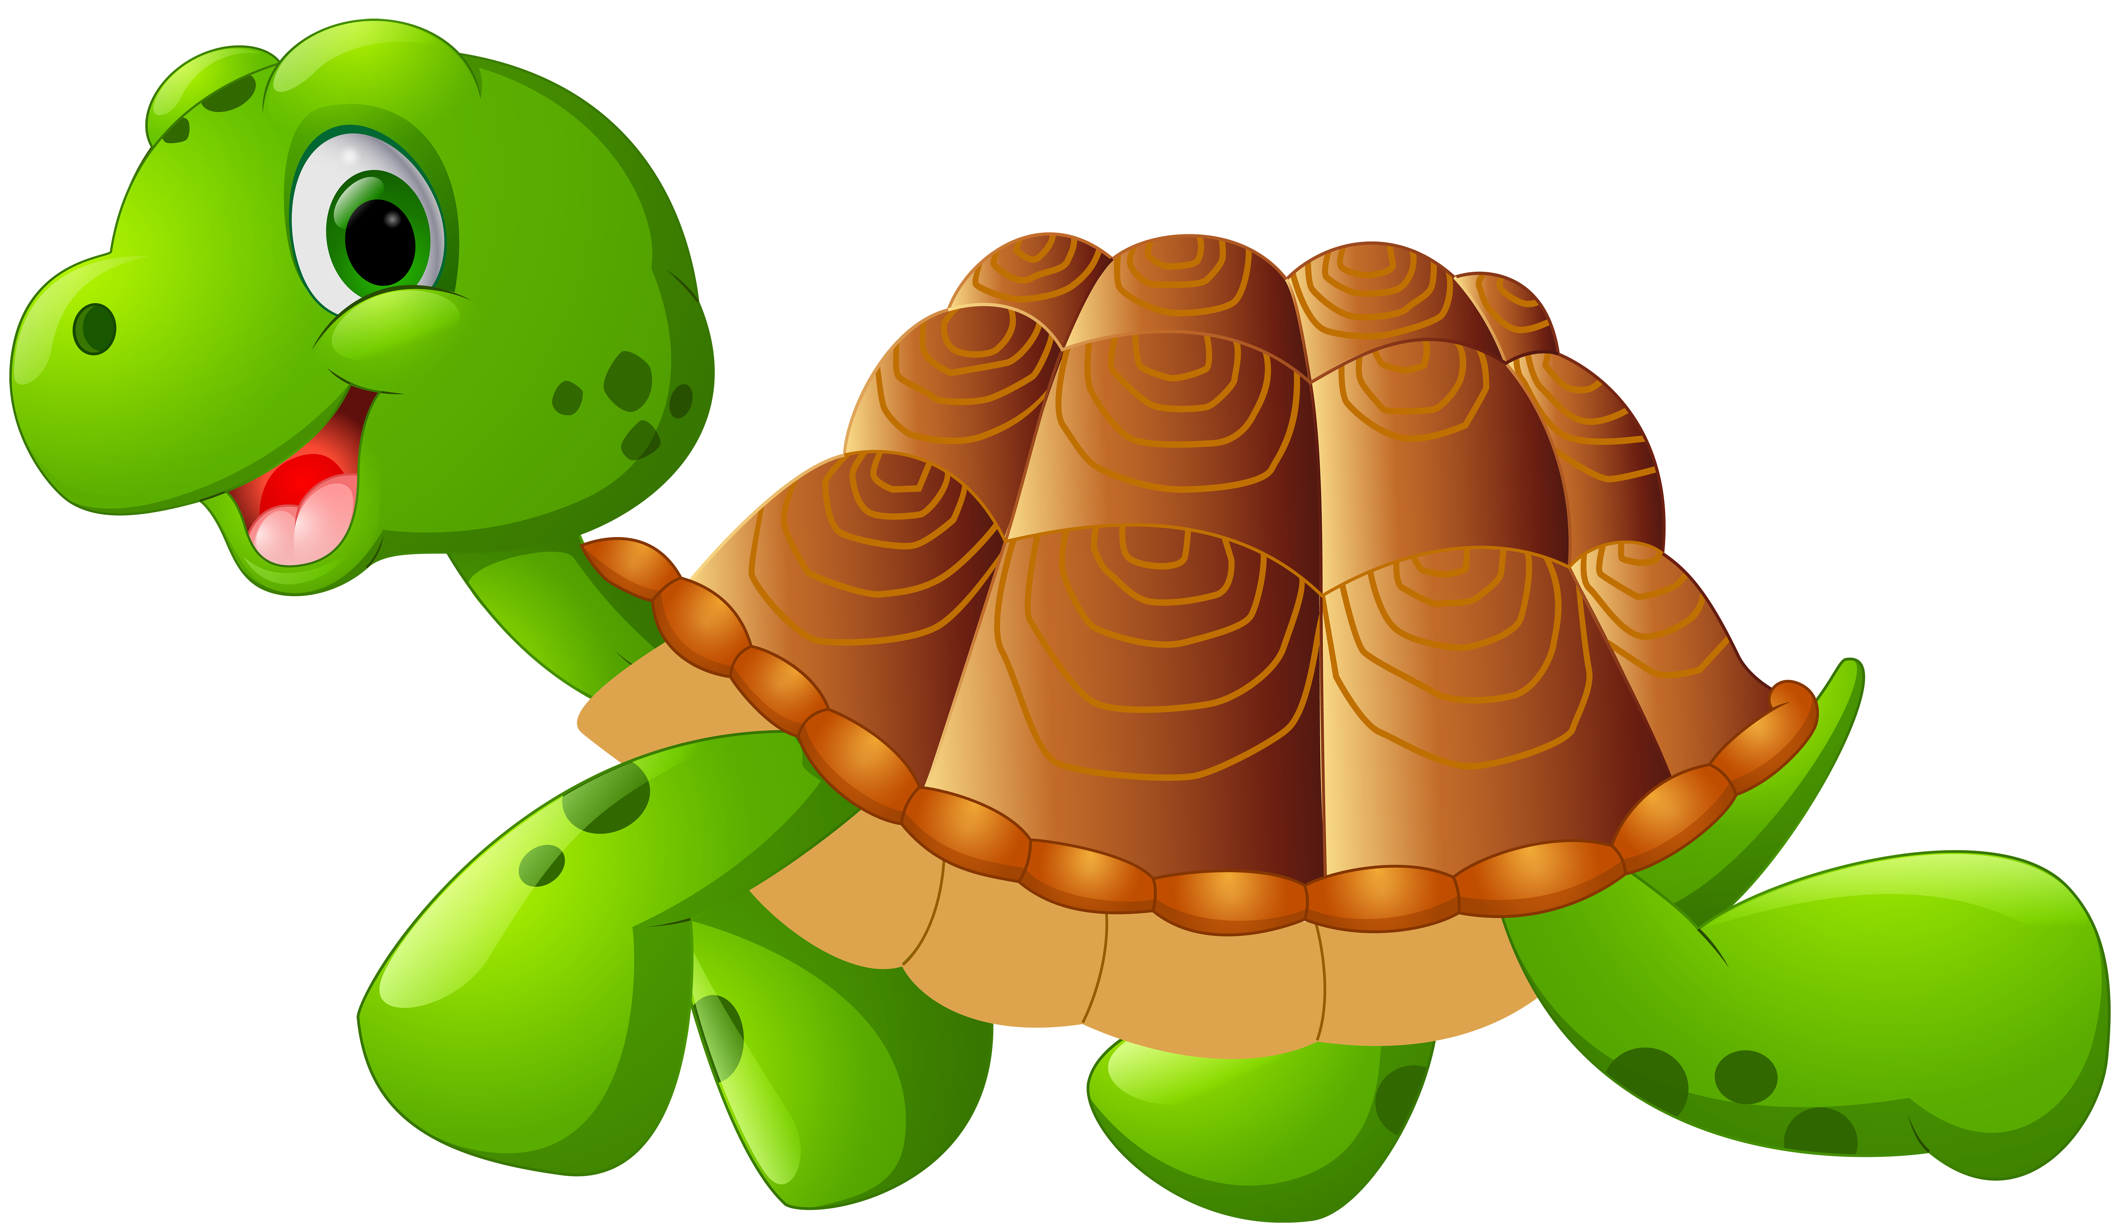

**LUNCH MENU 2022-2023**

**Your cafeteria is managed by**

**Canteen of Central New Mexico an equal opportunity employer**

