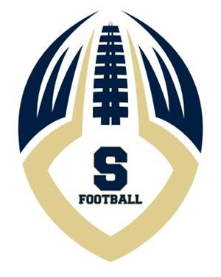
Council Rock South Golden Hawks
The Council Rock South Football team is entering another exciting season. Thank you for your present and past support and we are asking you to consider advertising with us. Our ad book this year will be virtual and listed in our game program.
These advertisements reach thousands of consumers in our area. Further, we encourage all supporters of Council Rock South Football Team to patronize those businesses who advertise with us.
Please consider this donation as your charitable contribution for support of the coaches, staff and players for the fundamentals we need to achieve VICTORY!!!!!!
All ads must be emailed in .pdf file form to:
Sheila.labadie@comcast.net
Or Text a pic of ad or business card to 215-837-4597
Thank you in advance and please come out to a game and cheer the team on. The game schedule, along with your business ad, is on our website at:
www.crsfootball.com
$200.00
Checks can be made to CRS Football Booster Club
Mail to: P.O. Box 264, Richboro, PA 18954

