CR South Hawks Football

invites

Northampton Indians Football and Cheerleading

to Northampton Indians Day!
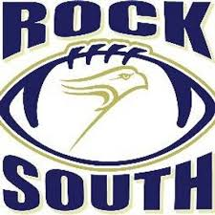
- Saturday, October 19th, 2019 at 2:30 PM
- Walt Snyder Stadium
*All Northampton Indian players, cheerleaders, and coaches can wear their jersey, uniform, or shirt to get in the game for FREE!*
*Any player that would like to run out with the team should report to the snack stand by 2:10*

