NEWS | From: NORMAN DIEGNAN & ASSOCIATES  Senior Member of Public Relations Society of America
For Immediate Release | (908) 832-7951  FAX (908) 832-9650  n.diegnan@comcast.net  www.diegnan-associates.com

Hunterdon Harmonizers to Perform August 1 in
“Music Under The Stars” Concert Series:
Event to Feature Tribute to the 75th Anniversary of the Normandy Invasion

READINGTON, NJ - The Hunterdon Harmonizers will be performing in Deer Path Park on Aug. 1 at 7 pm as a part of the county park system’s “Music Under the Stars” concert series.

This year’s theme, “What a Wonderful World,” will include Broadway hits in four-part a cappella style, swing numbers, old standards, and stirring patriotic songs. A special tribute to commemorate the 75th anniversary of the Normandy invasion, which led to the Allies’ victory in World War II, will highlight the performance, dedicated to all World War II veterans and in particular, those in attendance who proudly served America during the war.

As an added treat, the concert will feature a performance by TRUE VOICE PROJECT, a non-profit choir for high school students and young adults who enjoy creative musical collaboration.

The Hunterdon Harmonizers Barbershop Chorus is based in Flemington and is dedicated to promoting and preserving the American art form known as barbershop harmony and expanding this style into contemporary a cappella music. They bring their love of harmony to broad-based audiences at events throughout New Jersey.

The summer concert series is sponsored by the Hunterdon County Division of Parks and Recreation and continues each Thursday through August 15. Concerts starts at 7 pm in the park, located at 120 West Woodschurch Rd. Admission is free.

Deer Path Park offers incredible vistas at sunset and plenty of room for families to spread out a blanket, enjoy a picnic, play frisbee or volleyball and explore the playgrounds. For more information about scheduled performances and plans in the event of inclement weather, visit the Parks and Recreation section of the county website.
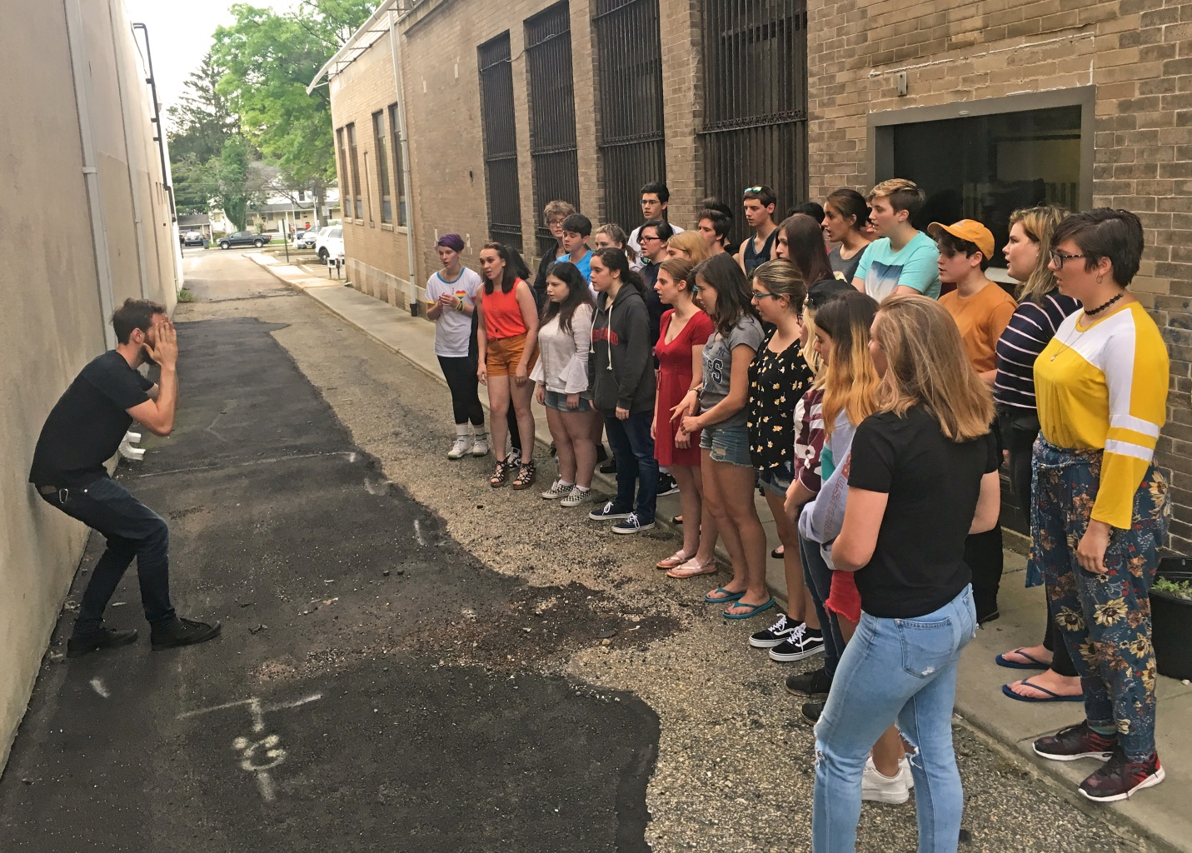

Caption: True Voice Project will join The Hunterdon Harmonizers on Aug. 1 at Deer Path Park.

