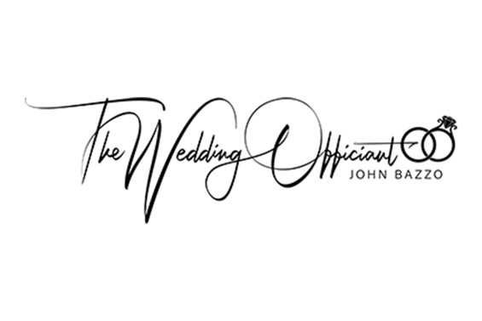

***Getting to Know You***

The purpose of this questionnaire is to allow me to know a bit more about the couples that I have the honor of marrying. This helps me to write a more personalized ceremony. Please feel free to share as much or as little as you’d like but I ask for ***full contact info*** to make communication easier.

Full Names:

Contact E-mail and phone number:

Wedding date, time and location:

Rehearsal date and location:

Tell me when and how you met:

What are some of the things that you love about one another?

What common interests do you share?

Was there a pivotal moment in your relationship that you’d like to share?

Any funny or amusing stories?

Would you like God mentioned? Prayers? Specific verses or readings?

Family or friends you’d like mentioned?

Any other comments you’d care to make?

I look forward to your reply and to the day of your wedding. Please reach out to me with any questions.

Thank you,

John Bazzo

(248) 874-5318

[Johnbazzo1@gmail.com](mailto:Johnbazzo1@gmail.com)