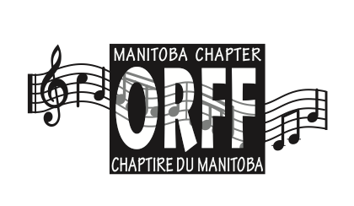
HELEN NEUFELD MEMORIAL SCHOLARSHIP

Application form for applicant taking Level II/III in July 2023

Name:
Address:
City: Province: Postal Code
Telephone: Other Phone:
Email:
Current Teaching Position:

Musical Training
Below is a brief outline; please include Orff Level 1 and supporting documentation which further details your training

Instrumental:

Vocal:

Examinations, Diplomas, Degrees:

General Education
State institution attended and date degree(s) completed or expect to be completed

Degree(s):
Institution:
Years affiliated with Manitoba Orff Chapter (applicant must be a current member of MOC):

Involvement with the Orff approach and Musical Activities
Outline your involvement with the Orff approach through school/community/church programs, workshops, professional music education organizations, etc

Please submit the following by April 30, 2023 :  - this application page  - a statement of rationale (why are you interested in Level II/III and what impact will it have on your teaching practice)  - any supporting documents which provide further details | Please send your application to:  MANITOBA ORFF CHAPTER  Scholarship Committee  157 Archibald, Winnipeg, MB R2J 0W1  Completed applications may also be emailed to rothschilderica@gmail.com

For further details or questions, please email Erica Rothschild (MOC Vice-President) at rothschilderica@gmail.com

