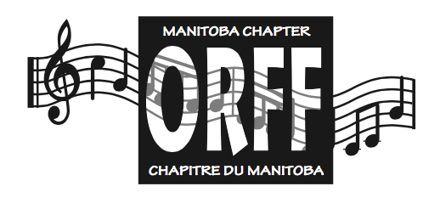MORNA-JUNE MORROW AWARD

Excellence in Music Education

Application Form

Sponsor Information

Name of Sponsor:

Address:

City: Province: Postal Code:

Telephone: Other Phone:

Email:

Affiliation to Nominee (must not be a parent of a student):

Number of years you have known the Nominee:

Nominee Information

Name of Nominee:

Address:

City: Province: Postal Code:

Telephone: Other Phone:

Email:

Position:

School Division/Institution:

Teaching Experience

Please list Nominee’s teaching experience, commencing from most recent:

|  |  |  |
| --- | --- | --- |
| Location | Number of Years | Level/Position |
|  |  |  |
|  |  |  |
|  |  |  |
|  |  |  |
|  |  |  |
|  |  |  |

Nominee’s Contributions to the Profession

School Program

Briefly describe your Nominee’s major program focus.

Extra-Curricular Program

List activities your Nominee has been involved in implementing or facilitating in his/her school/institution.

Community Involvement

List involvement in community-related music activities; for example, church or community choirs, and contributions to the area of Music Education outside the teaching profession.

Professional Development

List most recent involvement in professional development, in-services, workshops, Orff levels training, etc., beginning with most recent.

Contributions to Local Music Organizations

List involvement on music boards/executives such as MOS, MMEA, MCA, MBA, etc.

Publications/ Recognition Awards

Publications

List any publications your Nominee has authored.

Recognition Awards

List awards your nominee has received.

**Signature of sponsor: _________________________________________________________**

**Signature of nominee: _________________________________________________________**

**Date: _______________________________________________________________________**

Please submit the following by **September 30, 2022**:

* this application page
* rationale for nomination
* any supporting documents which provide further details

Please send your application to:

MANITOBA ORFF CHAPTER

Scholarships and Awards Committee

157 Archibald St

Winnipeg, R2J 0W1

**For further details or questions, please email**

**Erica Rothschild (MOC Vice-President) at** [**erica.rothschild@dsfm.mb.ca**](mailto:erica.rothschild@dsfm.mb.ca) **.**