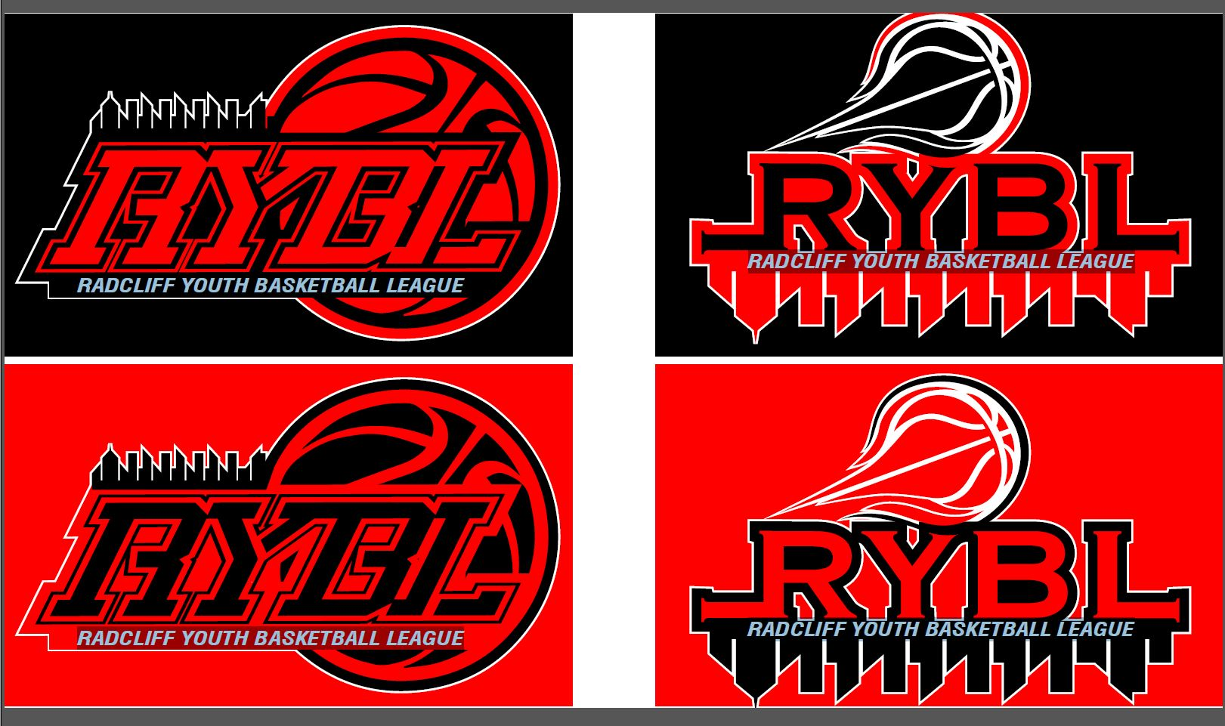
RadcliffYouthBasketballLeague
P.O. BOX 315 / Radcliff, KY 40159
Website: Radcliffybl.com

Child’s Full Name: ___________________________________ Date of Birth: ________________ Age: _________ Sex ________

Parent/Guardian Name: ______________________________________________________________________________________

Home Address: ____________________________________ City: ___________________ State: __________ Zip: ____________

E-Mail (Required): ____________________________________ Home Phone: _____________ Cell: _______________________

Interested in becoming a Coach or Other Volunteer with the league (Circle One): YES _______ NO _________
Uniform Size of Youth: T-Shirt _____________ Shorts _____________ (Parents are responsible for replacement cost of uniform if incorrect size is given when child is not present for fitting.)

- Has your child ever been a part of an organized basketball team? If so, how many seasons? ______________
- Will your child have a sibling participating in the league? YES _______ NO _______
- Do we have permission to publish photos/videos of your child for marketing, advertising and/or on any form of social media? YES _______ NO ______
- Does your child have any physical limitations or medical conditions that his/her coach should be aware of?
YES ________ NO _______. If yes, child must have a medical release from his/her doctor (Please attach med release to this form).

EMERGENCY CONTACT: Please list alternate contact in case of emergency if parent/guardian cannot be reached.

Name: ______________________________________ Phone # ___________________ Alt Phone # ________________

Name: ______________________________________ Phone # ___________________ Alt Phone # ________________

Signature of Parent/Guardian: __________________________________________ Date: ________________________

League Fee: $65.00 Each additional registered child (living in the home), fee decreases $5.00. Payable to Radcliff Youth Basketball League (RYBL) Cash, Check or Money Order.
REGISTRATION FEE IS NON-REFUNDABLE ONCE UNIFORMS HAVE BEEN ORDERED
(Partial refund after uniform order ONLY with a Dr. Statement or PCS orders)

AMOUNT PAID: ___________________ DATE: ______________ RECEIPT #: _____________________________

Payment Received By: ___________________________

