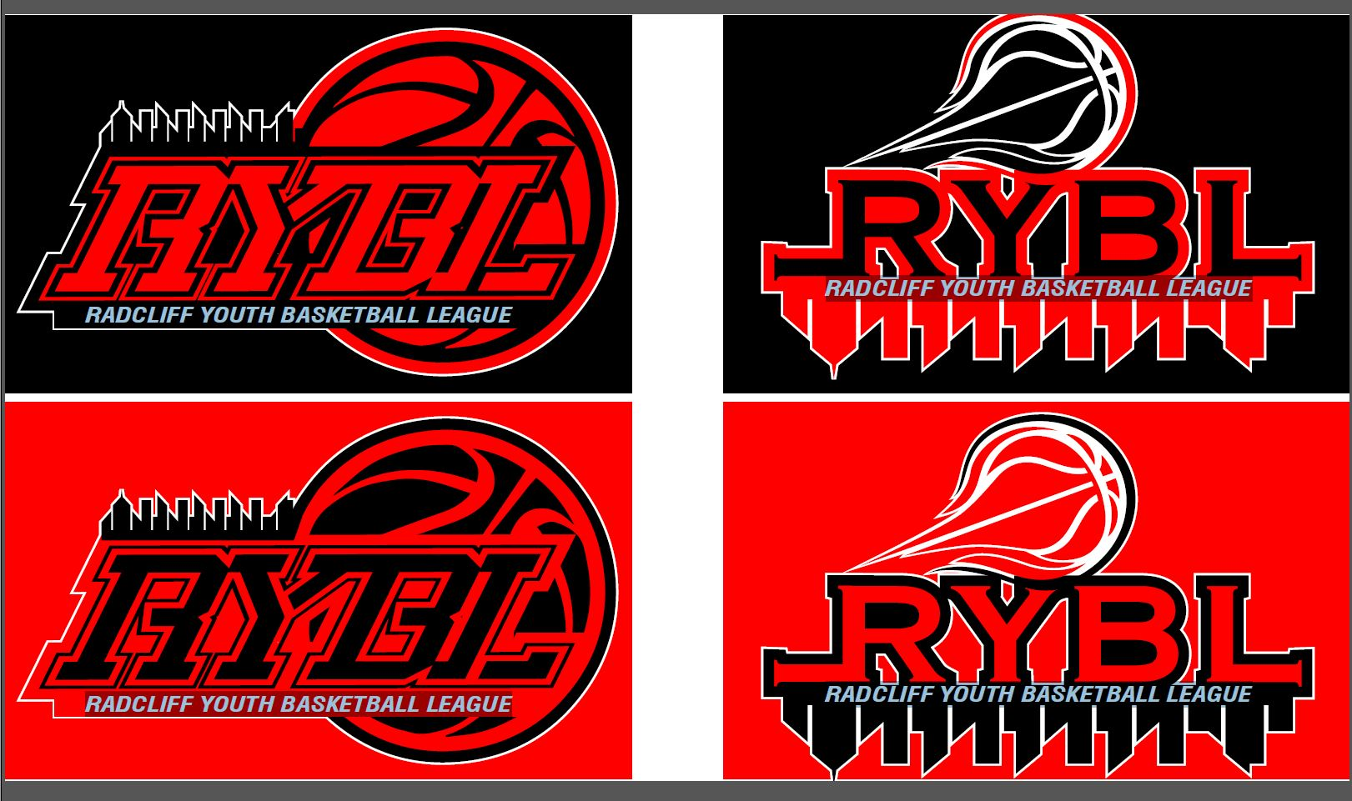

**RadcliffYouthBasketballLeague**

**P.O. BOX 315 / Radcliff, KY 40159**

**Phone: (270) 268-1800**

**Website: Radcliffybl.com**

**2021-2022 SEASON INFORMATION**

* **SEPTEMBER 2021 – COACHES REGISTRATION & TRAINING**
* **OCTOBER 2021 – PLAYER REGISTRATION AGES 4 – 15**
* **NOVEMBER 2021 – PLAYERS DRAFT**
  + **PARENTS MEETING**
  + **PRACTICES BEGIN (ALL AGE GROUPS)**
* **DECEMBER 2021 – GAMES BEGIN (ALL AGE GROUPS)**
* **MARCH 2022 – RYBL PLAYOFFS AND CHAMPIONSHIP GAMES**

**ACTUAL DATES, TIMES & LOCATIONS WILL BE POSTED ONCE AVAILABLE**

**PLEASE VISIT OUR WEBSITE:** [**www.Radcliffybl.com**](http://www.Radcliffybl.com)



**RadcliffYouthBasketballLeague**

**P.O. BOX 315 / Radcliff, KY 40159**

**Phone: (270) 268-1800**

**Website: Radcliffybl.com**

**2021-2022 SEASON INFORMATION**

* **SEPTEMBER 2021 – COACHES REGISTRATION & TRAINING**
* **OCTOBER 2021 – PLAYER REGISTRATION AGES 4 – 15**
* **NOVEMBER 2021 – PLAYERS DRAFT**
  + **PARENTS MEETING**
  + **PRACTICES BEGIN (ALL AGE GROUPS)**
* **DECEMBER 2021 – GAMES BEGIN (ALL AGE GROUPS)**
* **MARCH 2022 – RYBL PLAYOFFS AND CHAMPIONSHIP GAMES**

**ACTUAL DATES, TIMES & LOCATIONS WILL BE POSTED ONCE AVAILALBE**

**PLEASE VISIT OUR WEBSITE:**[**www.Radcliffybl.com**](http://www.Radcliffybl.com)