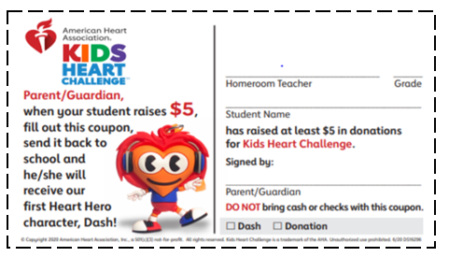
February 22, 2021

Dear Family,

It’s time for the Kids Heart Challenge! Winsor Hill School is helping the American Heart Association build healthier lives free from cardiovascular diseases and stroke. Kids Heart Challenge is a community service opportunity designed to help students learn about the importance of making healthy choices to take care of their hearts. Students will also help improve the health and hearts of others by collecting donations in support of the American Heart Association and its research, education and advocacy work right here in Rhode Island and across the country. Our efforts truly make a difference and help save lives.
The Kids Heart Challenge will take place during Physical Education class the week of March 1st – March 5th. All students in grades K through 5 (in school or distance learning) will join in heart healthy activities during our program. We are thankful for your participation. Our school is proud to help the American Heart Association as they are supporting our community in many ways during this pandemic. To date, the AHA has funded fast-response grants to study COVID-19’s effects on patients with cardiovascular disease and launched a COVID-19 Data Registry used by hundreds of hospitals nation-wide that has made it possible to learn from COVID patients quickly and improve treatments more rapidly. We understand every family may not be able to donate, however, all students will enjoy and learn from the heart healthy educational resources that will be shared during our program.
If your family would like to help with a donation, please use the American Heart Association’s online donation program and email friends and family to support this cause. We will be using the online fundraising option only this year. To access the American Heart Association’s online donation program, go to www.heart.org/KHC - Register to participate online and follow these directions. *You may also use your mobile device. Visit your Mobile App store and search: Kids Heart Challenge to download the free app!

1. Scroll down to “Find Your Child’s School” and type Winsor Hill in the search box.
2. Click the “Search” button and see “Results Matching Your School’s Name.” (You may also need to click the “Filter Results by State” button to find your school.)
3. Click the “Sign Up” button located under your school name. Donate and set a fundraising goal if you wish. Click “Next” and Create a Profile.
4. Scroll down to “Spread the Word” and you are now ready to email or send a personalized e-card to family and friends.
You may ask for help with donations and encourage others to join you in a Challenge to Move More, Be Kind and Choose Water.

Kindly complete your online fundraising no later than March 12, 2021. Online donations through your child’s webpage are encouraged. Thank you for your support of this fun and worthy event!

Sincerely,

Mrs. Parillo
Physical Education & Health

*INTRODUCING OUR 2020-2021 MISSION POSSIBLE HEART HEROES – Dash, Sam, Iker, Kai, Journey and Taye & Scout. Collect all 6 Heroes and help save lives. See your Kids Heart Challenge online headquarters for details.

*PARTICIPATE IN DAILY HEART-HEALTHY CHALLENGES! MOVE MORE. BE KIND. CHOOSE WATER. RECEIVE A FREE RED HEART HERO WRISTBAND when you register online to participate in our program. Go to www.heart.org/KHC or download the Kids Heart Challenge App to your mobile device. Once you set up your child’s webpage, scroll down to Family Heart-Healthy Challenge (or Track Your Daily Challenge if using the app.) and select your Challenge(s) to Move More, Be Kind and Choose Water. Go to “Spread the Word” and select “Send Email” or “Send e-card” - email family and friends to ask for help with donations and to join you in a Challenge.

*COMPLETE FINN’S MISSIONS! Receive the yellow Finn wristband when you ACCEPT FINN’S MISSIONS and complete them all. Missions include: Viewing our HANDS ONLY CPR video/quiz, Recognizing Stroke video/quiz and the Move More Family Challenge. Share these lifesaving videos with family and friends! Thanks for being a Heart Hero!

