**Successful Planting Tips**

This month, Crescent City Tree, LLC will focus the topic of “Successful Planting Tips”. I have asked and received extensive information from Louisiana Nursery and Landscape. According to the professional at Louisiana Nursery and Landscape, the following outlines will instruct you on how to plant your tree(s) so that it will grow into a beautiful species. Also, a little TLC doesn’t hurt either.

**Planting Container Grown Plants:** 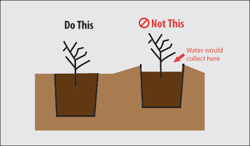

1. Dig a hole twice as wide as the container.
2. Make sides of planting hole rough.
3. Set the plant so the top of the root ball is level with or slightly above finished grade.
4. Fill the hole ½” full of texturized soil and water.
5. Continue to fill the hole with soil and water. Eliminate all air pockets.
6. Add remaining soil mix to ground level.
7. Mulch plants to control weeds and retain soil moisture.

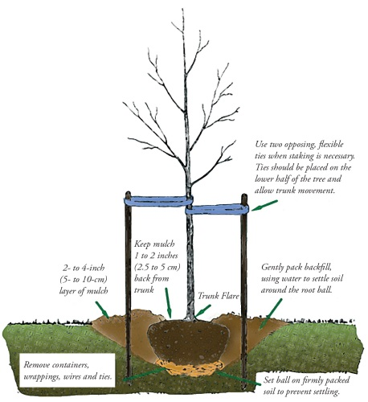

**Planting Trees & Shrubs:**

1. Dig a hole wider than the root ball, but not deeper.
2. Set the plant so the top of the root ball is level with or slightly above existing grade.
3. Fill the hole 2/3 full of texturized backfill.
4. Fill the hole with water to firm the soil. Eliminate all air pockets.
5. Add remaining soil to ground level.
6. Stake the tree and create an earth saucer to hold additional water.
7. Mulch plants to control weeks and retain soil moisture.

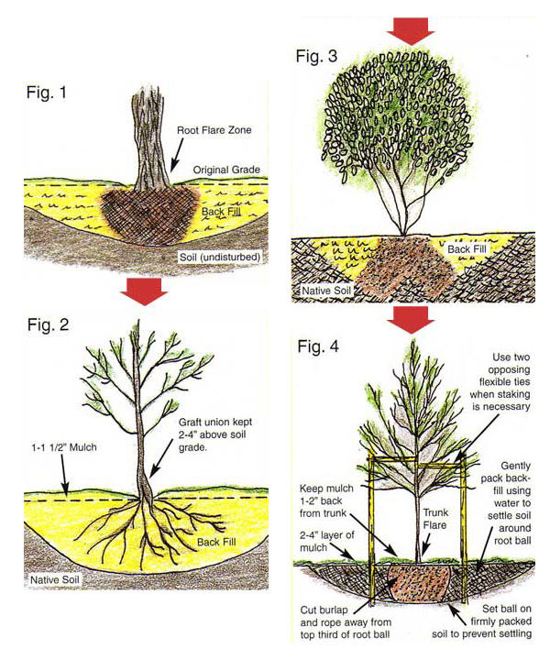

**Planting Evergreens**

1. Dig a hole wider than the root ball but not deeper.
2. Set the plant so the top of the root ball is level with or slightly above existing grade.
3. Fill the hole 2/3 full of texturized soil.
4. Fill the hole with water to firm the soil. Eliminate all air pockets.
5. Add remaining soil to ground level, water the plant in, and try to eliminate air pockets.
6. Cover the root area with 2”-3” of mulch to retain soil moisture and control weeds.