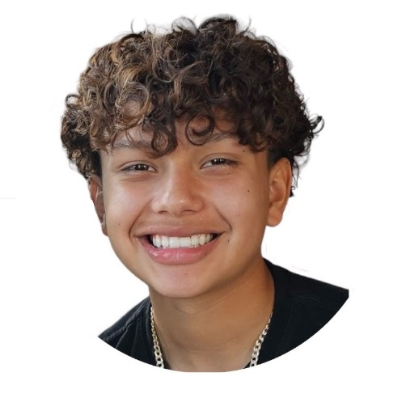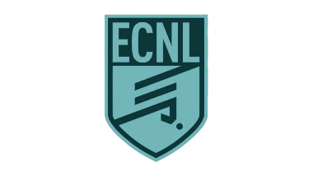 

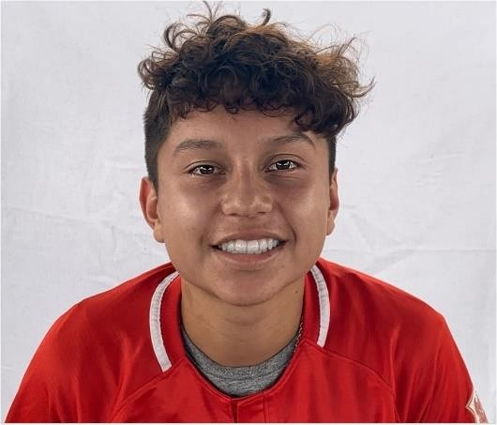

Santiago

“Sunny” Castillo

**Forward / Midfielder**

**DOB:** 02/11/2009

Height: 5’6 – Weight: 141

**Graduation May 2022**

**Player Summary:**

* High Soccer IQ
* Attack minded
* Accurate & Quality passing
* Strong ball control
* Brazilian and European style
* Playing Year round

**Video:**

**Contact Info:**

**E-Mail:**

[yucatech0@yahoo.com](mailto:yucatech0@yahoo.com)

**Phone**:

469-878-4985

I believe in year-round training to reinforce my ball control, boost my creativity on the field, and excel in my game decision-making. I am a go-getter, and as a defender, no one passes through me.

**Strong & Dynamic Play**: Emphasis in strong defense and attacking techniques. Demonstrate great ball dominion to make more moves and create openings or better situations for passes.

**Versatility:** great cognitive skills that allow for fast passes, I can move from midfielder to defender which permits me to be more flexible and knowledgeable in any area of the field.

**CLUB EXPERIENCE**

Dallas Texans Academy ECNL 2023-present

* DANA Cup 2023 Champion - Denmark
* Norway Cup 2023 Champion - Norway

BVB International Academy ECRL 2022-2023

* Captain – ECRL
* Captain – Classic D1

Dallas Texans ECRL 2021-2022 (team moved to BVB)

* Captain - ECRL
* ECRL top goal scorer (20 goals) 16 games 2020
* Captain – Classic D1

Allegiance Academy 2020-2021

* Captain – Classic D1

Dallas Texans 2017-2020

* Captain – Classic D1

**ODP EXPERIENCE**

ODP of North Texas 2018-present

# NTX ODP 2008 Boys State Team 2018

# NTX ODP 2009 Boys State Team 2019,2020,2021,2022

* NTX ODP Sub-Regional Competition 2019,2020,2021,2022,2023

# NTX ODP Regional Team Tryout Murfreesboro, TN 2020 ,2021

# NTX ODP Regional Team Tryout Charolette, NC 2023(Selected)

# NTX ODP National Team Tryout Orlando, FL (Jan 2024)

**ACADEMICS & Extra Curricular**

# North Garland High School

# National Honor Society

# Varsity Soccer team as Freshman