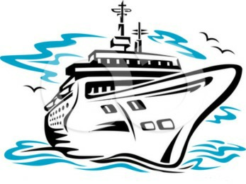Kathy and Mac’s Travel

Allentown, PA

610-821-8829

www.kathymacstravel.com

_________________________________________________________________________________________________________________________

Finger Lakes Wine Tour

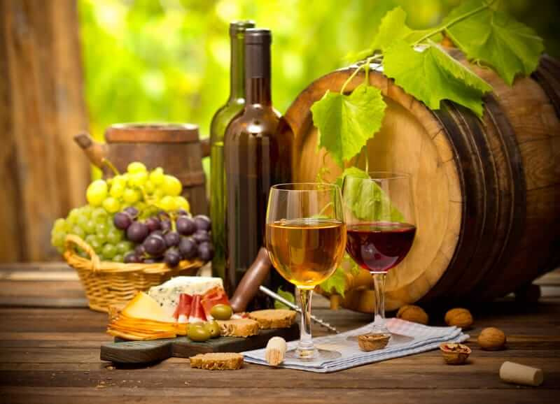

Aug. 11th & 12th 2018

Join Kathy and Mac for a spectacular tour of the Finger Lakes, NY wine country and experience the best wines on the East Coast!

|  |  |  |
| --- | --- | --- |
| Pricing and Details | | Trip Includes:   * Round-trip Transportation- Enjoy traveling in upscale luxury comfort by J&J Luxury Transportation * Saturday and Sunday- Tours and wine tasting at Glenora Winery, 3 Brothers Winery, Fulkerson Winery, and Villa Bellangelo Winery, Penguin Winery, Chateau LaFayette Reneau Winery * Dinner at Belhurst Castle (Saturday)- This exquisite1880’s historic castle has incomparable atmosphere, set to perfection! * 1 night stay at the Ramada Geneva Lakefront in Seneca Lake- Setting on a lake, this 148-room, 3-star hotel welcomes guests with conveniences like an indoor pool and free in-room WiFi. * Sunday morning-Full Breakfast * Sunday Afternoon- Lunch at Ginny Lee Café at Wagner Vineyards- Designed with a vista overlooking the vineyards and Seneca Lake, The Ginny Lee is the ideal place to enjoy a delightful and relaxing meal * Bus trip includes: movie, 50/50 drawing, entertainment, wine giveaways, and refreshments |
| Single Occupancy | $412.00pp |
| Double Occupancy | $332.00pp |
| Triple Occupancy | $304.00pp |
| 6am- | Depart from Roma Building, Cedar Crest Blvd. |
| 8:30am | Breakfast @ Bingham’s Family Restaurant, Lenox, PA (on your own) |

**Call today to reserve your spot! Seats fill up quickly for these great tours!**