You are accordingly invited to an informal workshop.

Solutions to Achieve Financial Security in Today’s Market
By Yan Zhang

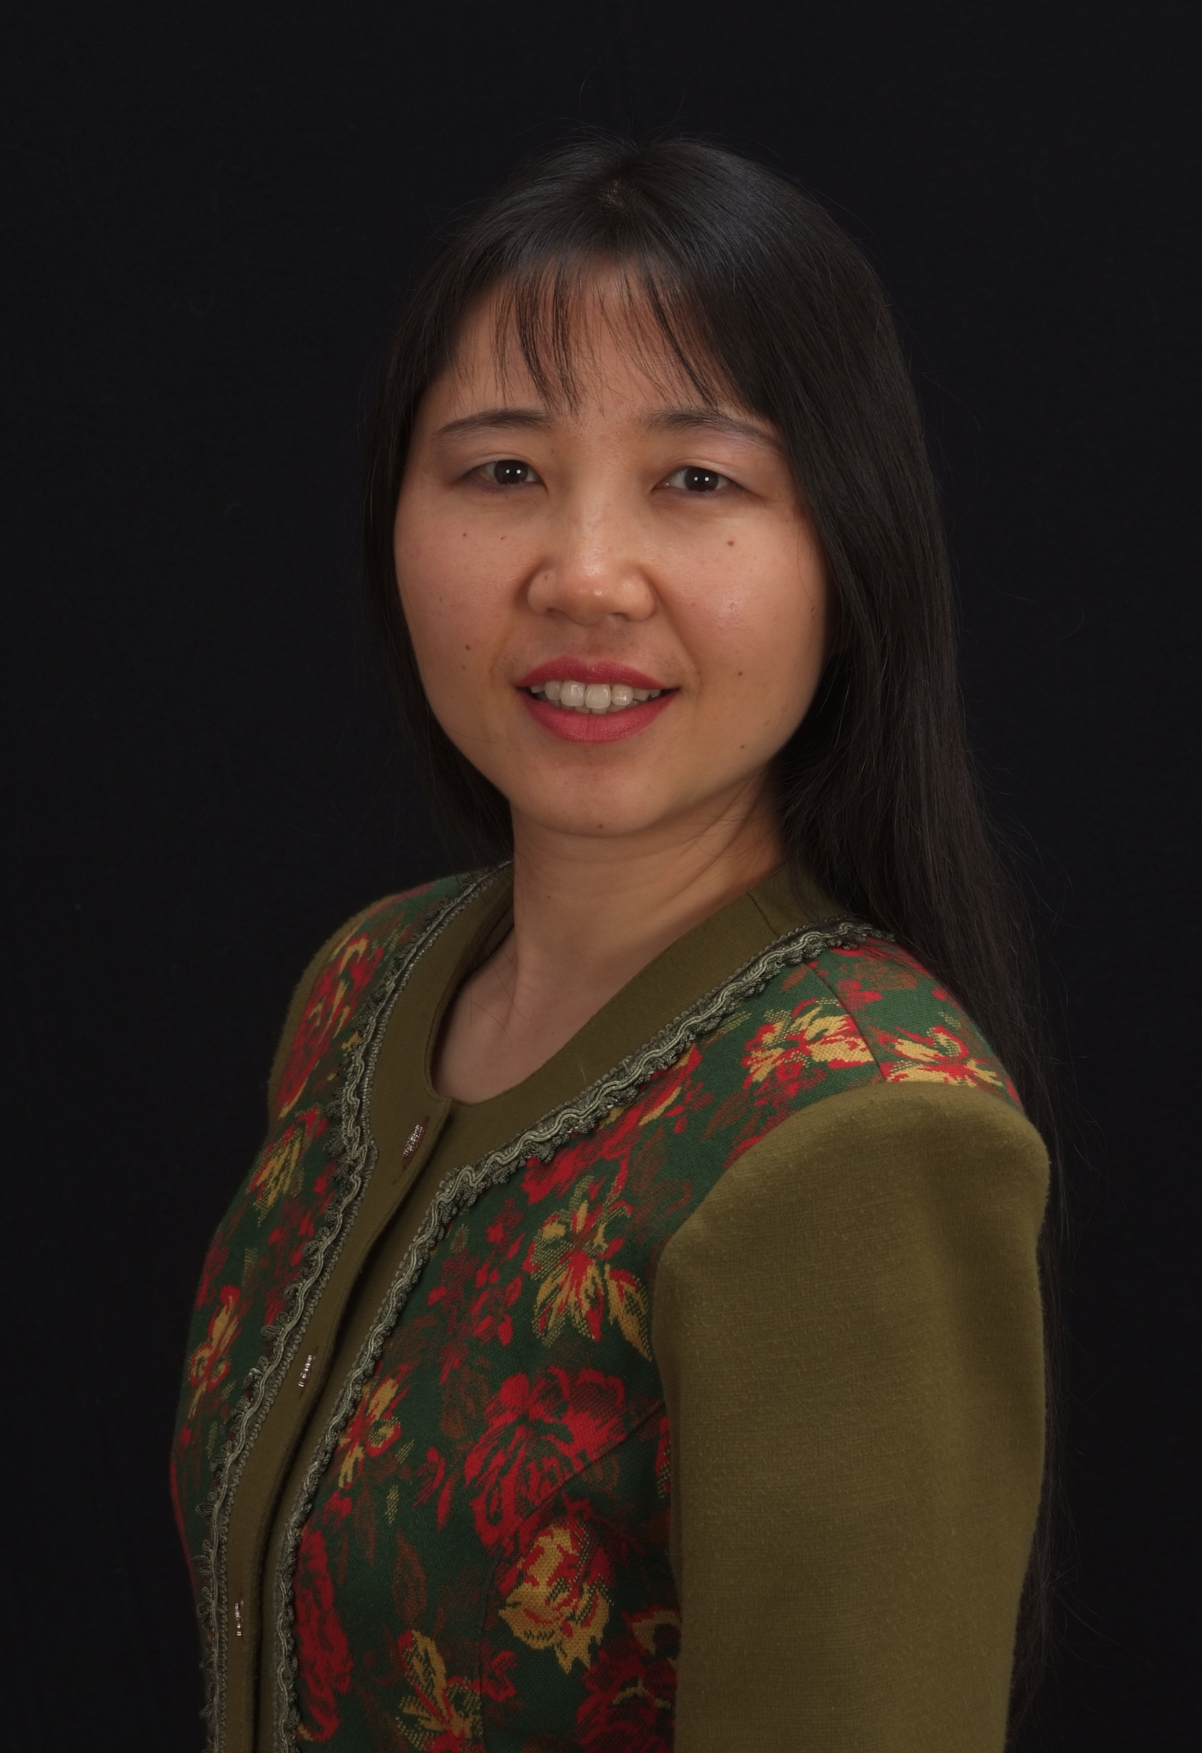

Yan Zhang received a Bachelor of Science Degree in Education from Hebei University in China in 1985. In 1991, she earned a Masters Degree in Social Psychology from Nagoya University in Japan. She has had a professional career with several Fortune 500 Companies, including Olympus Optical Company, Ltd., and The Home Depot.
She founded Retirement Solution 101 where she promotes safe money strategies and
tax advantaged programs.

Yan believes we need to make our money work hard for us, while we work hard for our money, and it’s never too late or too early to plan it right for our retirement. As a first-generation Chinese-American, Yan is proud to live in the “land of the free,” but she feels strongly we cannot be truly free unless we are also financially free. Her goal in life is to impact people’s lives by helping them build solid financial foundation.

As a licensed financial consultant, Yan offers support to those who desire to improve their financial situations in vast communities. Yan’s knowledge has changed her life and built a legacy for many other families, now she would like to make a difference in yours. You’ve got everything to gain and nothing to lose.

Yan can be reached at 770-634-5396 or Yan@RetirementSolution101.com.

