Carson Ranger District 1536 South Carson Street Carson City, Nevada 775-882-2766
Bull Canyon Trail
Humboldt-Toiyabe National Forest Carson Ranger District
Comments:
This trail begins to climb Bull Canyon immediately south of Bull Creek. Approximately 1 ½ miles up canyon from the Wolf Creek Trail, the Bull Lake Trail goes south. This junction is not signed. Cross the meadow and follow the trail 1.4 miles to Bull Lake.
Back on the main trail, continue climbing up the canyon until you reach a large meadow surrounded by mountains. This trail goes through the middle of the meadow and on the opposite side you should see a Jeffrey Pine with a trail blaze. It is almost in a direct line of sight from the trail on the Bull Canyon side of the meadow to the Noble Canyon side.
On the west side of this meadow you begin a very steep ascent to the top of the ridge. After reaching the top you begin a very steep decent and you will reach Noble Lake in about 30 minutes. This area is well signed.
Trailhead:
Drive south on Hwy 4 from Markleeville, CA to Wolf Creek Road, turn east and travel 6 miles to the Wolf Creek Trailhead. Then hike the Wolf Creek Trail 4 ½ miles to Bull Canyon.
Remember:
Always carry drinking water. Prevent erosion, follow the trail and don’t cut switchbacks. Keep trails clean by packing out what you pack in. Protect plants and wildlife. LEAVE NO TRACE

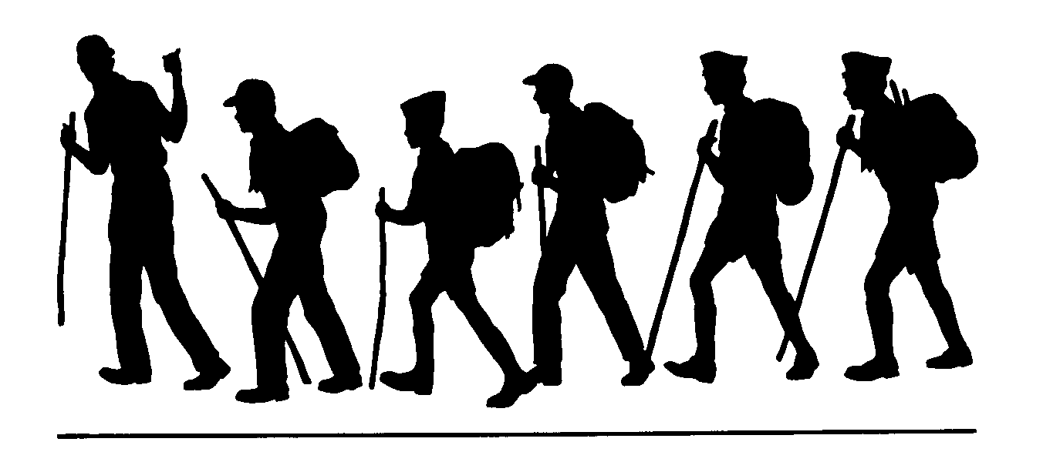
Length (one way)
3 ½ miles

Season
June to December
or until first snow

Difficulty
Moderate-Strenuous

Maps
Carson-Iceberg Wilderness
USGS 7.5
Wolf Creek
Ebbetts Pass

Elevation
Bull Canyon 8320’
Noble Lake 8640’

Carson Ranger District 1536 South Carson Street Carson City, Nevada 775-882-2766

