[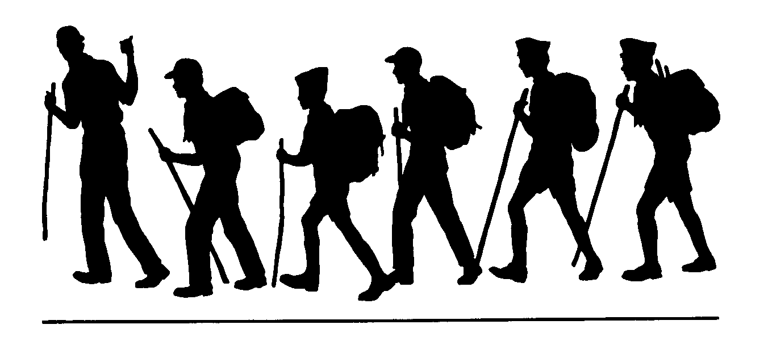](https://www.google.com/url?sa=i&url=https://www.clipart.email/clipart/family-hiking-clipart-black-and-white-278388.html&psig=AOvVaw13JGbr3YVn3H-LI7b9a1xB&ust=1587497326660000&source=images&cd=vfe&ved=0CAIQjRxqFwoTCMDP4sne9-gCFQAAAAAdAAAAABAF)

**Burnside Lake Hike**

**Humboldt-Toiyabe National Forest Carson Ranger District**

**General Location:** Grover’s Hot Springs State Park. Markleeville, CA

**Comments:**

The Burnside Lake hike begins by following the trail marked Charity Valley. After about 1 ½ miles of easy trail through the wood, the Charity Valley Trail switchbacks steeply climb up before coming to a fork where the Burnside Lake Trail begins. This his is south facing which is very nice in spring and fall. It can be somewhat hot in the summer.

A consideration for this hike is that Burnside Lake can be reached by four-wheel drive vehicles from Hwy 88 in the Hope Valley area.

**Trailhead:**

From Markleeville, CA head west along Hot Springs Road toward Grover’s Hot Springs State Park. In about 3 miles look to your right for a sign saying Charity Valley. Parking is available here, or if you wish to shorten the hiking distance, enter Grover’s Hot Springs State Park (there is a day use fee) and follow the entrance road until it dead ends at an overflow parking area. This well signed area is where the trail begins.

**Remember:**

Always carry drinking water. Prevent erosion, follow the trail and don’t cut switchbacks. Keep trails clean by packing out what you pack in. Protect plants and wildlife. LEAVE NO TRACE

**Length (one way)**

6 miles

**Season**

May to December

or until first snow

**Difficulty**

Moderate-Strenuous

**Maps**

Mokelumne Wilderness

**USGS 7.5**

Markleeville

Carson Pass

**Elevation**

Grover’s Hot Springs 5700’

Highest Point on Trail 8160’

**Carson Ranger District 1536 South Carson Street Carson City, Nevada 775-882-2766**