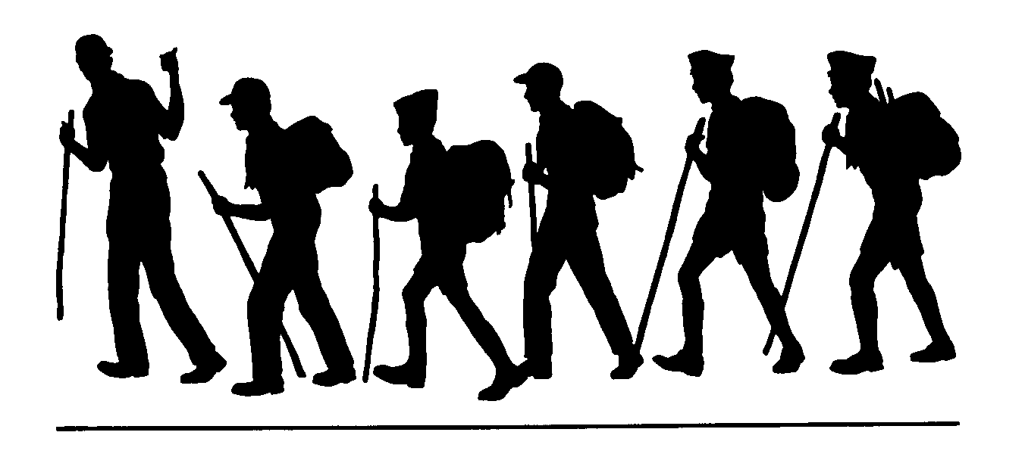
Charity Valley Trail
Humboldt-Toiyabe National Forest Carson Ranger District
General Location: Grover’s Hot Springs State Park, Markleeville, CA or Blue Lakes Road off Hwy. 88, CA.
Comments:
Wide vistas, craggy rock faces and a brisk (seasonal) stream are some of the pleasures of this scenic trail. This hike has the virtue of being mostly downhill if you begin at the Blue Lakes trailhead. The opposite is true if you begin at Grover’s Hot Springs. A personal preference is to do this as a one way trip with one car left at Grover’s as part of a car shuttle. This provides a scenic and not too strenuous walk beginning from Blue Lakes Road, with the reward of a soak at the Hot Springs or a dip in the cold pool at the end of the day. Just don’t forget your keys and remember there is an admission fee to Grover’s Hot Springs State Park.
Trailhead:
Choice A, From Markleeville head west along Hot Springs Road towards Grover’s Hot Springs State Park. In about 3 miles look to your right for a sign saying Charity Valley. Parking is available here, or if you wish to shorten the hiking distance by one mile each way, enter Grover’s Hot Springs and follow the entrance road until it dead ends at an overflow parking area. This well signed area is where the trail begins.
Choice B, Traveling west through Hope Valley along Hwy 88, turn left at Blue Lakes Road. Look for the Charity Valley trail sign to your left after traveling about 6 miles up Blue Lakes Road. The trailhead is on the ridge just before dropping into Charity Valley. The sign is inconspicuous and easy to miss, but is located before the end of the paved road. Park across the road, or in one of several nearby pull-outs.
Remember:
Always carry drinking water. Prevent erosion, follow the trail and don’t cut switchbacks. Keep trails clean by packing out what you pack in. Protect plants and wildlife. LEAVE NO TRACE

Length (one way)
8 miles
Season
June to December or until first snow

Difficulty
Moderate

Maps
Mokelumne Wilderness
USGS 7.5
Markleeville
Carson Pass

Elevation
Grover’s Hot Springs 6240’
Blue Lakes Trailhead 8640’

Carson Ranger District 1536 South Carson Street Carson City, Nevada 775-882-2766

