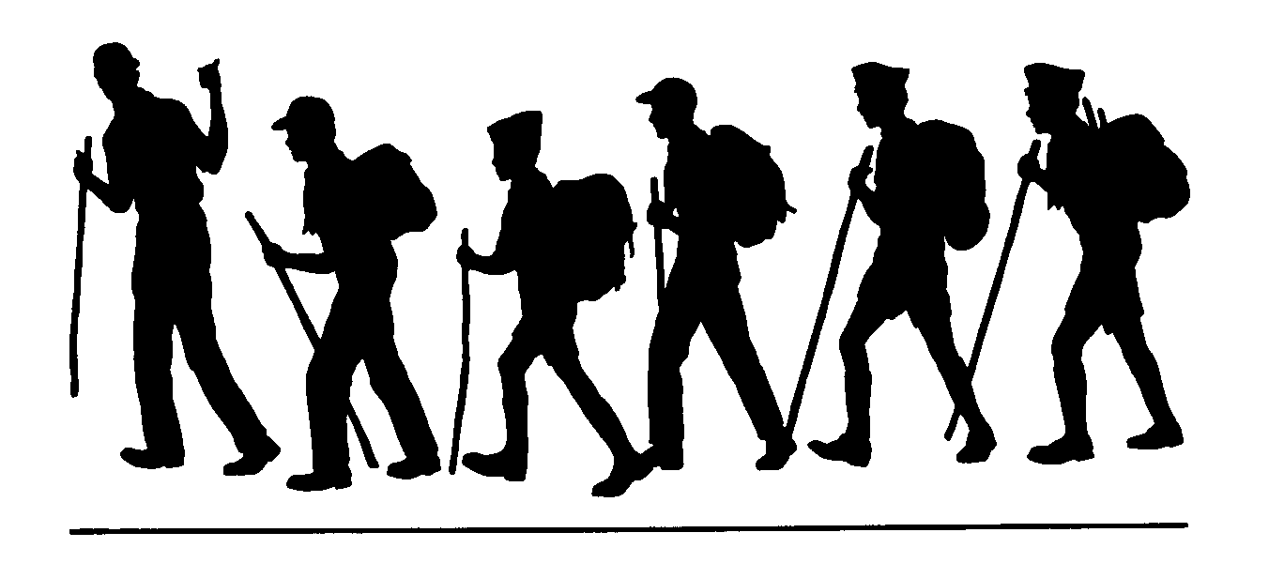
Corral Valley Trail
Humboldt-Toiyabe National Forest Carson Ranger District
General Location: Coleville/Walker, California
Comments:
The Corral Valley/Driveway Trail begins with a steep ascent through thickly forested areas of White Fir, Sierra Red Fir, Western White Pine and Lodgepole Pine. The trail levels off onto a sagebrush, volcanic rock saddle which offers a spectacular view of the Carson-Iceberg Wilderness and of Slinkard and Bagley Valleys, and an eagles-eye view of the Topaz Lake area and beyond.
A historic Basque “Ari Mutillak” (chimney like rock stack) is seen off to the side of this trail. Also of interest along the Corral Valley Trail, look for an enormous two trunked juniper tree with a diameter of 12 feet and a girth of 36 feet. This tree may be the largest, living juniper in the Sierra Mountain Range.
Corral Valley Creek and Coyote Valley Creek host the Paiute Cutthroat Trout, a threatened species. No fishing is allowed.
Trailhead:
Drive south on Hwy. 395 through Minden and Gardnerville to just south of Coleville, CA. (If you get to Walker, you have gone too far.) Turn west on Mill Canyon Road and go up the hill staying to the right at the first intersection. It’s about 5 ½ miles to Rodriquez Flat. At Rodriquez Flat turn left to the trailhead for the Corral Valley and Driveway Trails. Please avoid parking at Little Antelope Pack Station as parking there is for a station’s clients.
This trailhead is a gateway into the Carson-Iceberg Wilderness and a map is strongly recommended to help you navigate the many trails in this area. Corral Valley Trail and Driveway Trail begin at the same trailhead. At the fork on the saddle, the Driveway Trail is to the right, Corral Valley is to the left. The Driveway Trail is noted on some maps and not on others. The trail itself is signed. Follow either trail and loop along the other for a beautiful, long day hike.
Remember:
Always carry drinking water. Prevent erosion, follow the trail and don’t cut switchbacks. Keep trails clean by packing out what you pack in. Protect plants and wildlife. LEAVE NO TRACE

Length (one way)
Corral Valley/Driveway
Trail Loop ~ 12 miles
Season
May/June-November
or first snow fall
Maps
Carson-Iceberg Wilderness
USGS 7.5
Coleville
Lost Cannon Peak
Disaster Peak
Elevation
Rodriquez Flat 7680’
Saddle Trail Junction 8720’
Corral Valley 7900’

Carson Ranger District 1536 South Carson Street Carson City, Nevada 775-882-2766

