[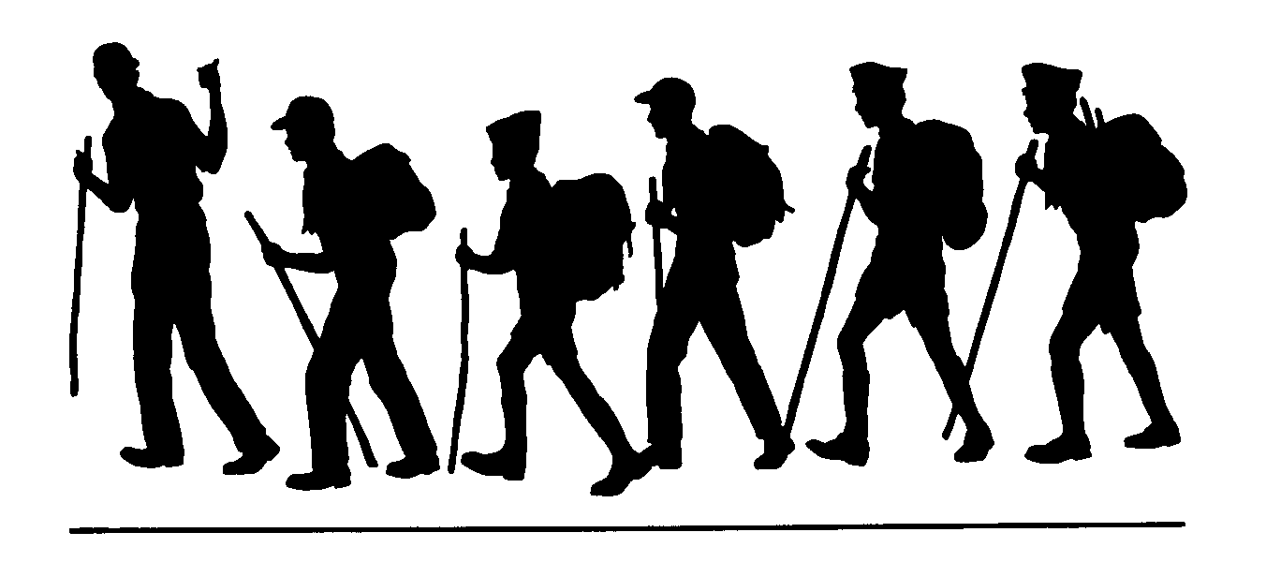](https://www.google.com/url?sa=i&url=https://www.clipart.email/clipart/family-hiking-clipart-black-and-white-278388.html&psig=AOvVaw13JGbr3YVn3H-LI7b9a1xB&ust=1587497326660000&source=images&cd=vfe&ved=0CAIQjRxqFwoTCMDP4sne9-gCFQAAAAAdAAAAABAF)

**Granite Lake Trail**

**Humboldt-Toiyabe National Forest Carson Ranger District**

**General Location:** Blue Lakes Road off Hwy 88 in Hope Valley, CA

**Comments:**

Granite Lake is popular with fishermen. It is a clear, high mountain lake that is very accessible. The trail continues from Granite Lake into open country with unique rock formations and wide vistas, but no other specific destination.

**Trailhead:**

Traveling west along Hwy ii through Hope Valley, turn left at the signed Blue Lakes Road turn off. After about 6 miles the paved road ends and you continue on a good dirt road through lower Blue Lakes Campground and Middle Creek Campground. Park at the dam between the two lakes.

There are several paths leading from the parking area. Follow the one leading left that looks most used. The trails usually lead to the main trail or fade out causing you to retrace your steps. Note the way you travel to avoid confusion on you return trip.

**Remember:**

Always carry drinking water. Prevent erosion, follow the trail and don’t cut switchbacks. Keep trails clean by packing out what you pack in. Protect plants and wildlife. LEAVE NO TRACE

**Length (one way)**

About 1 ½ miles. The trail

goes further.

**Season**

Late June to December

or until first snow

**Difficulty**

Easy-Moderate

**Maps**

Mokelumne Wilderness

**USGS 7.5**

Carson Pass

Pacific Valley

**Elevation**

Granite Lake 8700’

**Carson Ranger District 1536 South Carson Street Carson City, Nevada 775-882-2766**