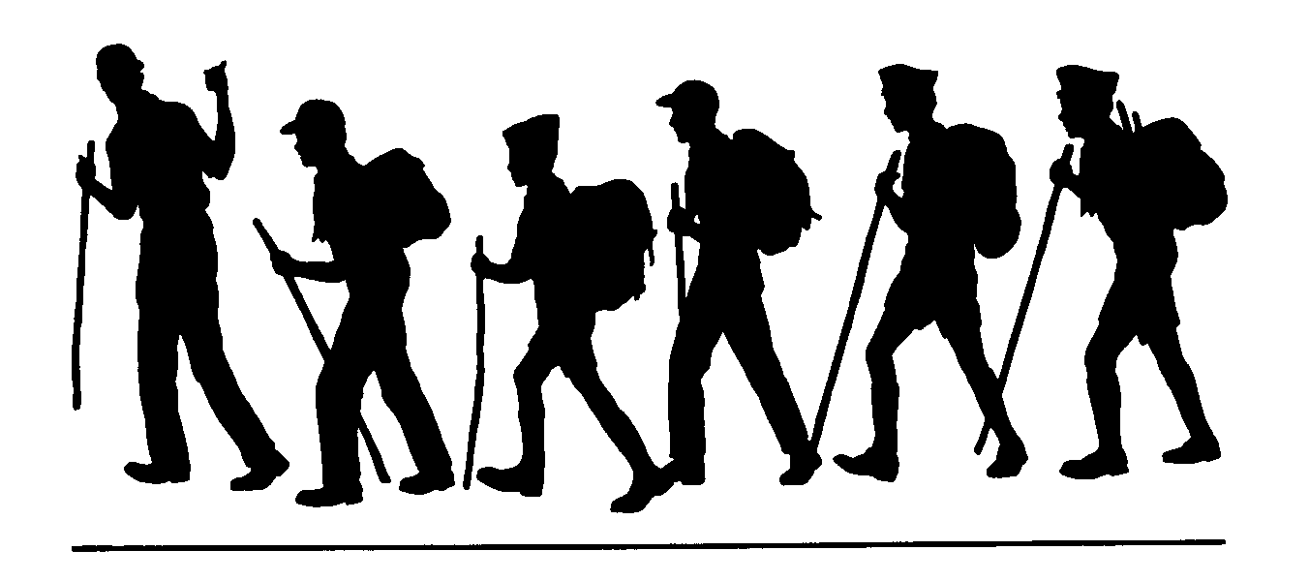
Wolf Creek Trail
Asa Lake and Bull Lake
Humboldt-Toiyabe National Forest Carson Ranger District
General Location: Carson-Iceberg Wilderness, Markleeville, CA
Comments:
The Wolf Creek hike takes you into the Carson-Iceberg Wilderness. Leaving from Wolf Creek Meadow Parking area, the trail follows the creek. At about mile 5 you will come to the junction of the Bull Canyon Trail. This trail departs to the right and climbs steeply to the west, leading you to Bull Lake.
At about mile 6 on the Wolf Creek Trail you will find the Murray Canyon Trail departing to the left. This trail will lead you to the East Carson River Trail. If you continue to the right, you will find yourself on the Elder Creek Trail which will lead you eventually to the Pacific Crest Trail. Asa Lake is a short distance north on the PCT.
Trailhead:
From Markleeville, CA drive south on Highway 4 to Centerville Flats, then left on to Wolf Creek Road and then on to Wolf Creek Meadows. At the south end of the meadows is the trailhead for the Wolf Creek Trail. At the trailhead you will be able to self-register for an overnight permit for use of the wilderness.
Remember:
Always carry drinking water. Prevent erosion, follow the trail and don’t cut switchbacks. Keep trails clean by packing out what you pack in. Protect plants and wildlife. LEAVE NO TRACE

Length (one way)
Bull Lake 5 miles
PCT 8 miles
Asa Lake 8.5 miles
Season
May/June until first snow until first snowfall.
Difficulty
Easy to Bull Lake Junction then moderate too strenuous after Junction.
Maps
Carson-Iceberg Wilderness
USGS 7.5
Wolf Creek
Disaster Peak
Dardanelle Cone
Elevation
Beginning 6240’
Bull Lake 8640’
Junction PCT 8400’
Asa Lake 8250’

Carson Ranger District 1536 South Carson Street Carson City, Nevada 775-882-2766

