
Building Inspection Report

123 STREET NAME CITY NAME, STATE NAME

Inspection Date:
10-11-12

Prepared For:
JOHN DOE

Prepared By:
REGIONAL HOME INSPECTION SERVICES OF NEW JERSEY
P.O. BOX 1664
MEDFORD, NJ 08055

609-654-2244
609-654-0229 Fax
Lic #24G100023800
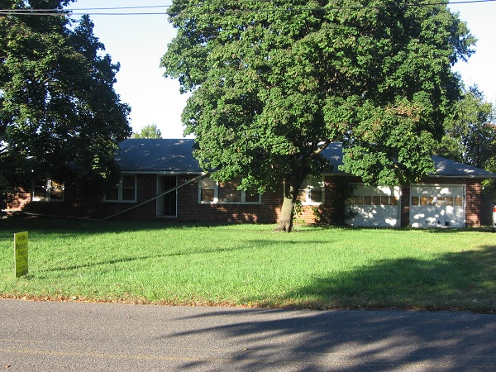
Report Number:

Inspector:
SCOTT M. LANG

© 2026 REGIONAL HOME INSPECTION SERVICES OF NEW JERSEY

Table Of Contents
Report Overview 3
Structure 6
Roofing 9
Exterior 11
Electrical 13
Heating 15
Cooling / Heat Pumps 17
Insulation / Ventilation 18
Plumbing 19
Interior 21
Appliances 23
Standards of Practice 24
Maintenance Advice 32

Report Overview

THE HOUSE IN PERSPECTIVE
The house in perspective is a 63 year old, detached, frame, single-family, vacant, ranch-style dwelling. It consists of a 1st floor: foyer, living and dining rooms, kitchen, 3 bedrooms, family room, bath, mud-room, and pantry.
This is a well-built home. Numerous improvements are needed. As with all homes, ongoing maintenance is also required. While the improvements that are recommended in this report are not considered unusual for a home of this age and location, the number of improvements is unusual. Please remember, however, that there is no such thing as a perfect home.

CONVENTIONS USED IN THIS REPORT
For your convenience, the following conventions have been used in this report.
Major Concern: a system or component, which is considered significantly deficient or is unsafe. Significant deficiencies need to be corrected and, except for some safety items, are likely to involve significant expense.
Safety Issue: denotes a condition that is unsafe and in need of prompt attention.
Repair: denotes a system or component which is missing or which needs corrective action to assure proper and reliable function.
Improve: denotes improvements, which are recommended but not required.
Monitor: denotes a system or component needing further investigation and/or monitoring in order to determine if repairs are necessary.
Please note that those observations listed under “Discretionary Improvements” are not essential repairs, but represent logical long-term improvements.
- For the purpose of this report, it is assumed that the house faces east.

IMPROVEMENT RECOMMENDATION HIGHLIGHTS / summary
The following is a synopsis of the potentially significant improvements that should be budgeted for over the short term. Other significant improvements, outside the scope of this inspection, may also be necessary. Please refer to the body of this report for further details on these and other recommendations.
- Improve: All wood debris, abandoned mechanical systems, and/or trash should be removed from the crawl space. Organic debris around a property increases risk of insect or rot damage.
- Repair: Dead mice were noted at the crawl, house, and attic. Treatment and removal is needed.
• Repair: Damaged crawl entry and frame will need replacing.
- Repair: Standing water was observed in the crawl space. See photos #2 and #9. Wet crawl spaces risk building damage from rot and insects and can cause interior mold or mildew. Roof and lot drainage repairs or improvements should be addressed as a first step to controlling water in the crawl space (see “Exterior”). Adding 1 or more sump pumps is necessary. This condition should then be monitored to determine if additional, potentially costly measures are necessary.
- Repair: The floor structure and sill plate shows evidence of minor rot at the south-side crawl, etc. Rot weakens the structure and causes distress to the building. Damaged wood should be repaired or replaced and the conditions that have promoted the rot (such as wet conditions and/or poor ventilation) should be remedied.
- Repair: Mildew or mold was found in various locations of the crawl and attic. See photo #3. This is usually due to improper ventilation. One (1) square foot of free vent area should be provided for every five hundred (500) square feet of crawl space. Proper ventilation helps control humidity and reduces the risk of rot. Crawl spaces can be vented to the building interior or exterior, depending on crawl space configuration. See also Ventilation pages.
- Repair: Some evidence of roof leaks was observed at the attic stacks, etc. Please refer to the Roofing section of the report for recommendations.
- Repair: Evidence of termite damage was observed at the south-side crawl framing, etc. and there is risk of additional hidden damage since termites can do a substantial amount of damage. If the property has not already been treated, a licensed pest control specialist should be engaged to eliminate further termite activity within the home. Damaged wood should be repaired or replaced by a qualified contractor. Any wood soil contact should be eliminated.
- Repair: The flashings at the stack piping leaks and should be replaced. Piping repairs are also needed and had apparently been stripped.
- Repair: The flashings or cover at the attic fan r and at the electric masthead are damaged and should be repaired to avoid leaks.
- Repair: The cap of the masonry chimney was cracked or damaged and should be replaced. See photo #4. The chimney flue should be checked for damage. Damaged flues can be unsafe.
- Repair: Damaged or missing gutters at most areas should be repaired or replaced as necessary to avoid spilling roof runoff around the building – a potential source of water entry or water damage. See photo #5.
- Repair: Localized rot and damage was observed in the fascia (the wooden board to which the gutter is typically fastened). Improvements are needed.
- Repair: Damage to the eave in various locations is suspected to be the result of vermin activity. Repairs are needed. Depending on the nature of the vermin activity, consulting an animal control specialist may be desirable.
- Major Concern, Repair: The window frames require painting and caulking or capping.
- Repair: The old windows where original are in need of glazing (putty) improvements.
- Possible Major Concern, Repair, Safety Issue: Both overhead garage doors are substantially rotted and did not operate normally. They should be repaired or replaced as necessary.
- Repair: Both garage door openers did respond but would not open doors fully. They should be repaired as necessary.
- Repair, Safety Issue: The door between the garage and the interior of the house should be rated to resist fire as per local codes. Hollow core doors do not meet this requirement.
• Major Concern: Inspection of the electrical system revealed the need for numerous repairs and several damaged wires were noted. These should be high priority for safety reasons. Unsafe electrical conditions represent a shock hazard. A licensed electrician should be consulted to undertake the repairs recommended below.
- Repair: Abandoned wiring throughout the attic should be replaced or appropriately terminated. See photo #6.
- Repair: Damaged wiring throughout the attic should be replaced or appropriately repaired. See photo #7.
- Repair: Wiring exposed on interior finishes at the garage should be relocated or protected by a rigid conduit.
- Repair: Improper electrical connections should be repaired. All electrical connections should be made inside junction boxes fitted with cover plates.
- Repair: All junction boxes in the attic should be fitted with cover plates, in order to protect the wire connections.
• Repair: Attic located York handler or heat pump did respond at its’ fan only. Exterior condensing unit had been removed and will require replacing. See below and Cooling.
• Repair: Damaged attic ducting will need repairs.
- Major Concern, Repair: It is suspected that an underground oil storage tank exists on the property at the rear yard. See photo #8. If the tank has leaked you could face a costly environmental cleanup task since the US EPA has indicated that leaky residential oil tanks are an environmental hazard for which Federal spill cleanup regulations could apply. Buried tanks which have not leaked can be opened, cleaned, and filled in-place or they can be removed entirely. Before purchasing the property you should have the tank or soil tested to assure that no leaks have occurred. If the tank is to continue in use it may be possible to purchase tank leak cleanup insurance, possibly through your oil company. Tank replacement with a newer (fiberglass) leak-resistant type or tank relocation indoors will also involve a significant expense.
- Repair: Evidence of condensation, mold, and/or mildew was observed at the rear attic. This condition is usually the result of insufficient ventilation. Ventilation should be improved and this area should be monitored. If ignored, this situation could worsen and cause substantial rot.
- Repair: The power ventilator appears to be inoperative and damaged.
• Monitor, Repair: No water supply exists. Tank is present at the crawl. No well pump is visible. Repairs and restoring service are needed.
• Repair: Damaged crawl piping will need replacing or major re-piping.
- Repair: The waste piping is leaking and damaged at the crawl. See photo #9.
- Monitor, Repair: Water damage was noted at the garage and chimney.
- Monitor, Repair: The installation of interior finishes and trim is incomplete throughout.
- Major Concern, Repair: Apparent V.A. (vinyl asbestos) floor tile was noted at the family room. Covering or removing the deficient tile is needed.
• Improve: Most windows had been blocked off and boarded up throughout.
• Monitor, Repair: Laundry, kitchen, and other appliances and all fixtures were removed.

THE SCOPE OF THE INSPECTION
All components designated for inspection in the ASHI® Standards of Practice are inspected, except as may be noted in the “Limitations of Inspection” sections within this report.
It is the goal of the inspection to put a homebuyer in a better position to make a buying decision. Not all improvements will be identified during this inspection. Unexpected repairs should still be anticipated. The inspection should not be considered a guarantee or warranty of any kind.
This inspection is visual only. Representative samples of building components are viewed in areas that are accessible at the time of the inspection. No destructive testing or dismantling of building components is performed.

Please refer to the pre-inspection contract for a full explanation of the scope of the inspection.
WEATHER CONDITIONS
Dry weather conditions prevailed at the time of the inspection.
The estimated outside temperature was 45 degrees F.
RECENT WEATHER CONDITIONS
Occasional rain has been experienced in the days leading up to the inspection.

Structure

description of Structure

Foundation: •Concrete Block •Poured Concrete •Not Visible •Crawl Space Configuration •Inspection Was By Direct Access at Main House •Mud-Room or Family Room Crawl Space Not Accessible •Slab on Grade Garage•15% Of Foundation Was Not Visible
Columns: •Concrete Block
Floor Structure: •Wood Joist •Concrete •Not Visible
Wall Structure: •Wood Frame
Ceiling Structure: •Joist
Roof Structure: •Rafters •Plywood Sheathing

Structure observations
Positive Attributes
The construction of the home is high quality. The materials and workmanship, where visible, are above average. The inspection did not discover evidence of substantial structural movement. Concrete crawl space floor was noted.
General Comments
Typical minor flaws and significant standing water were detected in the structural components of the building. Some repairs, pumping out the crawl water, and re-inspection are needed. See below.
The garage was constructed on slab, negating inspection of the foundation, framing, etc. at this area. Termite or pest activity and/or damage were found. See below.
Frame floors and roof were apparent.

recommendations / observations
Foundation
- Monitor: Common minor settlement cracks were observed in the foundation walls in various locations. This implies that some structural movement of the building has occurred. Cracks of this type should be sealed and watched for any sign of additional movement. In the absence of any sign of ongoing movement, other repairs should not be necessary.
• Monitor: The exposed block foundation did appear generally satisfactory.
• Improve: Sealing the openings in the foundation is needed.
Crawl Space
- Improve: All wood debris, abandoned mechanical systems, and/or trash should be removed from the crawl space. Organic debris around a property increases risk of insect or rot damage.
- Improve: All potential vermin entry points to the crawl space should be sealed to reduce risk of pest activity or damage.
- Improve: There is evidence of vermin activity in the crawl space. A pest control specialist should be consulted for treatment and control advice.
- Repair: Dead mice were noted at the crawl, house, and attic. Treatment and removal is needed.
• Repair: Damaged crawl entry and frame will need replacing.
- Repair: Standing water was observed in the crawl space. See photos #2 and #9. Wet crawl spaces risk building damage from rot and insects and can cause interior mold or mildew. Roof and lot drainage repairs or improvements should be addressed as a first step to controlling water in the crawl space (see “Exterior”). Adding 1 or more sump pumps is necessary. This condition should then be monitored to determine if additional, potentially costly measures are necessary.
Floors
• Monitor: Exposed floor framing did appear generally functional, with the noted exceptions.
- Monitor: The floor structure shows common sagging and movement. This is usually the result of the age and framing design of the building. There was not evidence of need for immediate, costly repair.
• Repair: Visible pest or termite activity and/or damage were observed. See photo #1. Repairs and/or treatment by qualified contractors are needed.
- Repair: The floor structure and sill plate shows evidence of minor rot at the south-side crawl, etc. Rot weakens the structure and causes distress to the building. Damaged wood should be repaired or replaced and the conditions that have promoted the rot (such as wet conditions and/or poor ventilation) should be remedied.
- Repair: Mildew or mold was found in various locations of the crawl and attic. See photo #3. This is usually due to improper ventilation. One (1) square foot of free vent area should be provided for every five hundred (500) square feet of crawl space. Proper ventilation helps control humidity and reduces the risk of rot. Crawl spaces can be vented to the building interior or exterior, depending on crawl space configuration. See also Ventilation pages.
- Repair: Damaged subflooring (supporting layer of flooring atop floor joists and below finish flooring or carpeting) was found at the bath. This material should be re-supported or replaced. Some repairs had been completed.
Roof
• Monitor: 16” on-center rafter framing was noted.
- Monitor, Repair: Evidence of condensation was observed on the underside of the roof sheathing. See photo #3. This can weaken the sheathing and ultimately necessitate replacement. Improved roof and attic ventilation (see Insulation and Ventilation) can reduce condensation. During re-roofing, the sheathing should be investigated to determine if replacement is needed.
- Repair: Some evidence of roof leaks was observed at the attic stacks, etc. Please refer to the Roofing section of the report for recommendations.
Wood Boring Insects
- Monitor: This home is in an area known for termite activity. Termites can do a substantial amount of damage to the wood structural components of a home. Any form of wood/soil contact should be avoided. Controlling dampness in the soil around the perimeter of a home, including below porches and in crawl spaces, is recommended. Preventative chemical treatment, performed by a licensed pest control specialist, is also advisable.
• Monitor: Indications of previous termite treatment was noted. Further information and warranty should be obtained.
- Improve: Evidence of termite activity and tubing was observed at the crawl and there is risk of additional hidden damage. See photo #1. If the property has not already been treated, a licensed pest control specialist should be engaged. Further evaluation and/or repairs by a qualified contractor are needed.
- Repair: Evidence of termite damage was observed at the south-side crawl framing, etc. and there is risk of additional hidden damage since termites can do a substantial amount of damage. If the property has not already been treated, a licensed pest control specialist should be engaged to eliminate further termite activity within the home. Damaged wood should be repaired or replaced by a qualified contractor. Any wood soil contact should be eliminated.
- Monitor: Conditions that are attractive to wood boring insects should be avoided since they can damage the property. These conditions include the storage of wood in damp environments, wood/soil contact around the perimeter of the home (decking, siding, etc.), damp soils, leaky roofs, and unventilated spaces (roofs, garages, crawl spaces, etc.).
Discretionary Improvements
If heavy objects (pianos, bookcases, china cabinets, etc.) are going to be placed in the building, strengthening of the floor structure is desirable in those areas.

limitations of Structure inspection
As we have discussed and as described in your inspection contract, this is a visual inspection limited in scope by (but not restricted to) the following conditions:
- Structural components concealed behind finished surfaces could not be inspected.
- Only a representative sampling of visible structural components were inspected.
- Furniture and/or storage restricted access to some structural components.
- Engineering or architectural services such as calculation of structural capacities, adequacy, or integrity are not part of a home inspection.
- No access was gained to the family or north-side mud-room crawl space(s).

Please also refer to the pre-inspection contract for a detailed explanation of the scope of this inspection.

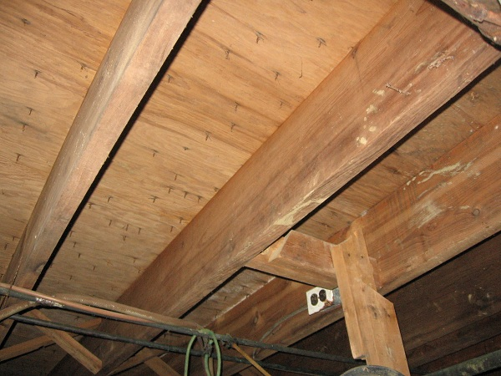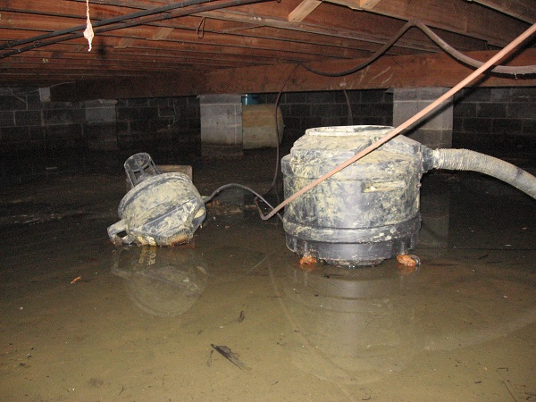

Photo #1 Photo #2

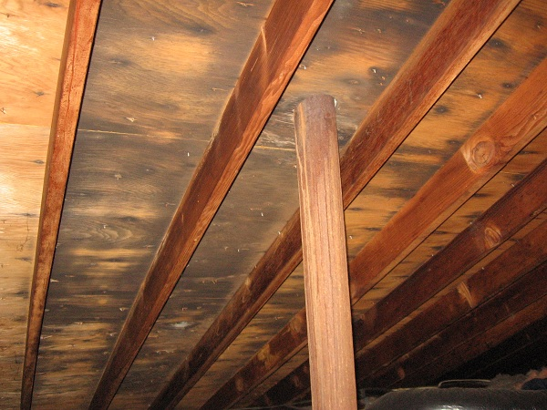

Photo #3

Roofing

description of Roofing

Roof Covering: •Asphalt Shingle
Roof Flashings: •Metal
Chimneys: •Masonry
Roof Drainage System: •Aluminum •Downspouts discharge above grade
Skylights: •None
Method of Inspection: •Walked on roof

Roofing observations
General Comments
In all, the shingled roof coverings show evidence of normal wear and tear for a home of this age. Trim away tree branches close to the roof.

recommendations / observations
Sloped Roofing
- Monitor: Most of the shingled roofing is in fair condition.
- Monitor: Frame, hip-style roof exists.
- Monitor: The roofing at the front is in fair condition but shows evidence of moss and organic build up in shaded areas. This condition may reduce the life expectancy of the roofing. Trimming or removing trees could improve this condition.
- Improve: Debris should be removed from the roofing to reduce risk of leaks and early roof wear.
• Monitor: It is recommended that the present layers of roofing materials be removed prior to re-roofing. Two roofing layers exist. This adds cost of demolition and debris removal to the re-roof cost.
- The south and west sides of a roof typically wear faster than the balance of the roof, while the other exposures of the roof may last for a longer period of time. If the best roof sections have less than five years of remaining life when the worst sections already need replacement it is usually logical to replace all roof slopes during re-roofing.
Flashings
- Repair: The flashings at the stack piping leaks and should be replaced. Piping repairs are also needed and had apparently been stripped.
- Repair: The flashing at the chimney, roof vents, etc. are rusting. It should be painted to extend its life.
- Repair: The flashings or cover at the attic fan r and at the electric masthead are damaged and should be repaired to avoid leaks.
Chimneys
- Repair: The masonry chimney needs re-pointing (replacing the mortar between the bricks) to avoid water damage.
- Repair: The cap of the masonry chimney was cracked or damaged and should be replaced. See photo #4. The chimney flue should be checked for damage. Damaged flues can be unsafe.
- Repair: A rain cap and vermin screen should be installed on the masonry chimney and the chimney flue should be checked for damage. See photo #4. Damaged flues can be unsafe.
- Monitor: The chimney is no longer in service. It could be removed down to a level below the roof line.
Gutters & Downspouts
- Repair: The gutters require cleaning to avoid spilling roof runoff around the building – a potential source of water entry or water damage.
- Repair: Damaged or missing gutters at most areas should be repaired or replaced as necessary to avoid spilling roof runoff around the building – a potential source of water entry or water damage. See photo #5.
- Repair: Loose or damaged downspouts at all areas should be repaired promptly.
• Repair: Missing elbows of the downspouts at most areas will need replacement.
- Repair: It is recommended that gutters and downspouts be installed where missing to avoid spilling roof runoff around the building – a potential source of water entry or water damage. See also photos below.
Discretionary Improvements
A drip edge flashing should be installed around the perimeter of the roof to ensure that water drains from the roof directly into the gutters. This flashing also helps protect the roof sheathing from damage at the eave.
As a preventative measure, it may be wise to redirect all downspouts so they discharge at least five (5) feet from the house.
The installation of rain caps and vermin screens on chimneys is a logical improvement.

limitations of Roofing inspection
As we have discussed and as described in your inspection contract, this is a visual inspection limited in scope by (but not restricted to) the following conditions:
- Not the entire underside of the roof sheathing is inspected for evidence of leaks.
- Interior finishes may disguise evidence of prior leaks.
- Estimates of remaining roof life are approximations only and do not preclude the possibility of leakage. Leakage can develop at any time and may depend on rain intensity, wind direction, ice build up, and other factors.
- Antennae, chimney/flue interiors that are not readily accessible are not inspected and could require repair.
- Roof inspection may be limited by access, condition, weather, or other safety concerns.

Please also refer to the pre-inspection contract for a detailed explanation of the scope of this inspection.

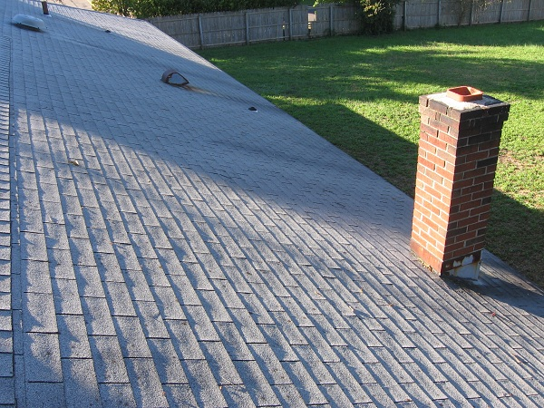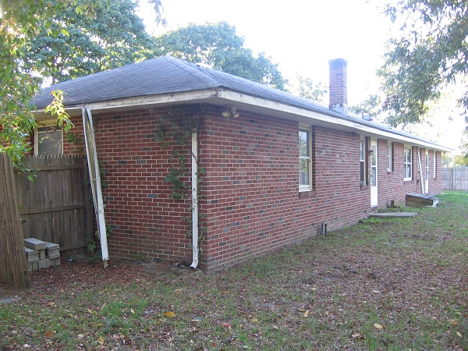

Photo #4 Photo #5

Exterior

description of Exterior

Wall Covering: •Brick
Eaves, Soffits, And Fascias: •Wood
Exterior Doors: •Solid Wood
Window/Door Frames and Trim: •Wood •Metal-Covered •Metal
Entry Driveways: •N/A
Entry Walkways And Patios: •Concrete
Porches, Decks: •Concrete •Brick
Steps, Railings: •Concrete •Brick
Overhead Garage Door(s): •Wood (2)
Surface Drainage: •Level Grade
Retaining Walls: •None
Fencing: •Wood

Exterior observations
Positive Attributes
The house has all brick constructed exterior walls. Portions of the windows had been previously replaced. The garage is completely finished.
General Comments
The exterior of the home has been badly neglected. Major repairs will be necessary to bring it up to acceptable standards.

recommendations / observations
Exterior Walls
- Repair: Damaged moldings at the garage, crawl entry, etc. should be replaced.
Exterior Eaves
- Repair: The soffit and fascia should be painted.
- Repair: Localized rot and damage was observed in the fascia (the wooden board to which the gutter is typically fastened). Improvements areneeded.
- Repair: Damage to the eave in various locations is suspected to be the result of vermin activity. Repairs are needed. Depending on the nature of the vermin activity, consulting an animal control specialist may be desirable.
• Repair: Damaged soffit was noted in various locations. Repairs are needed.
- Repair: Tree branches should be trimmed away from the house.
Windows
- Major Concern, Repair: The window frames require painting and caulking or capping.
- Repair: The old windows where original are in need of glazing (putty) improvements.
Garage
- Possible Major Concern, Repair, Safety Issue: Both overhead garage doors are substantially rotted and did not operate normally. They should be repaired or replaced as necessary.
- Repair, Safety Issue: The overhead garage doors require adjustment for easy and safe operation.
- Repair, Safety Issue: No safety springs/cables were noted on the garage door springs. The installation of the springs/cables would improve safety during operation.
- Repair: Both garage door openers did respond but would not open doors fully. They should be repaired as necessary.
- Repair, Safety Issue: The door between the garage and the interior of the house should be rated to resist fire as per local codes. Hollow core doors do not meet this requirement.

Lot Drainage
- Major Concern, Repair: The grading should be improved to promote the flow of storm water away from the house at all sides. This can often be accomplished by the addition of topsoil. The ground should slope away from the house at a rate of one inch per foot for at least the first ten feet. At least eight (8) inches of clearance should be maintained between soil level and the bottom of exterior wall siding.
Steps
• Repair: Poor mortar at the front entry will need repointing.
Landscaping
- Repair: Tree branches and bushes should be trimmed away from the house to avoid damage to the building.
- Repair: Vines growing on exterior walls and fence should be kept trimmed away from siding, window trims, and the eaves to reduce risk of insect and water damage.
Fencing
- Major Concern, Repair: The fencing is in poor condition. Replacement will be necessary.
- Improve: The fencing should be painted or stained to prolong its life.
Discretionary Improvements
To reduce long term maintenance and improve appearance, it may be advantageous to install aluminum soffit and fascia. This improvement can involve significant cost.
Installing replacement windows in place of the original windows at the living room, rear house, etc. would be a logical long term goal. This is a major expense.

limitations of Exterior inspection
As we have discussed and as described in your inspection contract, this is a visual inspection limited in scope by (but not restricted to) the following conditions:
- A representative sample of exterior components was inspected rather than every occurrence of components.
- The inspection does not include an assessment of geological, geotechnical, or hydrological conditions, or environmental hazards.
- Screening, shutters, awnings, or similar seasonal accessories, fences, recreational facilities, outbuildings, seawalls, break-walls, docks, erosion control and earth stabilization measures are not inspected unless specifically agreed-upon and documented in this report.

Please also refer to the pre-inspection contract for a detailed explanation of the scope of this inspection.

Electrical

description of Electrical

Size of Electrical Service: •120/240 Volt Main Service - Service Size: 200 Amp
Service Drop: •Overhead
Service Entrance Conductors: •Aluminum
Service Equipment &
Main Disconnects: •Main Service Rating 200 Amps •Breakers •Located: Garage
Service Grounding: •Copper
Service Panel &
Overcurrent Protection: •Panel Rating: 200 Amp •Breakers •Located: Garage
Sub-Panel(s): •None Visible
Distribution Wiring: •Copper •Aluminum-Multi-Strand
Wiring Method: • Non-Metallic Cable "Romex"
Switches & Receptacles: •Grounded and Ungrounded
Ground Fault Circuit Interrupters: •None Found
Smoke Detectors: •Present

Electrical observations
Positive Attributes
The size of the electrical service is sufficient for typical single family needs. The service and entry cables, meter and panel had been replaced.
General Comments
Major Concern: Inspection of the electrical system revealed the need for numerous repairs and several damaged wires were noted. These should be high priority for safety reasons. Unsafe electrical conditions represent a shock hazard. A licensed electrician should be consulted to undertake the repairs recommended below.

recommendations / observations
Service / Entrance
• Repair: Clearing the tree limbs off the service cable are needed.
Main Panel
• Monitor: 200-amp panel and main are generally satisfactory and were not original.
• Repair: Missing panel screws will need replacing.
Distribution Wiring
- Repair: Abandoned wiring throughout the attic should be replaced or appropriately terminated. See photo #6.
- Repair: Damaged wiring throughout the attic should be replaced or appropriately repaired. See photo #7.
- Repair: Wiring exposed on interior finishes at the garage should be relocated or protected by a rigid conduit.
- Repair: Improper electrical connections should be repaired. All electrical connections should be made inside junction boxes fitted with cover plates.
- Repair: All junction boxes in the attic should be fitted with cover plates, in order to protect the wire connections.
- Repair: The installation of the distribution wiring in the attic is non-standard. It is suspected that the installation was performed by an amateur, rather than a licensed electrician.
Outlets
- Repair: Outlets at most rooms are loose. They should be replaced.
- Repair: Missing outlet cover plates throughout the home and garage should be replaced to avoid a shock hazard.
Switches
- Repair: The damaged light switch at the mud room, rear entry, etc. should be repaired.
- Repair: The missing switch cover plates throughout will need installation.
Lights
- Repair: The light(s) at the front and rear entries is inoperative. If the bulbs are not blown, the circuit should be repaired.

limitations of Electrical inspection
As we have discussed and as described in your inspection contract, this is a visual inspection limited in scope by (but not restricted to) the following conditions:
- Electrical components concealed behind finished surfaces are not inspected.
- Only a representative sampling of outlets and light fixtures were tested.
- Furniture and/or storage restricted access to some electrical components, which may not be inspected.
- The inspection does not include remote control devices, alarm systems and components, low voltage wiring, systems, and components, ancillary wiring, systems, and other components, which are not part of the primary electrical power distribution system.

Please also refer to the pre-inspection contract for a detailed explanation of the scope of this inspection.

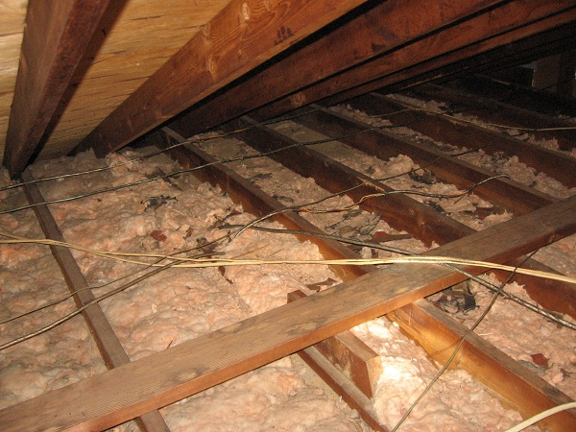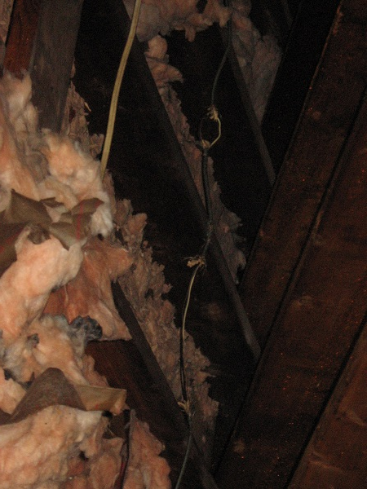

Photo #6 Photo #7

Heating

description of Heating

Energy Source: •Electricity
Heating System Type: •Forced Air Furnace or Heat Pump

Heating observations
General Comments
Electric heat pump did apparently exist. Heat pump did apparently replace an original oil heat system. See below. Tank is apparently still buried at the rear yard. See photo below.

recommendations / observations
Furnace
• Repair: Attic located York handler or heat pump did respond at its’ fan only. Exterior condensing unit had been removed and will require replacing. See below and Cooling.
• Monitor: Previous heat was oil-fired and was at the garage. Chimney, access, and holding tank remain.
Supply Air Ductwork
• Repair: Damaged attic ducting will need repairs.
- Repair: Loose or missing grill covers in various locations will need securing or replacement.
- Repair: Balancing of the ductwork is recommended to improve the distribution of heat supply.
- Improve: Duct cleaning is recommended.
Boiler
• Monitor: The oil boiler was suspected as the original heat and had been removed. See above.
Combustion / Exhaust
- Major Concern, Repair: It is suspected that an underground oil storage tank exists on the property at the rear yard. See photo #8. If the tank has leaked you could face a costly environmental cleanup task since the US EPA has indicated that leaky residential oil tanks are an environmental hazard for which Federal spill cleanup regulations could apply. Buried tanks which have not leaked can be opened, cleaned, and filled in-place or they can be removed entirely. Before purchasing the property you should have the tank or soil tested to assure that no leaks have occurred. If the tank is to continue in use it may be possible to purchase tank leak cleanup insurance, possibly through your oil company. Tank replacement with a newer (fiberglass) leak-resistant type or tank relocation indoors will also involve a significant expense.
- Monitor: Oil fill and vent were noted at the rear.
Thermostat
- Repair: The thermostat cover is missing. Installation is needed.
• Monitor: The location of the thermostat is at the hall in the home.

limitations of Heating inspection
As we have discussed and as described in your inspection contract, this is a visual inspection limited in scope by (but not restricted to) the following conditions:
- The adequacy of heat supply or distribution balance is not inspected.
- The interiors of flues or chimneys, which are not readily accessible, are not inspected.
- The furnace heat exchanger, humidifier, or dehumidifier, and electronic air filters are not inspected.
- Solar space heating equipment/systems are not inspected.

Please also refer to the pre-inspection contract for a detailed explanation of the scope of this inspection.

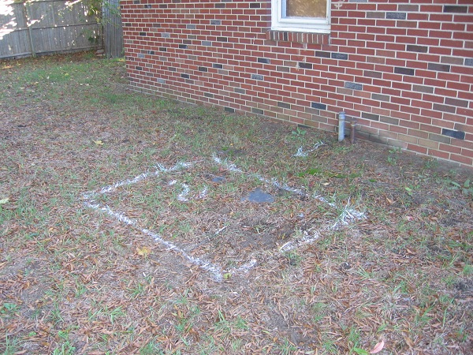

Photo #8

Cooling / Heat Pumps

description of Cooling / Heat Pumps

Energy Source: •Electricity •240 Volt Power Supply
Central System Type: •Air Source Heat Pump System
Other Components: •Air Handler/Fan In Attic

Cooling / Heat Pumps observations
Positive Attributes
The heat pump serves to air-condition the home and provide heat during cooler weather conditions.
General Comments
Missing or removed condensing unit disallowed inspection of the heat pump. See below. Replacing and other repairs are needed. See also Heating.

recommendations / observations
Heat Pump
• Repair: Air conditioning and condensing unit had been removed or stripped. Some lines remain.
• Monitor: Attic handler did operate. A pan is present below the handler and this York unit is stamped and labeled a heat pump.
Supply Air Ductwork
- Improve: Duct cleaning is recommended. Attic duct damage was noted. Repairs are needed.
Thermostat
• Monitor: The thermostat is located at the hall in the home.

limitations of Cooling / Heat Pumps inspection
As we have discussed and as described in your inspection contract, this is a visual inspection limited in scope by (but not restricted to) the following conditions:
- Window mounted air conditioning units are not inspected.
- The cooling supply adequacy or distribution balance are not inspected.

Please also refer to the pre-inspection contract for a detailed explanation of the scope of this inspection.

Insulation / Ventilation

description of Insulation / Ventilation

Attic Insulation: •R13 Fiberglass in Main Attic
Exterior Wall Insulation: •Not Visible
Crawl Space Insulation: •Not Visible
Vapor Retarders: •None Visible
Roof Ventilation: •Roof Vents •Soffit Vents •Power Ventilator
Crawl Space Ventilation: •Exterior Wall Vents

Insulation / Ventilation observations
General Comments
As is typical of homes of this age and construction, insulation levels are relatively modest.

recommendations / Energy saving Suggestions
Attic / Roof
- Insulation improvements may be cost effective, depending on the anticipated term of ownership.
- Repair: Insulation should be evened out.
- Repair: Compressed and some damaged insulation should be rearranged and/or repaired.
- Repair: The level of ventilation should be improved. It is generally recommended that one (1) square foot of free vent area be provided for every one hundred and fifty (150) square feet of ceiling area. Proper ventilation will help to keep the house cooler during warm weather and extend the life of roofing materials. In cold climates, it will help reduce the potential for ice dams on the roof and condensation within the attic.
- Repair: Evidence of condensation, mold, and/or mildew was observed at the rear attic. This condition is usually the result of insufficient ventilation. Ventilation should be improved and this area should be monitored. If ignored, this situation could worsen and cause substantial rot.
- Repair: The power ventilator appears to be inoperative and damaged.
- Repair: There is evidence of vermin activity and droppings. A pest control specialist should be consulted in this regard.
Crawl Space
- Improve: It would be wise to insulate the “rim joist” cavities around the perimeter of the crawl space.
- Repair: Plumbing pipes within the crawl space should be insulated to protect them from freezing.
- Repair: Ventilation of the crawl space is insufficient. One (1) square foot of free vent area should be provided for every five hundred (500) square feet of crawl space. Proper ventilation will help to control humidity and reduce the potential for rot. Crawl spaces can be vented to the building interior or exterior, depending on the configuration of the crawl space.
- Improve: Obstructed crawl space wall vents at most areas should be cleared or opened.

limitations of Insulation / Ventilation inspection
As we have discussed and as described in your inspection contract, this is a visual inspection limited in scope by (but not restricted to) the following conditions:
- Insulation/ventilation type and levels in concealed areas are not inspected. Insulation and vapor barriers are not disturbed and no destructive tests (such as cutting openings in walls to look for insulation) are performed.
- Potentially hazardous materials such as Asbestos and Urea Formaldehyde Foam Insulation (UFFI) cannot be positively identified without a detailed inspection and laboratory analysis. This is beyond the scope of the inspection.
- An analysis of indoor air quality is not part of our inspection unless explicitly contracted-for and discussed in this or a separate report.
- Any estimates of insulation R-values or depths are rough average values.
Please also refer to the pre-inspection contract for a detailed explanation of the scope of this inspection.

Plumbing

description of Plumbing

Water Supply Source: •Private Water Supply
Service Pipe to House: •Plastic •Not Visible
Waste System: •Private Sewage System •Reported by Seller •Reported by Real Estate Representative
Drain, Waste, & Vent Piping: •Copper •Cast Iron •Not Visible
Water Heater: •N/A
Other Components: •Sump Pump

Plumbing observations
General Comments
The plumbing system requires numerous improvements and piping repairs. Both well and septic systems exist. Further evaluation and testing by a qualified contractor is needed.

recommendations / observations
Supply Plumbing
• Monitor, Repair: No water supply exists. Tank is present at the crawl. No well pump is visible. Repairs and restoring service are needed.
- Monitor: Supply piping in the crawl space may be susceptible to freezing during extremely cold weather. Heating or insulating this pipe would be wise.
Waste / Vent
• Repair: Stacks and other piping had been stripped from the dwelling. Repiping is needed.
• Repair: Damaged crawl piping will need replacing or major repiping.
• Monitor: An apparent septic or other private sewer system was noted. This buried system was not tested as part of this inspection. Further evaluation and testing by a qualified septic contractor is needed prior to settlement.
- Repair: The waste piping is leaking and damaged at the crawl. See photo #9.
- Repair: The waste piping at the crawl should be better supported.
- Monitor: For the most part, the waste piping is old. It may be prone to unexpected problems. Improvement is recommended on an as needed basis.
Fixtures
• Repair: Plumbing fixtures and appliances had been removed.
Sump Pump
- Repair: The sump pump is inoperative and should be repaired or replaced as necessary.
- Repair: The installation of the sump pump should be improved to ensure proper performance and unit had fallen.
Discretionary Improvements
Upgrading the old plumbing fixtures within the home would be a logical long-term improvement.
Supply piping may be susceptible to freezing during extremely cold weather. Heating or insulating this pipe would be wise.

limitations of Plumbing inspection
As we have discussed and as described in your inspection contract, this is a visual inspection limited in scope by (but not restricted to) the following conditions:
- Portions of the plumbing system concealed by finishes and/or storage (below sinks, etc.), below the structure, or beneath the ground surfaces are not inspected.
- Water quantity and water quality are not tested unless explicitly contracted-for and discussed in this or a separate report.
- Interiors of flues or chimneys, which are not readily accessible, are not inspected.
- Water conditioning systems, solar water heaters, fire and lawn sprinkler systems, and private waste disposal systems are not inspected unless explicitly contracted-for and discussed in this or a separate report.

Please also refer to the pre-inspection contract for a detailed explanation of the scope of this inspection.

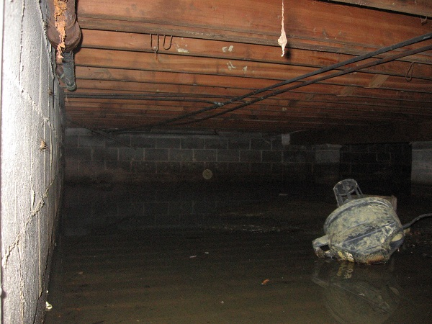

Photo #9

Interior

description of Interior

Wall And Ceiling Materials: •Drywall
Floor Surfaces: •Tile •Wood
Window Type(s) & Glazing: •Double/Single Hung •Double Glazed •Single Pane with Storm Window
Doors: •Wood-Solid Core

Interior observations
General Condition of Interior Finishes
On the whole, the interior finishes of the home are to be in poor condition. While cosmetic improvements are not the focus of this report, this is an area where substantial improvement may be desirable.
General Condition of Windows and Doors
The windows have been lacking maintenance.
General Condition of Floors
The flooring system shows evidence of typical minor sags and unevenness.

recommendations / observations
Wall / Ceiling Finishes
• Improve: Many areas of drywall had been replaced and were unfinished.
- Monitor, Repair: Water damage was noted at the garage and chimney.
- Monitor: Evidence of patching was detected in the dining room and other ceilings.
- Monitor: Damage to the interior finish was observed at most rooms.
- Monitor: Minor cracks were noted.
- Monitor, Repair: The installation of interior finishes and trim is incomplete throughout.
- Monitor: Signs of mildew were observed at the ceiling vents and at the attic.
Floors
- Major Concern, Repair: Apparent V.A. (vinyl asbestos) floor tile was noted at the family room. Covering or removing the deficient tile is needed.
• Improve: Refinishing the wood floors throughout are needed.
- Repair: The tile floor is loose and/or cracked at the mud room.
- Repair: The installation of the trim is incomplete throughout.
Windows
- Repair: The windows are in mild disrepair. This is a common condition that does not necessitate immediate major repair. Trimming and adjustment, hardware improvements and glazing repairs would be logical long term improvements. In practice, improvements are usually made on an as needed basis only. The most important factor is that the window exteriors are well-maintained to avoid rot or water infiltration.
- Monitor: Water staining was observed below the window sill(s) at the garage. Caulking should be improved as a first step. Refer also to the Exterior section of this report.
- Repair: The window(s) are broken in the living room, etc.
- Repair: Damaged screens were noted on windows in the bedrooms.
• Improve: Most windows have been blocked off and boarded up throughout.
Doors
- Repair: Doors should be trimmed or adjusted as necessary to work properly.
• Improve: Adding a storm door(s) at the front entry is suggested.
- Monitor, Repair: Water damage was observed adjacent to the exterior door at the rear entry.
• Repair: Damaged or missing interior doors were noted at the front entry and at the mud room.
• Repair: Hollow door should be replaced at the garage entry.
Environmental Issues
- Monitor: Lead based paint was in use until approximately 1978. According to the Federal Department of Housing and Urban Development, a lead hazard can be present in a house of this age. This can only be confirmed by laboratory analysis. An evaluation of lead in paint is beyond the scope of this inspection. For more information, consult the Environmental Protection Agency (E.P.A.) for further guidance and a list of testing labs in your area.
Discretionary Improvements
Install new exterior lock sets upon taking possession of the home.

limitations of Interior inspection
As we have discussed and as described in your inspection contract, this is a visual inspection limited in scope by (but not restricted to) the following conditions
- Furniture, storage, appliances and/or wall hangings are not moved to permit inspection and may block defects.
- Carpeting, window treatments, central vacuum systems, household appliances, recreational facilities, paint, wallpaper, and other finish treatments are not inspected.

Please also refer to the pre-inspection contract for a detailed explanation of the scope of this inspection.

Appliances

description of Appliances

Appliances Tested: •None
Laundry Facility: •240 Volt Circuit for Dryer
Other Components Tested: • N/A Door Bell

Appliances observations
General Comments
Kitchen, laundry, and other appliances had been removed.

recommendations / observations
Clothes Dryer
• Monitor, Repair: Laundry, kitchen, and other appliances and all fixtures were removed.
Door Bell
- Repair: The door bell is inoperative and missing.

limitations of Appliances inspection
As we have discussed and as described in your inspection contract, this is a visual inspection limited in scope by (but not restricted to) the following conditions
- Thermostats, timers and other specialized features and controls are not tested.
- The temperature calibration, functionality of timers, effectiveness, efficiency and overall performance of appliances is outside the scope of this inspection.

Please also refer to the pre-inspection contract for a detailed explanation of the scope of this inspection.

AMERICAN SOCIETY OF HOME INSPECTORS®

Standards of Practice

1. Introduction
2. Purpose & Scope
3. Structural Components
4. Exterior
5. Roofing System
6. Plumbing System
7. Electrical System
8. Heating System
9. Air Conditioning System
10. Interior
11. Insulation & Ventilation
12. Fireplaces & Solid Fuel Burning Appliances
13. General Limitations & Exclusions
Glossary

Note: Underlined words are defined in the Glossary

As approved by ASHI Membership July, 1999
Effective 1 January 2000
© 1999 American Society of Home Inspectors®

1. INTRODUCTION

1.1 The American Society of Home Inspectors®, Inc. (ASHI®) is a not-for-profit professional society established in 1976. Membership in ASHI is voluntary and its members include private, fee-paid home inspectors. ASHI®'s objectives include promotion of excellence within the profession and continual improvement of its members' inspection services to the public.

2. PURPOSE AND SCOPE

2.1 The purpose of these Standards of Practice is to establish a minimum and uniform standard for private, fee-paid home inspectors who are members of the American Society of Home Inspectors. Home inspections performed to these Standards of Practice are intended to provide the client with information regarding the condition of the systems and components of the home as inspected at the time of the Home Inspection.

2.2 The Inspector shall:
A. inspect:
- readily accessible systems and components of homes listed in these Standards of Practice.
- installed systems and components of homes listed in these Standards of Practice.
B. report:
- on those systems and components inspected which, in the professional opinion of the inspector, are significantly deficient or are near the end of their service lives.
- A reason why, if not self-evident, the system or component is significantly deficient or near the end of its service life.
- the inspector's recommendations to correct or monitor the reported deficiency.
- on any systems and components designated for inspection in these Standards of Practice which were present at the time of the Home Inspection but were not inspected and the reason they were not inspected.

2.3 These Standards of Practice are not intended to limit inspectors from:
A. including other inspection services, systems or components in addition to those required by these Standards of Practice.
B. specifying repairs, provided the inspector is appropriately qualified and willing to do so.
C. excluding systems and components from the inspection if requested by the client.

3. STRUCTURAL COMPONENTS

3.1 The inspector shall:
A. inspect:
- the structural components including foundation and framing.
- by probing a representative number of structural components where deterioration is suspected or where clear indications of possible deterioration exist. Probing is NOT required when probing would damage any finished surface or where no deterioration is visible.
B. describe:
- the foundation and report the methods used to inspect the under-floor crawl space.
- the floor structure.
- the wall structure.
- the ceiling structure.
- the roof structure and report the methods used to inspect the attic.

3.2 The inspector is NOT required to:
A. provide any engineering service or architectural service.
B. offer an opinion as to the adequacy of any structural system or component.

4. EXTERIOR

4.1 The inspector shall:
A. inspect:
- the exterior wall covering, flashing and trim.
- all exterior doors.
- attached decks, balconies, stoops, steps, porches, and their associated railings.
- the eaves, soffits, and fascias where accessible from the ground level.
- the vegetation, grading, surface drainage, and retaining walls on the property when any of these are likely to adversely affect the building.
- walkways, patios, and driveways leading to dwelling entrances.
B. describe the exterior wall covering.

4.2 The inspector is NOT required to:
A. inspect:
- screening, shutters, awnings, and similar seasonal accessories.
- fences.
- geological, geotechnical, or hydrological conditions.
- recreational facilities.
- outbuildings.
- seawalls, break-walls, and docks.
- erosion control and earth stabilization measures.

5. ROOF SYSTEM

5.1 The inspector shall:
A. inspect:
- the roof covering.
- the roof drainage systems.
- the flashings.
- the skylights, chimneys, and roof penetrations.
B. describe the roof covering and report the methods used to inspect the roof.

5.2 The inspector is NOT required to:
A. inspect:
- antennae.
- interiors of flues or chimneys which are not readily accessible.
- other installed accessories.

6. PLUMBING SYSTEM

6.1 The inspector shall:
A. inspect:
- the interior water supply and distribution systems including all fixtures and faucets.
- the drain, waste and vent systems including all fixtures.
- the water heating equipment
- the vent systems, flues, and chimneys.
- the fuel storage and fuel distribution systems.
- the drainage sumps, sump pumps, and related piping.
B. describe:
- the water supply, drain, waste, and vent piping materials.
- the water heating equipment including the energy source.
- the location of main water and main fuel shut-off valves.

6.2 The inspector is NOT required to:
A. inspect:
- the clothes washing machine connections.
- the interiors of flues or chimneys which are not readily accessible.
- wells, well pumps, or water storage related equipment.
- water conditioning systems.
- solar water heating systems.
- fire and lawn sprinkler systems.
- private waste disposal systems.
B. determine:
- whether water supply and waste disposal systems are public or private.
- the quantity or quality of the water supply.
- operate safety valves or shut off valves.

7. ELECTRICAL SYSTEM

7.1 The inspector shall:
A. inspect:
- the service drop.
- the service entrance conductors, cables, and raceways.
- the service equipment and main disconnects.
- the service grounding.
- the interior components of service panels and sub panels.
- the conductors.
- the overcurrent protection devices.
- a representative number of installed lighting fixtures, switches, and receptacles.
- the ground fault circuit interrupters.
B. describe:
- the amperage and voltage rating of the service
- the location of main disconnect(s) and sub panels
- the wiring methods
C. report:
- on the presence of solid conductor aluminum branch circuit wiring
- on the absence of smoke detectors

7.2 The inspector is NOT required to:
A. inspect:
- the remote control devices unless the device is the only control device.
- the alarm systems and components.
- the low voltage wiring, systems and components.
- the ancillary wiring, systems and components not a part of the primary electrical power distribution system.
B. measure amperage, voltage, or impedance.

8. HEATING SYSTEM

8.1 The inspector shall:
A. inspect:
- the installed heating equipment.
- the vent systems, flues, and chimneys.
B. describe
- the energy source.
- the heating method by its distinguishing characteristics.

8.2 The inspector is NOT required to:
A. inspect:
- the interiors of flues or chimneys which are not readily accessible.
- the heat exchanger.
- the humidifier or dehumidifier.
- the electronic air filter.
- the solar space heating system.
B. determine heat supply adequacy or distribution balance.

9. AIR CONDITIONING SYSTEMS

9.1 The inspector shall:
A. inspect the installed central and through-wall cooling equipment.
B. describe:
- the energy source.
- the cooling method by its distinguishing characteristics.
9.2 The inspector is NOT required to:
A. inspect electronic air filters.
B. determine cooling supply adequacy or distribution balance.

10. INTERIOR

10.1 The inspector shall:
A. inspect:
- the walls, ceilings, and floors.
- the steps, stairways, and railings.
- the countertops and a representative number of installed cabinets.
- a representative number of doors and windows.
- garage doors and garage door operators.
10.2 The inspector is NOT required to:
A. inspect:
- the paint, wallpaper, and other finish treatments.
- the carpeting.
- the window treatments.
- the central vacuum systems.
- the household appliances.
- recreational facilities.

11. INSULATION & VENTILATION

11.1 The inspector shall:
A. inspect:
- the insulation and vapor retarders in unfinished spaces.
- the ventilation of attics and foundation areas.
- the mechanical ventilation systems.
B. describe:
- the insulation and vapor retarders in unfinished spaces.
- the absence of insulation in unfinished spaces at conditioned surfaces.

11.2 The inspector is NOT required to:
A. disturb insulation or vapor retarders.
B. determine indoor air quality.

12. FIREPLACES AND SOLID FUEL BURNING APPLIANCES

12.1 The inspector shall:
A. inspect :
- the system components.
- the vent systems, flues, and chimneys.
B. describe:
- the fireplaces and solid fuel burning appliances.
- the chimneys.

12.2 The inspector is NOT required to:
A. inspect:
- the interiors of flues or chimneys.
- the firescreens and doors.
- the seals and gaskets.
- the automatic fuel feed devices.
- the mantles and fireplace surrounds.
- the combustion make-up air devices.
- the heat distribution assists whether gravity controlled or fan assisted.
B. ignite or extinguish fires.
C. determine draft characteristics.
D. move fireplace inserts or stoves or firebox contents.

13. GENERAL LIMITATIONS AND EXCLUSIONS

13.1 General limitations:
A. Inspections performed in accordance with these Standards of Practice
- are not technically exhaustive.
- will not identify concealed conditions or latent defects
B. These Standards of Practice are applicable to buildings with four or fewer dwelling units and their garages or carports.

13.2 General exclusions:
A. The inspector is not required to perform any action or make any determination unless specifically stated in these Standards of Practice, except as may be required by lawful authority.
B. Inspectors are NOT required to determine:
- the condition of systems or components which are not readily accessible.
- the remaining life of any system or component.
- the strength, adequacy, effectiveness, or efficiency of any system or component.
- the causes of any condition or deficiency.
- the methods, materials, or costs of corrections.
- future conditions including, but not limited to, failure of systems and components.
- the suitability of the property for any specialized use.
- compliance with regulatory requirements (codes, regulations, laws, ordinances, etc.).
- the market value of the property or its marketability.
- the advisability of the purchase of the property.
- the presence of potentially hazardous plants or animals including, but not limited to wood destroying organisms or diseases harmful to humans.
- the presence of any environmental hazards including, but not limited to toxins, carcinogens, noise, and contaminants in soil, water, and air.
- the effectiveness of any system installed or methods utilized to control or remove suspected hazardous substances.
- the operating costs of systems or components.
- the acoustical properties of any system or component.
C. Inspectors are NOT required to offer:
- or perform any act or service contrary to law.
- or perform engineering services.
- or perform work in any trade or any professional service other than home inspection.
- warranties or guarantees of any kind.
D. Inspectors are NOT required to operate:
- any system or component which is shut down or otherwise inoperable.
- any system or component which does not respond to Normal Operating Controls.
- shut-off valves.
E. Inspectors are NOT required to enter:
- any area which will, in the opinion of the inspector, likely be dangerous to the inspector or other persons or damage the property or its systems or components.
- the under-floor crawl spaces or attics which do not conform to recognized standards for clearance.
F. Inspectors are NOT required to inspect:
- underground items including, but not limited to underground storage tanks or other underground indications of their presence, whether abandoned or active.
- systems or components which are not installed.
- decorative items.
- systems or components located in areas which are not entered in accordance with these Standards of Practice.
- detached structures other than garages and carports.
- common elements or common areas in multi-unit housing, such as condominium properties or cooperative housing.
G. Inspectors are NOT required to:
- perform any procedure or operation which will, in the opinion of the inspector, likely be dangerous to the inspector or other persons or damage the property or its systems or components.
- move suspended ceiling tiles, personal property, furniture, equipment, plants, soil, snow, ice, or debris.
- dismantle any system or component, except as explicitly required by these Standards of Practice.

GLOSSARY OF UNDERLINED WORDS*

Alarm Systems
Warning devices, installed or free-standing, including but not limited to; carbon monoxide detectors, flue gas and other spillage detectors, security equipment, ejector pumps and smoke alarms

Architectural Service
Any practice involving the art and science of building design for construction of any structure or grouping of structures and the use of space within and surrounding the structures or the design for construction, including but not specifically limited to, schematic design, design development, preparation of construction contract documents, and administration of the construction contract

Automatic Safety Controls
Devices designed and installed to protect systems and components from unsafe conditions

Component
A part of a system

Decorative
Ornamental; not required for the proper operation of the essential systems and components of a home

Describe
To report a system or component by its type or other observed, significant characteristics to distinguish it from other systems or components

Dismantle
To take apart or remove any component, device or piece of equipment that would not be taken apart or removed by a homeowner in the course of normal and routine home owner maintenance

Engineering Service
Any professional service or creative work requiring engineering education, training, and experience and the application of special knowledge of the mathematical, physical and engineering sciences to such professional service or creative work as consultation, investigation, evaluation, planning, design and supervision of construction for the purpose of assuring compliance with the specifications and design, in conjunction with structures, buildings, machines, equipment, works or processes

Further Evaluation
Examination and analysis by a qualified professional, tradesman or service technician beyond that provided by the home inspection

Home Inspection
The process by which an inspector visually examines the readily accessible systems and components of a home and which describes those systems and components in accordance with these Standards of Practice

Household Appliances
Kitchen, laundry, and similar appliances, whether installed or free-standing

Inspect
To examine readily accessible systems and components of a building in accordance with these Standards of Practice, using Normal Operating Controls and opening Readily Openable Access Panels

Inspector
A person hired to examine any system or component of a building in accordance with these Standards of Practice

Installed
Attached such that removal requires tools

Normal Operating Controls
Devices such as thermostats, switches or valves intended to be operated by the homeowner

Readily Accessible
Available for visual inspection without requiring moving of personal property, dismantling, destructive measures, or any action which will likely involve risk to persons or property

Readily Openable Access Panel
A panel provided for homeowner inspection and maintenance that is within normal reach, can be removed by one person, and is not sealed in place

Recreational Facilities
Spas, saunas, steam baths, swimming pools, exercise, entertainment, athletic, playground or other similar equipment and associated accessories

Report
To communicate in writing

Representative Number
One component per room for multiple similar interior components such as windows and electric outlets; one component on each side of the building for multiple similar exterior components

Roof Drainage Systems
Components used to carry water off a roof and away from a building

Significantly Deficient
unsafe or not functioning

Shut Down
A state in which a system or component cannot be operated by Normal Operating Controls

Solid Fuel Burning Appliances
A hearth and fire chamber or similar prepared place in which a fire may be built and which is built in conjunction with a chimney; or a listed assembly of a fire chamber, its chimney and related factory-made parts designed for unit assembly without requiring field construction

Structural Component
A component which supports non-variable forces or weights (dead loads) and variable forces or weights (live loads)

System
A combination of interacting or interdependent components, assembled to carry out one or more functions

Technically Exhaustive
An investigation that involves dismantling, the extensive use of advanced techniques, measurements, instruments, testing, calculations, or other means

Under-Floor Crawl Space
The area within the confines of the foundation and between the ground and the underside of the floor

Unsafe
A condition in a readily accessible, installed component or system which is judged to be a significant risk of personal injury during normal, day-to-day use. The risk may be due to damage, deterioration, improper installation or a change in accepted residential construction standards

Wiring Methods
Identification of electrical conductors or wires by their general type, such as "non-metallic sheathed cable" ("Romex"), "armored cable" ("bx") or "knob and tube," etc.

*Note: In these Standards of Practice, redundancy in the description of the requirements, limitations and exclusions regarding the scope of the Home Inspection is provided for clarity.

Maintenance Advice

upon taking ownership
After taking possession of a new home, there are some maintenance and safety issues that should be addressed immediately. The following checklist should help you undertake these improvements:
- Change the locks on all exterior entrances, for improved security.
- Check that all windows and doors are secure. Improve window hardware as necessary. Security rods can be added to sliding windows and doors. Consideration could also be given to a security system.
- Install smoke detectors on each level of the home. Ensure that there is a smoke detector outside all sleeping areas. Replace batteries on any existing smoke detectors and test them. Make a note to replace batteries again in one year.
- Create a plan of action in the event of a fire in your home. Ensure that there is an operable window or door in every room of the house. Consult with your local fire department regarding fire safety issues and what to do in the event of fire.
- Examine driveways and walkways for trip hazards. Undertake repairs where necessary.
- Examine the interior of the home for trip hazards. Loose or torn carpeting and flooring should be repaired.
- Undertake improvements to all stairways, decks, porches and landings where there is a risk of falling or stumbling.
- Review your home inspection report for any items that require immediate improvement or further investigation. Address these areas as required.
- Install rain caps and vermin screens on all chimney flues, as necessary.
- Investigate the location of the main shut-offs for the plumbing, heating and electrical systems. If you attended the home inspection, these items would have been pointed out to you.

regular maintenance

every month
- Check that fire extinguisher(s) are fully charged. Re-charge if necessary.
- Examine heating/cooling air filters and replace or clean as necessary.
- Inspect and clean humidifiers and electronic air cleaners.
- If the house has hot water heating, bleed radiator valves.
- Clean gutters and downspouts. Ensure that downspouts are secure, and that the discharge of the downspouts is appropriate. Remove debris from window wells.
- Carefully inspect the condition of shower enclosures. Repair or replace deteriorated grout and caulk. Ensure that water is not escaping the enclosure during showering. Check below all plumbing fixtures for evidence of leakage.
- Repair or replace leaking faucets or shower heads.
- Secure loose toilets, or repair flush mechanisms that become troublesome.

spring and fall
- Examine the roof for evidence of damage to roof coverings, flashings and chimneys.
- Look in the attic (if accessible) to ensure that roof vents are not obstructed. Check for evidence of leakage, condensation or vermin activity. Level out insulation if needed.
- Trim back tree branches and shrubs to ensure that they are not in contact with the house.
- Inspect the exterior walls and foundation for evidence of damage, cracking or movement. Watch for bird nests or other vermin or insect activity.
- Survey the basement and/or crawl space walls for evidence of moisture seepage.
- Look at overhead wires coming to the house. They should be secure and clear of trees or other obstructions.
- Ensure that the grade of the land around the house encourages water to flow away from the foundation.
- Inspect all driveways, walkways, decks, porches, and landscape components for evidence of deterioration, movement or safety hazards.
- Clean windows and test their operation. Improve caulking and weather-stripping as necessary. Watch for evidence of rot in wood window frames. Paint and repair window sills and frames as necessary.
- Test all ground fault circuit interrupter (GFCI) devices, as identified in the inspection report.
- Shut off isolating valves for exterior hose bibs in the fall, if below freezing temperatures are anticipated.
- Test the Temperature and Pressure Relief (TPR) Valve on water heaters.
- Inspect for evidence of wood boring insect activity. Eliminate any wood/soil contact around the perimeter of the home.
- Test the overhead garage door opener, to ensure that the auto-reverse mechanism is responding properly. Clean and lubricate hinges, rollers and tracks on overhead doors.
- Replace or clean exhaust hood filters.
- Clean, inspect and/or service all appliances as per the manufacturer’s recommendations.

annually
- Replace smoke detector batteries.
- Have the heating, cooling and water heater systems cleaned and serviced.
- Have chimneys inspected and cleaned. Ensure that rain caps and vermin screens are secure.
- Examine the electrical panels, wiring and electrical components for evidence of overheating. Ensure that all components are secure. Flip the breakers on and off to ensure that they are not sticky.
- If the house utilizes a well, check and service the pump and holding tank. Have the water quality tested. If the property has a septic system, have the tank inspected (and pumped as needed).
- If your home is in an area prone to wood destroying insects (termites, carpenter ants, etc.), have the home inspected by a licensed specialist. Preventative treatments may be recommended in some cases.

Prevention is the best approach
Although we’ve heard it many times, nothing could be more true than the old cliché “an ounce of prevention is worth a pound of cure.” Preventative maintenance is the best way to keep your house in great shape. It also reduces the risk of unexpected repairs and improves the odds of selling your house at fair market value, when the time comes.
Please feel free to contact our office should you have any questions regarding the operation or maintenance of your home. Enjoy your home!

