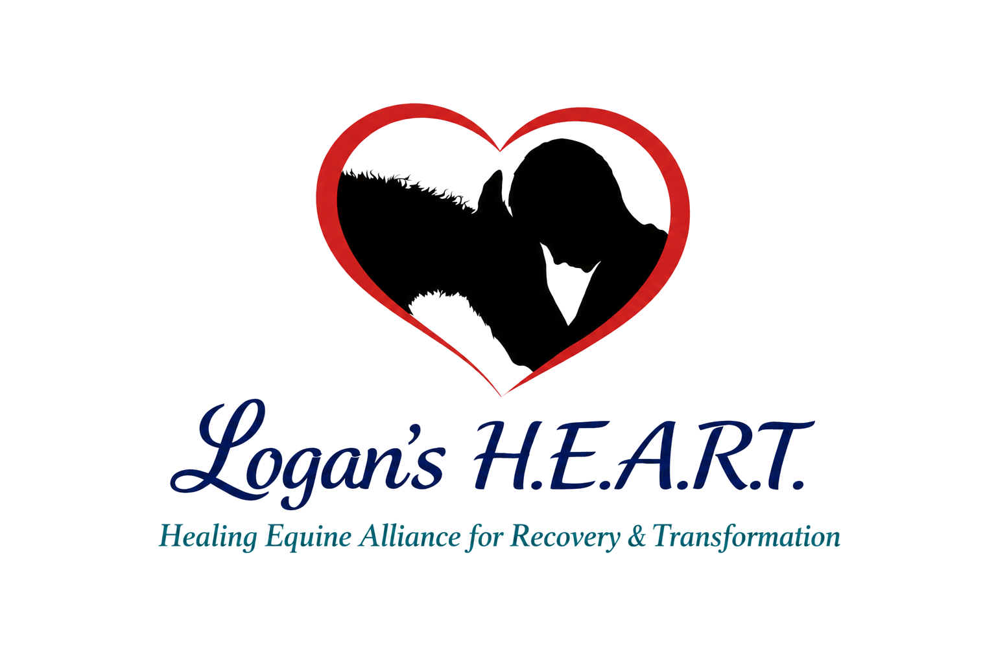

Equine Health and Care Information
Complete this form when a horse, pony, mule, or donkey will receive temporary care, handling, evaluation, socialization, or other services through Logan's H.E.A.R.T.
Owner and Equine Information
Owner or Authorized Agent: ________________________________ | Phone: _______________________________________
Email: ____________________________________________________ | Alternate Contact: ____________________________
Equine Name: ____________________________________________ | Barn Name: ___________________________________
Color and Identifying Markings: ___________________________ | Species and Breed: ___________________________
Sex: ________________________________ | Age or Estimated Age: ________________________
Registration, microchip, or other identification if applicable _________________________________________________
Routine Care Contacts
Veterinarian or Clinic: ________________________________ | Phone: ___________________________
Farrier: ________________________________ | Phone: ___________________________
Last Dental Care if known:____________________________ | Last Hoof Care if known: ___________________________
Health and Behavior
☐ Laminitis or founder ☐ PPID or Cushing's ☐ Insulin resistance ☐ Colic ☐ Lameness ☐ Allergies ☐ Seizures or neurologic concern ☐ Other: __________
Current diagnoses, injuries, medications, supplements, or treatments:
________________________________________________________________________________________________________________
________________________________________________________________________________________________________________
Known handling concerns, triggers, bite or kick history, herd behavior, or escape habits:
________________________________________________________________________________________________________________
________________________________________________________________________________________________________________

Equine Health and Care Information Continued
Equine Name _____________________________________ | Owner or Authorized Agent ___________________________
Feeding and Daily Care
Hay Type and Amount ________________________________ | Feeding Times ___________________________
Grain, ration balancer, supplements, and amounts
_______________________________________________________________________________________________________________
_______________________________________________________________________________________________________________
Pasture, dry-lot, turnout, grazing muzzle, soaking, or other dietary restrictions
_______________________________________________________________________________________________________________
_______________________________________________________________________________________________________________
Water or Electrolyte Instructions: ______________________________________________________________________________
Blanket or Weather Instructions: ______________________________________________________________________________
Handling and Housing
Permitted activities: ☐ Hand walking ☐ Grooming ☐ Groundwork ☐ Trailer loading ☐ Supervised public interaction ☐ Other: ______
Halter, lead, stall, turnout, companion, fencing, or separation instructions
________________________________________________________________________________________________________________
________________________________________________________________________________________________________________
Emergency Authorization and Costs
If I cannot be reached promptly, I authorize Logan's H.E.A.R.T. to contact the veterinarian listed above or another available veterinarian and obtain reasonably necessary emergency evaluation or treatment. I remain responsible for veterinary, medication, transport, farrier, and related expenses unless a different written agreement is signed.
☐ Use reasonable judgment in an emergency. ☐ Do not approve non-life-saving expenses over $____________ without contacting me.
Media Permission and Certification
☐ Logan's H.E.A.R.T. may photograph and post this equine. ☐ Yes, but do not identify me. ☐ No social media posts.
I certify that I own this equine or am authorized by the owner to provide these instructions. I have disclosed known health and behavior concerns and will promptly report material changes.
Owner or Authorized Agent Signature: ___________________________________ | Date ___________________________
Logan's H.E.A.R.T. Representative: ______________________________________ | Date ___________________________

