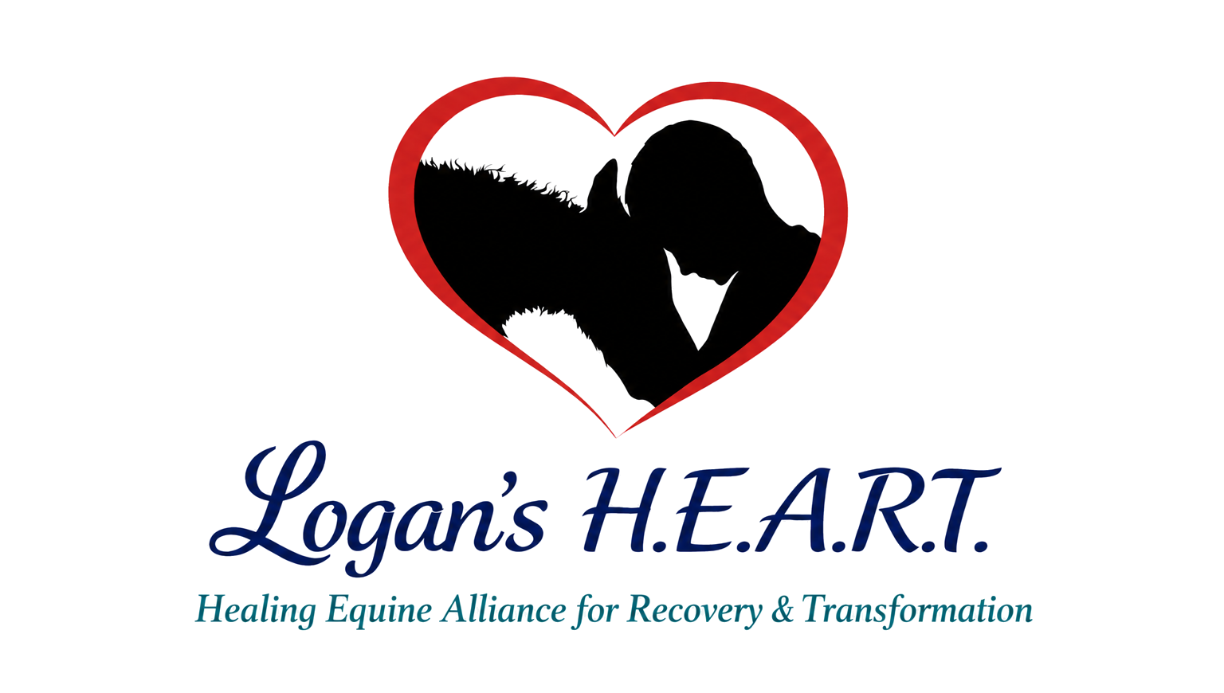

Photo and Social Media Release
Use this form to clearly grant, limit, or decline permission for photos and recordings.
Person Covered by This Release
Full Name: _________________________________________ | Phone or Email: ___________________________
☐ I am signing for myself. ☐ I am the parent or legal guardian of the minor named above.
Choose One
☐ YES - I authorize Logan's H.E.A.R.T. to photograph or record me or the minor and use the images, video, voice, or first name for its website, social media, educational materials, fundraising, newsletters, and nonprofit publicity.
☐ LIMITED - I authorize use only as follows: ______________________________________________
☐ NO - I do not authorize identifiable photos, video, voice recordings, or name to be posted or published.
Terms
If permission is granted, I understand that no payment is expected; content may be edited for length or format without changing its meaning; and online material may be shared or saved by others beyond Logan's H.E.A.R.T.'s control. I may revoke permission for future use by written notice, but revocation may not remove material already printed, distributed, shared, or published. Logan's H.E.A.R.T. will not intentionally include sensitive medical or personal information without separate permission.
Signature: ___________________________________ | Date ______________________
Printed Name: _____________________________ | Relationship if signing for a minor: ________________

