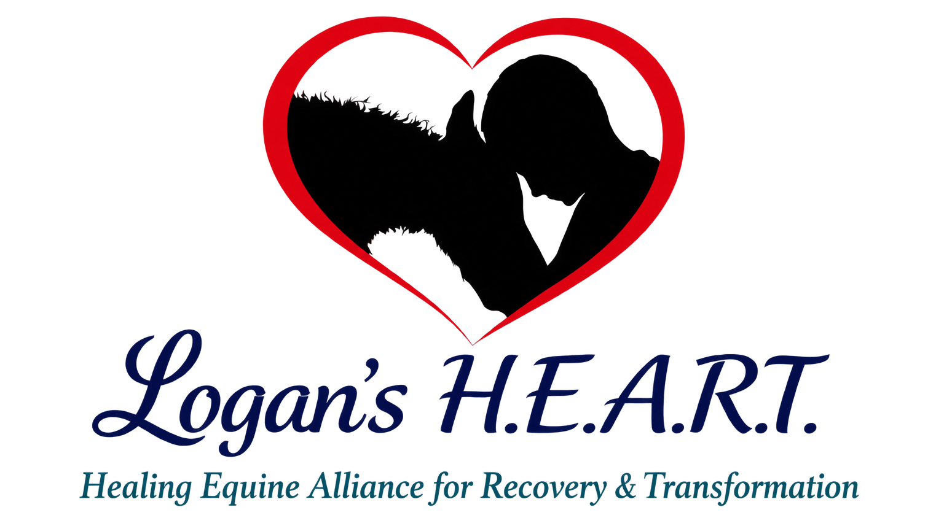

Volunteer and Visitor Liability Waiver
Complete this form before participating in animal care, farm activities, tours, or volunteer work.
Participant Information
Participant Name: ________________________________ | Phone: ___________________________
Address: ____________________________________________________________________
Email ________________________________ | Emergency Contact Phone ___________________________
Assumption of Risk
I understand that visiting or volunteering at a working farm and animal rescue involves risks that cannot be completely eliminated. Risks may include uneven or slippery ground; fences, gates, tools, vehicles, and equipment; weather; insects and allergens; and unpredictable behavior by horses, ponies, dogs, goats, poultry, or other animals. Animals may bite, kick, strike, step on, chase, knock down, or otherwise injure a person even when handled carefully.
Equines may react unpredictably to sounds, sudden movement, unfamiliar objects, people, or animals. Other intrinsic dangers include surface and subsurface conditions, collisions, and a participant acting beyond the participant's ability or failing to follow instructions. I knowingly assume these inherent and intrinsic risks and agree to follow all safety directions.
ATTENTION: Under Virginia law, there is no liability for an injury to or death of a participant in an agritourism activity conducted at this agritourism location if such injury or death results from the inherent risks of the agritourism activity. Inherent risks of agritourism activities include, among others, risks of injury inherent to land, equipment, and animals, as well as the potential for you to act in a negligent manner that may contribute to your injury or death. You are assuming the risk of participating in this agritourism activity.
Release and Agreement
To the fullest extent permitted by Virginia law, I release and agree not to hold Logan's H.E.A.R.T., its directors, officers, volunteers, property owners, and agents responsible for claims arising from the inherent or assumed risks described above. This release does not waive claims that cannot legally be waived. I accept responsibility for loss or damage I cause through intentional misconduct or failure to follow instructions.
☐ I have read this form, understand it, and sign it voluntarily.
This waiver remains effective for future visits and volunteer activities unless I revoke it in writing. Logan's H.E.A.R.T. may require a new form after material changes.
Participant Signature: ______________________________________________ | Date ______________________
Printed Name: ______________________________________________________
Parent or Guardian Signature if under 18 ____________________________________________________
Relationship if signing for a minor______________________________________ | Date ______________________

