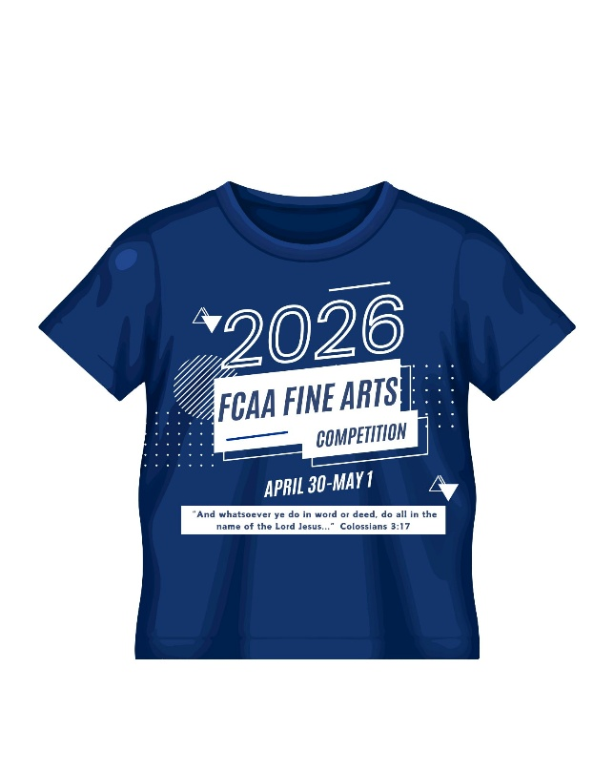

FCAA FINE ARTS T-SHIRT ORDER FORM
Pre-order Cost: $16 per shirt
Some shirts will also be available at the registration desk during the
competition, but only in limited sizes and cost $4 more per shirt.

Please email the order form to fcaafinearts@yahoo.com and mail the check made out to FCAA, 400 SW 13th Street, Okeechobee, FL. 34974, no later than Friday, March 30. We do encourage as many participants, sponsors, friends, and relatives as possible to order a t-shirt to wear for the awards ceremony on Friday evening of the competition.

School Name: _______________________________________
Size # ordered

Adult Small __________ x $16 = _____________

Adult Medium __________ x $16 = _____________

Adult Large __________ x $16 = _____________

Adult X-Large __________ x $16 = _____________

Adult XX-Large __________ x $20 = _____________

Adult XXX-Large __________ x $20 = _____________

Total # ordered: __________ TOTAL DUE: __________

