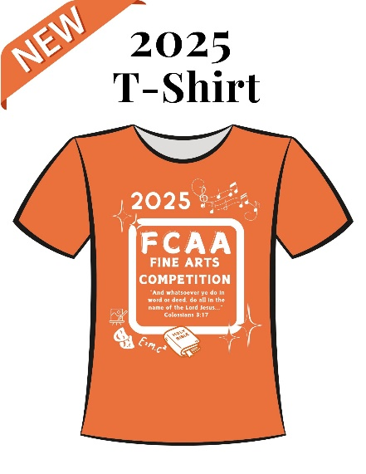

FCAA FINE ARTS T-SHIRT ORDER FORM

Pre-order Cost: $16 per shirt

*Some shirts will also be available at the registration desk during the*

*competition, but only in limited sizes and cost $4 more per shirt.*

Please email the order form to [fcaafinearts@yahoo.com](mailto:fcaafinearts@yahoo.com) and mail the check to FCAA, c/o Cathy Stewart, 1397 SW 18th Terrace, Okeechobee, FL. 34974, no later than Friday, March 28. We do encourage as many participants, sponsors, friends, and relatives as possible to order a t-shirt to wear for the awards ceremony on Friday evening of the competition.

School Name: _______________________________________

Size # ordered

Adult Small __________ x $16 = _____________

Adult Medium __________ x $16 = _____________

Adult Large __________ x $16 = _____________

Adult X-Large __________ x $16 = _____________

Adult XX-Large __________ x $19 = _____________

Adult XXX-Large __________ x $20 = _____________

Total # ordered: __________ TOTAL DUE: __________