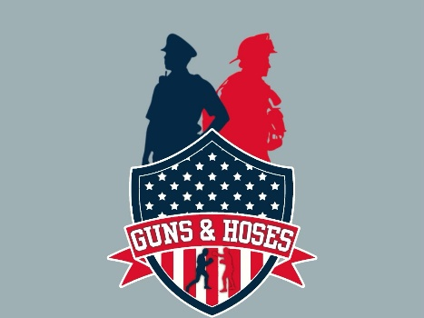
15th Annual Guns and Hoses Battle of the Badges
Boxing Event Sponsorship Levels

$25,000 Ring of Champions Sponsor Level (1 Available)
- Event Naming Rights (“The _____________ 15th Annual Guns and Hoses Battle of the Badges boxing Event”)
- Logo on all billboards throughout tri-state, on front of program & posters and on jumbo screens during event
- Two Gold VIP Tables for 16
- 16 VIP Party Passes (includes meals, beverage vouchers, and event T-shirts)
- VIP Self-Parking permits (8)
- Four Ringside seats
- General Admission tickets (30)
- Full page color ad on back of program and full page (inside front, inside back cover and center) of program (b/w)
- Sponsor is welcome to set up banners on the night of the event (per Venue guidelines)
- Logo Placement on Marketing Materials
- Arena Signage and Website Exposure
- Advertising Video (customer provides)
- Announcer Recognition throughout the Event as the title sponsor
- Premium Program Advertisement
- Digital Signage and Ring Presence
- On-Site Display and Hospitality
- Logo Placement on Front of Bout Cards
- Big-Check Presentation Between Rounds 1 and 2 signifying sponsor level.
- Comprehensive Recognition (Press releases, pre-show video, program, website, social media, and email invitations)
- Participation in award presentations during two bouts
- Framed Guns and Hoses Poster autographed by all the participants.
- Sponsor gift

$15,000.00 Ten Count Sponsor Level (2 Available)
- One GOLD VIP Table of 8
- One SILVER VIP Table of 8
- 16 VIP Party Passes (includes meals, beverage vouchers, and event T-shirts)
- VIP Self-Parking permits (8)
- 15 General Admission Tickets
- Recognition in pre-show video, event program, website, social media, and email invitations
- Logo on all billboards throughout area, on front of program & posters and on jumbo screens during event
- 1/2 page color ad on back of program and full page (inside front, inside back cover and center) of program (b/w)
- Ring Announcer will mention sponsor several times throughout the event as Ten Count Sponsor Sponsor is welcome to set up banners on the night of the event (per Venue guidelines)
- Sponsor gift

$7,500 Heavyweight Sponsor (2 Available)
- One VIP GOLD table of 8 with Heavyweight priority placement
- 8 VIP Party Passes (includes meal and beverage voucher) DOES NOT INCLUDE VIP PARKING
- 10 General Admission tickets
- 1/3 page color ad on back of program and full page (inside front, inside back cover and center) of program (b/w)
- Heavyweight Sponsor recognition in pre-show video, digital event program, event website and footer of email invitations
- Vendor booth in the venue
- Sponsor gift

$5,000 Cruiserweight Sponsor (4 Available)
- One VIP GOLD table of 8 with Cruiserweight priority placement
- 8 VIP Party Passes (includes meal and beverage voucher) DOES NOT INCLUDE VIP PARKING
- 10 General Admission tickets
- Cruiserweight Sponsor recognition in pre-show video, digital event program, event website, and footer of email invitations
- Vendor booth in the venue
- Sponsor gift

$3,250 Middleweight Sponsor (2 Available)
- One SILVER VIP table of 8
- 8 VIP Party Passes (includes meal and a beverage) DOES NOT INCLUDE VIP PARKING
- 6 General Admission tickets
- Middleweight Sponsor recognition on pre-event video, digital event program, event website and footer of email invitations
- Vendor booth in the venue
- Sponsor gift

$2,500 Uppercut Sponsor (2 Available)
- Block of 28 reserved seats in premium reserved section (Limited quantity of premium sections available first come-first-served)
- 28 Uppercut passes with an adult beverage voucher.
- Uppercut Sponsor recognition in pre-show video, event program, event website and footer of email invitations

$1,500 Lightweight Sponsor (2 Available)
- Block of 18 reserved seats in priority section (Limited quantity of priority sections available first come-first-served)
- 18 Lightweight passes with an adult beverage voucher
- Uppercut Sponsor recognition in pre-show video, digital event program, event website and footer of email invitations

$500 Boxer Sponsorship
- Your sponsorship pays for your boxer's physical, blood work, uniform & equipment.
- 4 Ringside seats (Includes adult beverage voucher)
- Boxer Sponsorship recognition on the videoboard, digital program, mobile auction site, and footer of email invitations

$150.00 VIP Ringside Seat
- One VIP Ringside Seat
- One VIP Party Pass (includes meal and beverage voucher) DOES NOT INCLUDE VIP PARKING
- Maximum of 10 ringside seats per person/group We have a limited number of $150 ringside seats available. Ringside seats get you as close to the action in the ring as you can get without climbing in! Some groups purchase a few ringside seats along with their VIP table and then take turns sitting ringside!

