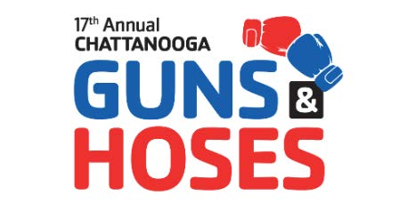
Dear Prospective Sponsor,
We are excited to extend an invitation for you to be a part of the 17th Annual Guns and Hoses Battle of the Badges, taking place at Camp Jordan Arena on October 30, 2026. As an esteemed sponsor, your contribution will play a vital role in supporting two incredibly worthwhile charities: the Forgotten Child Fund and the YMCA YCAP Program.
The Forgotten Child Fund is a local nonprofit organization dedicated to providing assistance and support to children and families in need throughout our community. From providing essential items like clothing, toys, and school supplies to offering financial assistance during times of crisis, the Forgotten Child Fund ensures that no child is left behind, especially during the holiday season.
On the other hand, the YMCA YCAP Program focuses on empowering at-risk youth in our community by providing them with opportunities for personal growth, academic support, and positive mentorship. Through various programs and activities, YCAP aims to instill confidence, resilience, and leadership skills in young individuals, setting them on a path towards success and fulfillment.
Both charities are IRS Certified 501(c)(3) organizations, meaning that your donation is tax-deductible to the fullest extent allowed by law.
By donating a silent auction item to our event, you will directly contribute to raising funds for these two exceptional charities. Your generosity will help provide essential resources and support to children and families facing hardship, as well as offer life-changing opportunities for at-risk youth in our community.
It's important to note that all the money raised from the silent auction and the event as a whole stay right here in the local Chattanooga area, ensuring that your contribution directly benefits those in need within our community.
The Guns and Hoses Battle of the Badges is a unique and impactful event made possible by the participation of local fire, police, and EMS volunteers who bravely step into the ring to support these important causes. Your support as a sponsor will not only contribute to the success of the event but also make a meaningful difference in the lives of countless individuals in our community.
Thank you for considering this opportunity to support the Guns and Hoses Battle of the Badges. We look forward to partnering with you to make a positive impact in our community.
Warm regards,
Robert Baty,
Board Member,
Chattanooga Guns and Hoses Battle of the Badges
Cell 423-400-3744
Robert@chattanoogagunsandhoses.org

