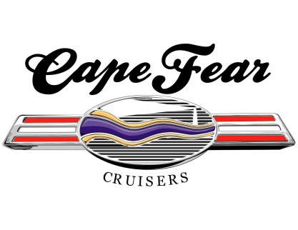
2026 Car Show SPONSOR RECEIPT

The Cape Fear Cruisers Car Club thanks you for your generous sponsorship in support of our 2026 Car and Truck shows to be held in Downtown Southport. As a non-profit 501(c)(3) charitable organization, all proceeds benefit local charities. Charities such as The Brunswick Toy Run, the Cape Fear Cruisers Car Club Scholarship Fund at Brunswick Community College, Southport Shop with a Cop Program, Southport Volunteer Fire Dept, OKI VFW Post 10226, and the Sarah E Whitmer Scholarship Fund at South Brunswick High School.

Donation to Cape Fear Cruisers, Inc.:

_____________________________________________________________________________________
(DONOR Name or Business)

Donation $_________________ Check # ___________ Cash ________

Date: __________________

Thank you for your support,

Jackie Winters
President, Cape Fear Cruisers Car Club
Tax ID # 81-3336763
Contact Info: Jackie.winters.cfc@gmail.com or 732-816-2284
www.capefearcruisers.com

Mailing Address:
Cape Fear Cruisers, Inc.
4891 Long Beach Rd., SE
Suite 3, #130
Southport, NC 28461-0551

