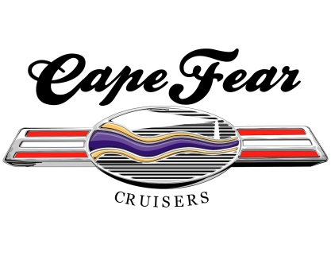

**2025 Car Show Sponsorship Opportunities**

Dear Sponsor,

We need your help. The Cape Fear Cruisers Car Club will be hosting 2 Car Shows in 2025 in downtown Southport. As a non-profit 501(c)(3) charitable organization, all proceeds benefit local charities. In 2024, we donated over $25,000 to multiple charities to include The Brunswick County Toy Run, Cape Fear Cruisers Car Club Scholarship Fund at Brunswick Community College, Southport Police Shop with a Cop Program, Southport Volunteer Fire Dept, OKI VFW Post 10226, the Sarah E Whitmer Scholarship Fund at South Brunswick High School, and the Fix-A-Friend Spay & Neuter Clinic.

**April 26th** –The 6th Annual ***Rockin’ & Rollin’ to the Red, White, and Blue Car & Truck Show*** as we pay tribute to patriotism and our first responders in downtown Southport.

**October 25th** – The 11th Annual ***Classic Cars ‘n Rock ‘n Roll Car & Truck Show*** returns to Howe and Bay Streets for a fun Halloween weekend event for Southport, as we decorate the vehicles and have spooky fun.

*We need your support!* Any donation is appreciated. Our sponsorship opportunities are listed below and the selection form is on Page 2. Here is what you will receive:

|  |  |  |  |  |  |
| --- | --- | --- | --- | --- | --- |
| **SPONSORSHIP LEVELS** | **$1,000**  **DIAMOND** | **$500**  **GOLD** | **$300**  **SILVER** | **$100**  **BRONZE** | **Other Amt**  **FRIEND** |
| * Your Business Logo on the **show T-Shirt**  *Due By Mar 15th* |  |  |  |  |  |
| * Invitation to present trophies at the shows * Logo Sign – 18” X 24” at both shows |  |  |  |  |  |
| * Our Web Page – Your logo & link to your business on capefearcruisers.com |  |  |  |  |  |
| * Social media – Your business announced as a sponsor on our Face Book pages |  |  |  |  |  |
| * Business name on at least 1 Trophy |  |  |  |  |  |
| * Sponsor Board – Name listed at both shows |  |  |  |  |  |



**2025 Car Show Sponsorship Opportunities**

Date: __________ Business Name: _____________________________________________________________

Contact Name: ____________________________________________ Phone: _________________________

Email: ____________________________________________________________________________________

Club Member/Solicitor: ______________________________________________________________________

**________** **$1,000 Diamond Sponsor**

**_______ $500 Gold Sponsor**

**_______ $300 Silver Sponsor**

**_______ $100 Bronze Sponsor**

**_______ Any Amount – Friend of the Club**

**________ $300 Club Participation Award Sponsor** (Red, White & Blue Show) *Due by March 15th*

**________ $300 Club Participation Award Sponsor** (Halloween Show) *Due by Sept 15th*

Please make your check payable to: ***Cape Fear Cruisers, Inc.***

***Credit cards are accepted at capefearcruisers.com.***

To have your check or cash picked up, call or email **Jackie Winters at 732-816-2284** or Jackie.winters.cfc@gmail.com or mail it to our PO Box at the address below.

**Publicity and Promotion:** Show articles, flyers, and details will be published in the local newspapers and posted on social media, in the Southport, Shallotte and Oak Island area.

We cannot do this without your generous support…….*THANK YOU!*

Regards,

Peggy Lilly

President, Cape Fear Cruisers Car Club

**Tax ID # 81-3336763**

Contact Info: [peggy.lilly@gmail.com](mailto:peggy.lilly@gmail.com) or 910-477-4331 [www.capefearcruisers.com](http://www.capefearcruisers.com)