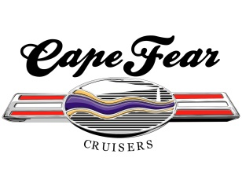
Cape Fear Cruisers, Inc.
(A 501(c)(3) Charitable Organization)

General Club Information

Board of Directors
Including
The Executive Board Officers

OFFICERS OF THE EXECUTIVE BOARD
Position | Name | Email | Phone | Term Expiration
President | Jackie Winters | Jackie.winters.cfc@gmail.com | 732-816-2284 | Dec 31, 2027
Vice President | Rob Kropp | RKropp43@gmail.com | 805-279-3659 | Dec 31, 2026
Secretary | Ginny Largent | ginnylargent@gmail.com | 301-801-3672 | Dec 31, 2026
Treasurer | Laura Clark | Laura.clark7777@gmail.com | 336-655-8672 | Dec 31, 2026
BOARD OF DIRECTORS INCLUDING THE EXECUTIVE BOARD OFFICERS
Director | Landa Bridges | Hav2gofishin@gmail.com | 980-312-1042 | Dec 31, 2026
Director | Rich Largent | snooksflyer@gmail.com | 301-801-3725 | Dec 31, 2026
Director | Peggy Lilly | Peggy.lilly@gmail.com | 703-409-6441 | Dec 31, 2026
Director | Bill Stenger | Reelbill1@yahoo.com | 330-842-0666 | Dec 31, 2026
Director | Bob Wysczelski | bob@wyski.net | 616-834-1103 | Dec 31, 2026

Mailing Address:
Cape Fear Cruisers Car Club
4891 Long Beach Rd. SE
Suite 3, #130
Southport, NC 28461-0551

General Phone # Posted on social media: 910-477-4331

e-Mail: capefearcruisers@gmail.com
Web: www.capefearcruisers.com
Facebook: https://www.facebook.com/CFearCruisers/ - This is our public page.
Facebook Group: https://www.facebook.com/groups/1430232360552539/ - Any member of the group can post items.

January 2026

