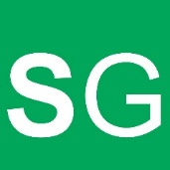**Simon Green Printing - Order Form**

To place an order, please complete the form below and email to: [dayopportunities@redbridge.gov.uk](mailto:dayopportunities@redbridge.gov.uk)

|  |  |
| --- | --- |
| Business Name (If applicable) |  |
| Contact Name |  |
| Email address |  |
| Contact number |  |
| Approximate delivery date |  |

|  |  |  |  |
| --- | --- | --- | --- |
| **Description** | **Quantity** | **Size (if applicable)** | **Colour** |
|  |  |  |  |
|  |  |  |  |
|  |  |  |  |
|  |  |  |  |
|  |  |  |  |
|  |  |  |  |
|  |  |  |  |
|  |  |  |  |
|  |  |  |  |
|  |  |  |  |
|  |  |  |  |
|  |  |  |  |

**Please use the section below for clothing orders. For all other orders, use the above section only.**

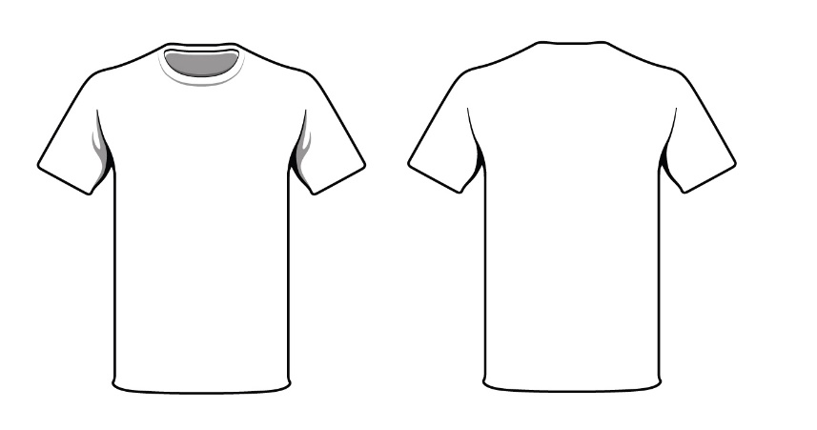

**Back**

**Front**

Use the shirt to sketch a rough design of your image and where you would like it to be placed.

If you have a specific image which you would like to use, please send to: [dayopportunities@redbridge.gov.uk](mailto:dayopportunities@redbridge.gov.uk)

Further Requirements: - *Please include image dimensions*

Please Note – The pricing varies depending on the quantity of images needed for clothing items. Once the order form is completed, we will be able to quote you a price based on your requirements. We also print on caps, mugs, coasters, keyrings, bags, puzzles, mouse mats, personalised stickers, signs and many more!