JUNE 2026
Monday | Tuesday | Wednesday | Thursday | Friday
1  Music with Ms. Candy   | 2  Police Department  10:00am   | 3 | 4     | 5
8  Music with Ms. Candy   | 9 |   10 | 11 | 12  Magical Matty  10:00-11:00am  
15  Music with Ms. Candy   | 16  Fire Department  9:30-10:30 am  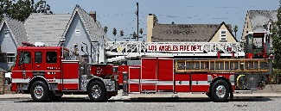 | 17 | 18 | 19  Closed for Juneteenth
22  Music with Ms. Candy   | 23 | 24  Critters-to-go: Sassafras 10:00am   | 25 | 26
29  INTERIM | 30  INTERIM

JULY 2026
Monday | Tuesday | Wednesday | Thursday | Friday
 |  | 1  INTERIM | 2  INTERIM |   3  CLOSED FOR  INDEPENDENCE DAY!
6  Music with Ms. Candy | 7 | 8  Creature Teacher  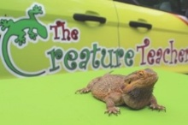  10:00 – 11:00 am | 9 | 10
13  Music with Ms. Candy | 14 | 15 | 16 | 17  Mr. Music    10:00-11:00 am
20  Music with Ms. Candy | 21 | 22 | 23 | 24
27  Music with Ms. Candy | 28 | 29 | 30 | 31  Spectrum Treats  10:00-11:00 am  

AUGUST 2026
Monday | Tuesday | Wednesday | Thursday | Friday
3  CLOSED FOR STAFF TRAINING | 4  CLOSED FOR STAFF TRAINING | 5  CLOSED FOR STAFF TRAINING | 6  CLOSED FOR STAFF TRAINING | 7  CLOSED FOR STAFF TRAINING  Splash back to School/ Open House!
10  FIRST DAY OF NEW SCHOOL YEAR! | 11 | 12 | 13 | 14
17 | 18 | 19 | 20 | 21
24 | 25 | 26 | 27 | 28
31

